Open Geospatial Consortium
Submission Date: <2026-04-15>
Approval Date: <yyyy-mm-dd>
Publication Date: <yyyy-mm-dd>
External identifier of this OGC® document: <http://www.opengis.net/doc/is/OMS-L/26-019>
Internal reference number of this OGC® document: 26-019
Version: 1.0
Category: OGC® Specification
Editor: Kathi Schleidt

OGC Observations, Measurements and Samples
–
Logical Model

Copyright notice
Copyright © 2026 Open Geospatial Consortium
To obtain additional rights of use, visit http://www.ogc.org/legal/.

Warning
This document is not an OGC Standard. This document is distributed for review and comment. This document is subject to change without notice and may not be referred to as an OGC Standard.
Document type: OGC® <Standard >
Document subtype: if applicable
Document stage: Draft
Document language: English
Recipients of this document are invited to submit, with their comments, notification of any relevant patent rights of which they are aware and to provide supporting documentation.
License Agreement
Permission is hereby granted by the Open Geospatial Consortium, ("Licensor"), free of charge and subject to the terms set forth below, to any person obtaining a copy of this Intellectual Property and any associated documentation, to deal in the Intellectual Property without restriction (except as set forth below), including without limitation the rights to implement, use, copy, modify, merge, publish, distribute, and/or sublicense copies of the Intellectual Property, and to permit persons to whom the Intellectual Property is furnished to do so, provided that all copyright notices on the intellectual property are retained intact and that each person to whom the Intellectual Property is furnished agrees to the terms of this Agreement.
If you modify the Intellectual Property, all copies of the modified Intellectual Property must include, in addition to the above copyright notice, a notice that the Intellectual Property includes modifications that have not been approved or adopted by LICENSOR.
THIS LICENSE IS A COPYRIGHT LICENSE ONLY, AND DOES NOT CONVEY ANY RIGHTS UNDER ANY PATENTS THAT MAY BE IN FORCE ANYWHERE IN THE WORLD.
THE INTELLECTUAL PROPERTY IS PROVIDED "AS IS", WITHOUT WARRANTY OF ANY KIND, EXPRESS OR IMPLIED, INCLUDING BUT NOT LIMITED TO THE WARRANTIES OF MERCHANTABILITY, FITNESS FOR A PARTICULAR PURPOSE, AND NONINFRINGEMENT OF THIRD PARTY RIGHTS. THE COPYRIGHT HOLDER OR HOLDERS INCLUDED IN THIS NOTICE DO NOT WARRANT THAT THE FUNCTIONS CONTAINED IN THE INTELLECTUAL PROPERTY WILL MEET YOUR REQUIREMENTS OR THAT THE OPERATION OF THE INTELLECTUAL PROPERTY WILL BE UNINTERRUPTED OR ERROR FREE. ANY USE OF THE INTELLECTUAL PROPERTY SHALL BE MADE ENTIRELY AT THE USER’S OWN RISK. IN NO EVENT SHALL THE COPYRIGHT HOLDER OR ANY CONTRIBUTOR OF INTELLECTUAL PROPERTY RIGHTS TO THE INTELLECTUAL PROPERTY BE LIABLE FOR ANY CLAIM, OR ANY DIRECT, SPECIAL, INDIRECT OR CONSEQUENTIAL DAMAGES, OR ANY DAMAGES WHATSOEVER RESULTING FROM ANY ALLEGED INFRINGEMENT OR ANY LOSS OF USE, DATA OR PROFITS, WHETHER IN AN ACTION OF CONTRACT, NEGLIGENCE OR UNDER ANY OTHER LEGAL THEORY, ARISING OUT OF OR IN CONNECTION WITH THE IMPLEMENTATION, USE, COMMERCIALIZATION OR PERFORMANCE OF THIS INTELLECTUAL PROPERTY.
This license is effective until terminated. You may terminate it at any time by destroying the Intellectual Property together with all copies in any form. The license will also terminate if you fail to comply with any term or condition of this Agreement. Except as provided in the following sentence, no such termination of this license shall require the termination of any third party end-user sublicense to the Intellectual Property which is in force as of the date of notice of such termination. In addition, should the Intellectual Property, or the operation of the Intellectual Property, infringe, or in LICENSOR’s sole opinion be likely to infringe, any patent, copyright, trademark or other right of a third party, you agree that LICENSOR, in its sole discretion, may terminate this license without any compensation or liability to you, your licensees or any other party. You agree upon termination of any kind to destroy or cause to be destroyed the Intellectual Property together with all copies in any form, whether held by you or by any third party.
Except as contained in this notice, the name of LICENSOR or of any other holder of a copyright in all or part of the Intellectual Property shall not be used in advertising or otherwise to promote the sale, use or other dealings in this Intellectual Property without prior written authorization of LICENSOR or such copyright holder. LICENSOR is and shall at all times be the sole entity that may authorize you or any third party to use certification marks, trademarks or other special designations to indicate compliance with any LICENSOR standards or specifications. This Agreement is governed by the laws of the Commonwealth of Massachusetts. The application to this Agreement of the United Nations Convention on Contracts for the International Sale of Goods is hereby expressly excluded. In the event any provision of this Agreement shall be deemed unenforceable, void or invalid, such provision shall be modified so as to make it valid and enforceable, and as so modified the entire Agreement shall remain in full force and effect. No decision, action or inaction by LICENSOR shall be construed to be a waiver of any rights or remedies available to it.

Contents
1. Scope 12
2. Conformance 12
3. References 13
4. Terms and Definitions 13
5. Conventions 18
5.1 Abbreviated terms and acronyms 18
5.2 Schema language 19
5.3 Model element names 19
5.4 Identifiers 20
6. Applying this model (informative) 20
6.1 General 20
6.2 Working with FeatureTypes 22
6.3 Creating Domain Classes 22
7. Fundamental characteristics of observations and samples (informative) 23
7.1 Observation Schema 23
7.1.1 General 23
7.1.2 Observation 24
7.1.3 ObservableProperty 26
7.1.4 ObservingProcedure 26
7.1.5 Observer 27
7.1.6 Host 27
7.1.7 Deployment 27
7.1.8 ObservationCharacteristics 28
7.1.9 ObservationCollection 28
7.1.10 ObservingCapability 29
7.2 Sample Schema 30
7.2.1 General 30
7.2.2 Sample 31
7.2.3 SpatialSample 32
7.2.4 MaterialSample 32
7.2.5 StatisticalSample 33
7.2.6 Sampling 33
7.2.7 Sampler 34
7.2.8 SamplingProcedure 35
7.2.9 PreparationStep 35
7.2.10 PreparationProcedure 35
7.2.11 SampleCollection 36
7.3 Monitoring Facilities Schema 36
7.3.1 General 36
7.3.2 MonitoringFacility 36
7.3.3 MonitoringNetwork 38
7.3.4 MonitoringProgram 39
7.3.5 MonitoringActivity 40
8. Logical Observation Schema (normative) 42
8.1 General 42
8.2 Observation 43
8.3 ObservableProperty 47
8.4 ObservingProcedure 48
8.5 Observer 49
8.6 Host 50
8.7 Deployment 51
8.8 ObservationCharacteristics 52
8.9 ObservationCollection 55
8.10 ObservingCapability 57
8.11 NamedValue 59
8.12 Codelist ObservationType 60
8.13 Codelist ObservationTypeByResultType 60
8.14 Codelist ObservationCollectionType 62
9. Logical Sampling Schema (normative) 64
9.1 General 64
9.2 Sample 65
9.3 SpatialSample 67
9.4 MaterialSample 68
9.5 StatisticalSample 70
9.6 Sampling 72
9.7 Sampler 74
9.8 SamplingProcedure 74
9.9 PreparationStep 75
9.10 PreparationProcedure 76
9.11 SampleCollection 77
9.12 PhysicalDimension 77
9.13 NamedLocation 78
9.14 StatisticalClassification 79
9.15 Codelist SampleType 79
9.16 Codelist SampleTypeByGeometryType 80
9.17 Codelist SamplerType 81
10. Logical Monitoring Core (normative) 81
10.1 General 81
10.2 MonitoringFacility 83
10.3 MonitoringNetwork 85
10.4 MonitoringActivity 86
10.5 MonitoringProgram 87
10.6 NetworkFacility 88
10.7 FacilityHierarchy 89
10.8 NetworkHierarchy 89
10.9 ProgramHierarchy 89
10.10 OperationalActivityPeriod 90
10.11 AnyDomainLink 90
11. Logical Monitoring Extended (normative) 91
11.1 General 91
11.2 MonitoringFacility Extended 93
11.2.1 reportedTo 93
11.2.2 mediaMonitored 94
11.2.3 legalBackground 94
11.2.4 responsibleParty 94
11.2.5 onlineResource 95
11.2.6 purpose 95
11.2.7 measurementRegime 95
11.2.8 mobile 96
11.2.9 resultAcquisitionSource 96
11.2.10 specializedMFType 97
11.2.11 geometryRequired 97
11.2.12 supersedes 97
11.2.13 supersededBy 98
11.3 MonitoringNetwork Extended 98
11.3.1 mediaMonitored 98
11.3.2 legalBackground 99
11.3.3 responsibleParty 99
11.3.4 onlineResource 99
11.3.5 purpose 100
11.3.6 organizationLevel 100
11.3.7 supersedes 101
11.3.8 supersededBy 101
11.4 MonitoringActivity Extended 101
11.4.1 activityTime 101
11.4.2 activityConditions 102
11.4.3 responsibleParty 102
11.4.4 onlineResource 103
11.5 MonitoringProgram Extended 103
11.5.1 mediaMonitored 103
11.5.2 legalBackground 103
11.5.3 responsibleParty 104
11.5.4 onlineResource 104
11.5.5 purpose 105
11.5.6 supersedes 105
11.5.7 supersededBy 105
11.6 Codelists 106
11.6.1 Codelist SpecializedMFType 106
11.6.2 Codelist PurposeOfCollection 106
11.6.3 Codelist Media 107
11.6.4 Codelist MeasurementRegime 107
11.6.5 Codelist ResultAcquisitionSource 108
11.6.6 Codelist ResultNature 109
11.6.7 Codelist LegislationLevel 109
Annex 111
Observation 112
Sampling 117
EF 123
EF Extended 128
MonitoringFacilityExt 128
MonitoringNetwork 133
MonitoringActivity 137
MonitoringProgram 139

Table of Figures
Figure 1: Modelling with full OMS Model 20
Figure 2: OGC SensorThings API data model 22
Figure 3: Core Logical Observation Schema 41
Figure 4: Logical ObservationCollection and ObservationCharacteristics Schema 42
Figure 5: Core Sampling Schema 63
Figure 6: Full Sampling Schema 64
Figure 7: Core Monitoring Schema 81
Figure 8: Monitoring Schema - OMS Context 82
Figure 9: Extended Monitoring Schema 87
Figure 10: Using Extended Monitoring 88

Keywords
The following are keywords to be used by search engines and document catalogues.
ogcdoc, OGC document, Observations, Measurements, Samples, Monitoring
Preface
The approved OGC Observations, Measurements and Samples (OMS) model is structured as three modeling layers which creates undue overhead for the implementation of domain models. Thus, a logical model layer compliant with the OMS model that provides all necessary associations is described in this document. Domain models created based on the OMS logical model will be compliant with OMS. In addition, concepts originating from the Environmental Monitoring Facilities Schema (EF) from the European INSPIRE Initiative are integrated as a valuable complement to the OMS Host class.
Attention is drawn to the possibility that some of the elements of this document may be the subject of patent rights. The Open Geospatial Consortium shall not be held responsible for identifying any or all such patent rights.
Recipients of this document are requested to submit, with their comments, notification of any relevant patent claims or other intellectual property rights of which they may be aware that might be infringed by any implementation of the standard set forth in this document, and to provide supporting documentation.
Security Considerations
No security considerations have been made for this Standard
Submitting organizations
The following organizations submitted this Document to the Open Geospatial Consortium (OGC):
DataCove e.U.
Fraunhofer IOSB
BRGM
Submitters
All questions regarding this submission should be directed to the editor or the submitters:

Name | Affiliation
Kathi Schleidt | DataCove e.U.
Hylke van der Schaaf | Fraunhofer IOSB
Sylvain Grellet | BRGM

Scope
This standard defines a logical model and related abstract schema for observations, for features involved in the observation process, and for features involved in sampling when making observations. These provide models for the exchange of information describing observation acts and their results, both within and between different scientific and technical communities.
The OMS Logical Model has been simplified from the multi-tier Observations, Measurements and Samples standard, flattening the modelling hierarchy to provide all OMS concepts in one consistent model. While the complexity of the full OMS model enables a great deal of flexibility in integrating concepts from existing legacy systems within OMS based models, it also proved difficult to work with as all associations referenced the conceptual interfaces in place of classes. The OMS Logical Model ameliorates these issues, easing adoption of OMS in both existing and new systems.
Observations commonly involve sampling of an ultimate feature-of-interest. This document defines a common set of sample types according to their spatial, material (for ex situ observations) or statistical nature. The schema includes relationships between sample features (sub-sampling, derived samples).
The OMS Host concept has been extended by concepts from the European INSPIRE Environmental Monitoring Facilities model, provided in the Monitoring section of this model. This covers relevant observational context such as Facilities, Networks, Programs and Activities. The INSPIRE model was slightly abstracted to align with an international context.
This document concerns only externally visible interfaces and places no restriction on the underlying implementations other than what is needed to satisfy the interface specifications in the actual situation.

Conformance
This Standard defines an logical transposition of the OGC Observations, measurements and samples standard.
Conformance with this Standard shall be checked using all the relevant tests specified in Annex A (normative) of this document. The framework, concepts, and methodology for testing, and the criteria to be achieved to claim conformance are specified in the OGC Compliance Testing Policies and Procedures and the OGC Compliance Testing web site.
All requirements-classes and conformance-classes described in this document are owned by the Standard(s) identified.

References
The following documents are referred to in the text in such a way that some or all of their content constitutes requirements of this document. For dated references, only the edition cited applies. For undated references, the latest edition of the referenced document (including any amendments) applies.

ISO 19103:2015, Geographic information — Conceptual schema language
ISO 19107:2019, Geographic information — Spatial schema
ISO 19108:2002, Geographic information — Temporal schema
ISO 19109: 2015 Geographic information — Rules for application schema
ISO 19123:2005, Geographic information — Schema for coverage geometry and functions
ISO 19136-1:2020 Geographic information — Geography Markup Language (GML)
ISO 19156:2023, Geographic information — Observation, measurements and samples

Terms and Definitions
This document uses the terms defined in Policy Directive 49, which is based on the ISO/IEC Directives, Part 2, Rules for the structure and drafting of International Standards. In particular, the word “shall” (not “must”) is the verb form used to indicate a requirement to be strictly followed to conform to this Standard and OGC documents do not use the equivalent phrases in the ISO/IEC Directives, Part 2.
For the purposes of this document, the following additional terms and definitions apply.

application schema
conceptual schema for data required by one or more applications
[SOURCE: ISO 19101-1:2014, 4.1.2]

coverage
feature that acts as a function to return values from its range for any direct position within its domain
[SOURCE: ISO/DIS 19123-1, 3.1.8]

data type
specification of a value domain with operations allowed on values in this domain
EXAMPLE Integer, Real, Boolean, String and Date.
Note 1 to entry: Data types include primitive predefined types and user-definable types.
[SOURCE: ISO 19103:2015, 4.14]

domain
well-defined set
Note 1 to entry: All elements within a domain (set) are of a given type.
[SOURCE: ISO 19109:2015, 4.8, modified — Original Note 1 to entry has been replaced with a new note to entry.]

domain feature
feature of a type defined within a particular application domain
Note 1 to entry: This can be contrasted with observations and sampling features, which are features of types defined for cross-domain purposes.
[SOURCE: ISO 19156:2023, 3.5]

ex situ
off-site
referring to the study, maintenance or conservation of a specimen or population away from its natural surroundings
Note 1 to entry: Opposite of in situ (on-site).
Note 2 to entry: an example of ex situ & direct is measuring a patient’s temperature with a mercury thermometer in a blood-sample.
Note 3 to entry: an example of ex situ & remote is measuring a patient’s temperature with an infra-red thermometer pointed at the blood sample.
[SOURCE: ISO 19156:2023, 3.6]

feature
abstraction of real world phenomena
Note 1 to entry: A feature can occur as a type or an instance. In this document, feature instance is meant unless otherwise specified.
[SOURCE: ISO 19101-1:2014, 4.1.11, modified — Note 1 to entry has been modified.]

feature-of-interest
subject of the observation
[SOURCE: ISO 19156:2023, 3.8]

feature type
class of features having common characteristics
[SOURCE: ISO 19156:2023, 3.9]

in situ
on-site
referring to the study, maintenance or conservation of a specimen or population without removing it from its natural surroundings
Note 1 to entry: Opposite of ex situ (off-site).
Note 2 to entry: an example of in situ & direct is measuring a patient’s temperature with a mercury thermometer in the patient’s rectum.
Note 3 to entry: an example of in situ & remote is measuring a patient’s temperature with an infra-red thermometer at a distance.
[SOURCE: ISO 19156:2023, 3.10]

measure
<GML> value described using a numeric amount with a scale or using a scalar reference system
Note 1 to entry: When used as a noun, measure is a synonym for physical quantity.
[SOURCE: ISO 19136-1:2020, 3.1.41]

measurement
set of operations having the object of determining the value of a quantity
[SOURCE: ISO 19101-2:2018, 3.21]

observation
act carried out by an observer to determine the value of an observable property of an object (feature-of-interest) by using a procedure, with the value is provided as the result
[SOURCE: ISO 19156:2023, 3.13]

observation result
estimate of the value of a property determined through a known observation procedure
[SOURCE: ISO 19156: 2023, 4.14]

observer
identifiable entity that can generate observations pertaining to an observable property by implementing a procedure
Note 1 to entry: An observer is an instance of a sensor, instrument, implementation of an algorithm or a being such as a person.
[SOURCE: ISO 19156:2023, 3.15]

positional accuracy
closeness of coordinate value to the true or accepted value in a specified reference system
Note 1 to entry: The phrase "absolute accuracy" is sometimes used for this concept to distinguish it from relative positional accuracy. Where the true coordinate value may not be perfectly known, accuracy is normally tested by comparison to available values that can best be accepted as true.
[SOURCE: ISO 19116:2025, 3.22]

procedure
specified way to carry out an activity or a process
[SOURCE: ISO 9000:2015, 3.4.5, modified — Note 1 to entry has been deleted.]

process
set of interrelated or interacting activities that use inputs to deliver an intended result
[SOURCE: ISO 9000:2015, 3.4.1, modified — Notes 1-6 have been deleted.]

property
facet or attribute of an object referenced by a name
EXAMPLE Abby’s car has the colour red, where “colour red” is a property of the car.
Note 1 to entry: in some communities, the observed property is referred to as the measurand
[SOURCE: ISO 19143:2010, 4.21, modified — Example and note have been added to the entry.]

property type
characteristic of a feature type
EXAMPLE Cars (a feature type) all have a characteristic colour, where “colour” is a property type.
Note 1 to entry: The value for an instance of an observable property type can be estimated through an act of observation.
Note 2 to entry: In chemistry-related applications, the term “determinand” or “analyte” is often used.
[Source: ISO 19109:2005 Adapted]

proximate feature-of-interest
entity that is directly of interest in the act of observing
Note 1 to entry: This is a specialized form of the feature-of-interest
[SOURCE: ISO 19156:2023, 3.20]

range
<coverage> set of feature attribute values associated by a function, the coverage, with the elements of the domain of a coverage
Note 1 to entry: This is consistent with the more generic definition of range in ISO 19107:2019.
[SOURCE: ISO/DIS 19123-1, 3.1.47]

sample
object that is representative of a concept, real-world object or phenomenon
[SOURCE: ISO 19156:2023, 3.22]

sampler
device or entity (including humans) that is used by, or implements, a sampling procedure to create or transform one or more sample(s)
[SOURCE: ISO 19156:2023, 3.23]

sensor
element of a measuring system that is directly affected by a phenomenon, body, or substance carrying a quantity to be measured
[SOURCE: JCGM 200:2012, 3.8, modified — EXAMPLES and NOTE deleted.]

ultimate feature-of-interest
entity that is ultimately of interest in the act of observing
Note 1 to entry: This is a specialized form of the feature-of-interest.
[SOURCE: ISO 19156:2023, 3.25]

unit of measure
reference quantity chosen from a unit equivalence group
Note 1 to entry: In positioning services, the usual units of measurement are either angular units or linear units. Implementations of positioning services must clearly distinguish between SI units and non-SI units. When non-SI units are employed, it is required that their relation to SI units be specified.
[SOURCE: ISO 19116:2019, 3.29]

value
element of a type domain
Note 1 to entry: A value considers a possible state of an object within a class or type (domain).
Note 2 to entry: A data value is an instance of a datatype, a value without identity.
Note 3 to entry: A value can use one of a variety of scales including nominal, ordinal, ratio and interval, spatial and temporal. Primitive datatypes can be combined to form aggregate datatypes with aggregate values, including vectors, tensors and images.
[SOURCE: ISO/IEC 19501:2005, 0000_5, modified — Note 3 to entry has been added.]

Conventions

Abbreviated terms and acronyms
EF | INSPIRE Environmental Monitoring Facilities Model
FoI | Feature-of-Interest
GFM | General Feature Model
GML | Geography Markup Language
INSPIRE | Infrastructure for Spatial Information in Europe
O&M | Observations and Measurements
OMS | Observations, Measurements and Samples
OMS-L | OMS Logical Model (this current document)
OGC | Open Geospatial Consortium
STA | OGC SensorThings API
TSML | TimeSeries Modeling Language
UML | Unified Modeling Language
UoM | Unit of Measurement
XML | Extensible Markup Language
WIGOS | WMO Integrated Global Observing System
WMDR | WIGOS Metadata Representation
WMO | World Meteorological Organization

Schema language
The conceptual schema specified in this document is in accordance with the Unified Modelling Language (UML) ISO/IEC 19501, following the guidance of ISO 19103.
The UML in Abstract Core and Basic packages is conformant with the profile described in ISO 19136-1:2020, Annex E. Use of this restricted idiom supports direct transformation into a GML Application Schema. The stereotype «FeatureType» states that a class is an instance of the «metaclass» FeatureType (ISO 19109) [2], and therefore represents a feature type.
The prose explanation of the model uses the term “property” to refer to both class attributes and association roles. This is consistent with the General Feature Model described in ISO 19109. In the context of properties, the term “value” refers to either a literal (for attributes whose type is simple), or to an instance of the class providing the type of the attribute or target of the association. Within the explanation, the property names (property types) are sometimes used as natural language words where this assists in constructing a readable text.

Model element names
This Standard specifies a logical model for observations using terminology that is based on current practice in a variety of scientific and technical disciplines. It is designed to apply across disciplines, so the best or “most neutral” term has been used in naming the classes, attributes and associations provided. The terminology does not, however, correspond precisely with any single discipline.

Identifiers
The normative provisions in this specification are denoted by the URI
http://www.opengis.net/spec/{standard}/{m.n}
All requirements and conformance tests that appear in this document are denoted by partial URIs which are relative to this base.

Applying this model (informative)

General
The current OGC OMS model consisting of three modeling layers creates undue overhead for the implementation of domain models. Thus, a logical model layer compliant with the OMS model that provides all necessary associations is described in this document.
OMS provides the relevant concepts for the structured description of observations, including the sampling structure, often essential for true understanding of the nature of the observations being provided. As data provisioning mechanisms are transitioning towards highly distributed linked approaches, the model structure and packaging have been significantly abstracted. This approach allows implementers to explicitly select the concepts to be supported based on their requirements, while clearly stating to which requirements and Conformance Classes their implementation complies. Both the Observation and Sample sections of this model have been structured using the following layering of packages:
- Conceptual: Within the Conceptual Model Packages, only Interfaces are provided. These models provide a very abstract view of the individual concepts they contain without reference to specific implementations. This approach allows for the inclusion of semantically aligned objects from external sources, that while having been created externally, do provide concepts sharing the same semantic meaning as the concepts from the Conceptual Models.
- Abstract Core: Within the Abstract Core Model Packages, only abstract featureTypes are provided following the semantic structure of the Conceptual model (i.e., realizing the interfaces provided by the Conceptual Model Packages). A consistent approach to metadata provision is introduced. All associations from the abstract featureTypes reference the conceptual interfaces for greater implementation flexibility. The Abstract Core Model Packages are designed for the creation of domain models. as required by individual communities. Due to their abstract definition, the classes from Abstract Core cannot be directly instantiated.
- Basic: Within the Basic Packages, simple concrete featureTypes (specializing the abstract ones from the Abstract Core model) are defined with some basic utility attributes added for rapid out-of-the-box deployment. A few additional concepts pertaining to collections and potential observations are introduced at this level. This is the only level of OMS that can be directly instantiated.
While the layered approach described above allows for great flexibility (as required of a conceptual model), it also adds a serious burden on those tasked with specializing parts of OMS within their domain models. As part of the flexibility of the OMS layered approach, all associations across model layers target the interfaces from the conceptual model. In order to derive domain classes from the abstract classes provided by OMS, one must also include the interfaces for relevant context on associations. This is partially due to Enterprise Architect (the UML modeling tool used) not allowing display of inherited associations as can be done with inherited attributes. The resulting diagrams rapidly become unreadable, as shown in the simple example below.
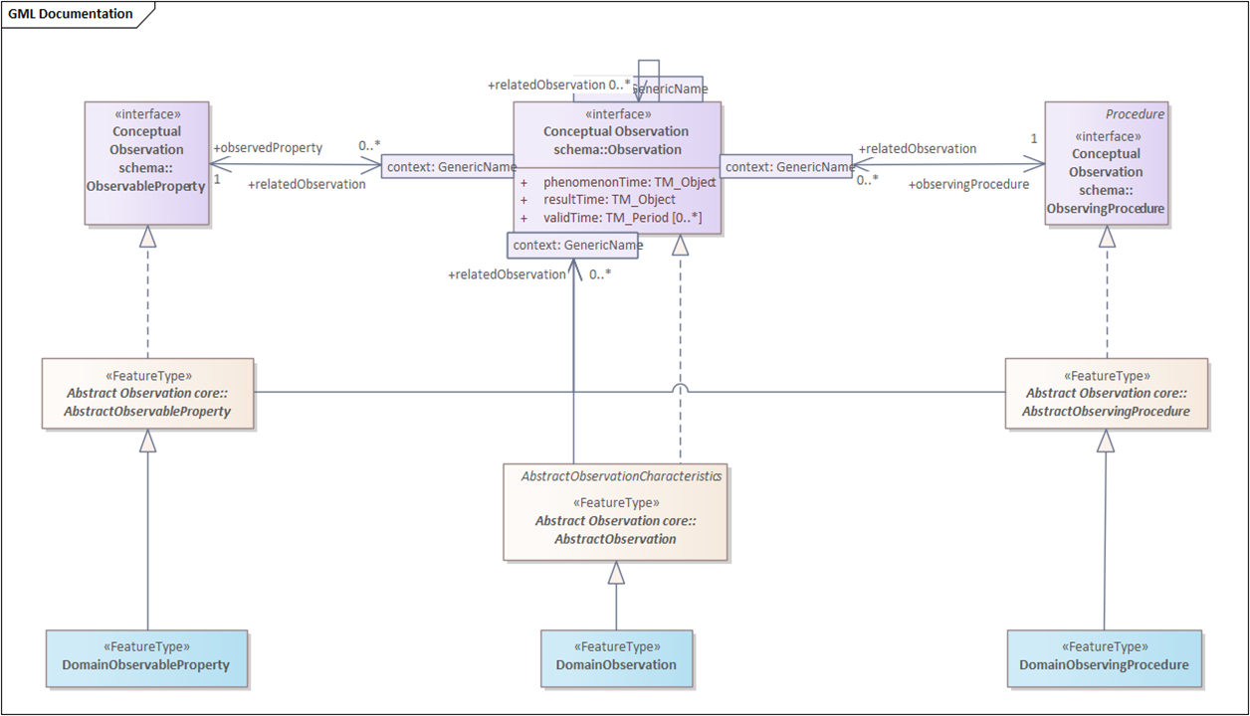
Figure 1: Modelling with full OMS Model
In this example, the Observation, ObservableProperty and ObservingProcedure types are specialized to domain types (e.g. because additional attributes are required). The top third of the diagram only serves the purpose of showing the associations between the interfaces. This adds additional unwanted overhead to models.
This issue was initially encountered during work done on updating the World Meteorological Organization (WMO) WIGOS Metadata Representation (WMDR) model to OMS. In this work it rapidly became apparent that the already complex WMDR models could not cope with the addition of the OMS interfaces together with the abstract classes. During the Time Series Modelling Language (TSML) update, contributors also encountered the same issue. As such, the current TSML work is based on the OMS Logical Model.
To overcome the above identified issue in the OMS Logical Model, all classes from the three layers of the OMS model are therefore provided as featureTypes, and all associations are available directly between these classes. As in the OMS model, this provides individual packages for Observation and Sampling. All these classes are aligned with the OMS model. However, not all classes are available at the conceptual level, e.g. the individual sample types SpatialSample, MaterialSample and StatisticalSample are not introduced until the OMS Basic Samples package. In these cases, the abstract class in the logical model had to be derived from the corresponding Basic Package.

Working with FeatureTypes
Within the OMS Logical model, the GML FeatureType Stereotype is used for all core classes. Thus, all classes of type FeatureType natively include the following basic attributes, in addition to geometry information:
- gml:id: A mandatory unique identifier for each feature instance, essential for referencing and linking between features. It must be unique within the scope of the document.
- gml:name: A label or name assigned to the feature, which may or may not be unique.
- gml:description: A text description of the feature.
Thus, these attributes are not modelled within this standard.

Creating Domain Classes
The OMS Logical model was created for the further derivation of bespoke domain models, tailoring the OMS structure towards specific requirements both by extending the existing classes as well as by defining additional classes and associations.
While the most straightforward approach is direct alignment, including one-to-one mapping of classes while maintaining class and attribute names, depending on the use case and target technology, modifications may be required. In some cases, classes will be renamed to better reflect domain concepts, while in other cases, classes may be merged if there is a clear one-to-one association between them.
This can be illustrated by the alignment of the OGC SensorThings API (STA) data model, shown in Figure 2, with OMS, shown in Figure 3 and Figure 4. At first glance, the models seem similar but different. However, with the following alignment, it becomes clear that STA fully conforms to OMS:
- Attribute renaming: OMS:Observation.parameter is renamed STA:Observation.properties
- Class renaming: OMS:Host is renamed STA:Thing; OMS:Observer is renamed STA:Sensor
- Class merge: OMS:ObservationCollection and OMS:ObservationCharacteristics have been merged to STA:Datastream

In this way, the OMS model can serve as the basis for a wide range of domain models, each tailored to the specific needs of their community, while maintaining structural interoperability.
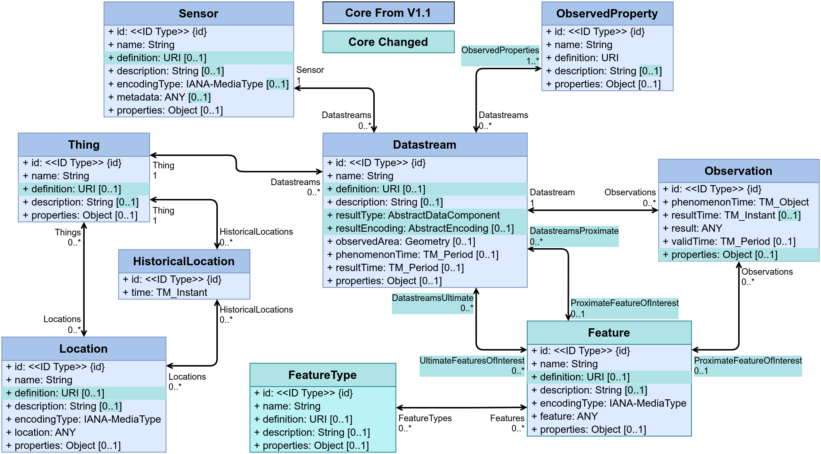
Figure 2: OGC SensorThings API data model

Fundamental characteristics of observations and samples (informative)

Observation Schema

General
The OMS Observation provides an efficient standardized method for providing information on properties of features. While the simplest approach for providing such feature information remains the definition of a simple attribute on this feature carrying this property, this approach is severely limited for providing additional relevant meta-information such as:
- The measurement methodology used in determining this property;
- The measurement device that provided the value;
- The facility at which this value was determined;
- The deployment time of the measurement device at the facility;
- Semantic details on the property being provided;
- Temporal support for properties that vary over time;
- Information on related observations.
In the process of defining specialized feature models for specific domains, it is valuable to reflect if this additional observational meta-information is of relevance for individual feature properties. When feature properties are static and observational meta-information is not relevant, a simple attribute will suffice; In situations where observational meta-information is relevant, e.g., environmental monitoring and reporting, utilization of the OMS Observation for provision of this feature property greatly eases professional data sharing.

Observation
An Observation is defined as an act carried out by an Observer to determine the value of an ObservableProperty of an object (featureOfInterest) by using an ObservingProcedure; the value is provided as the result. It is important to note that the terms ‘observation’, ‘interpretation’, ‘forecast’, ‘simulation’ correspond to this definition.
There are three different temporal properties on Observations
- phenomenonTime: The time for which the result applies to the characteristic of the FeatureOfInterest being observed. The phenomenonTime is often the time of interaction with a real-world feature either by a SamplingProcedure (time at which a Sample has been taken) or by an ObservingProcedure. If the result is the average of multiple samples taken at different times, then the phenomenonTime is the time interval over which these measurements were taken.
- resultTime: The instant of time when the result of the Observation became available. The resultTime typically corresponds to when the Procedure associated with the Observation was completed. For some observations this is identical to the phenomenonTime. However, there are important cases where they differ:
  - Where a measurement is made on a specimen in a laboratory, the phenomenonTime is the time the specimen was retrieved from its host, while the resultTime is the time the laboratory procedure was applied.
  - Where sensor observation results are post-processed, the resultTime is the post-processing time, while the phenomenonTime is the time of initial interaction with the world.
  - Simulations may be used to estimate the values for phenomena in the future or past. The phenomenonTime is the time that the result applies to, while the resultTime is the time that the simulation was executed.
- validTime: The time interval during which the result is assumed to be applicable for use. This attribute is commonly required in forecasting applications.

The featureOfInterest (FoI) association links to the feature that is the subject of the Observation. While in many cases, the FoI is a Sample (see section 7.2.2), any feature can serve as FoI. This object is either the real-world object whose properties are under observation, or it is an object used as a proxy for a real-world object that is not directly observable. Some examples of FoIs are:
- An instance of a feature modelled in a specific domain model (e.g., Borehole according to OGC GeoSciML).
- The bubble of air around the intake of an air quality monitoring station.
- An existing well being used for water quality measurements.

In some cases, the measurement process may be performed on an intermediary entity referred to as proximateFeatureOfInterest that acts as a proxy to the ultimate feature-of-interest that is being observed (measured, estimated or calculated). Thus, within the OMS model, there is a differentiation between:
- proximateFeatureOfInterest: The entity that is directly of interest in the act of observing.
- ultimateFeatureOfInterest: The entity that is ultimately of interest in the act of observing.
Some examples to illustrate the differentiation between proximate and ultimate FoI:
- To determine the concentrations of chemical compounds in a river, a sample is taken in a predefined location in the river. This sample is taken to a laboratory where the required chemical analysis is done. In this case, the river is the ultimateFeatureOfInterest, while the sample is the proximateFeatureOfInterest .
- Pertaining to documents and observations on the consistency thereof, for the Observation “This clause is inconsistent”, the ultimateFeatureOfInterest is the entire document, while the proximateFeatureOfInterest is the specific clause being addressed.

Observational meta-information is provided by the following associations
- The observedProperty association links to the ObservableProperty that is the subject of the Observation. The ObservableProperty referenced by observedProperty should correspond to a characteristic associated with the featureOfInterest.
- The observingProcedure association links to the ObservingProcedure used by the Observation to determine the value of the ObservableProperty provided by the result. The ObservingProcedure referenced by procedure should be suitable for the associated ObservableProperty.
- The observer association links to the Observer that is involved in the creation of this Observation.
- The host association links to the Host that is involved in the creation of this Observation. At least one Observer or Host should be provided.

Finally, the result association links to the result of the Observation. The type of the result provided by the result association should be suitable for the associated ObservableProperty
The Observation will provide a unit of measure (UoM) if the result is measurable. If the UoM is not contained in the result, it is to be provided in the context of the Observation. The provision modality is to be defined by communities. The unit of measure should be suitable for the associated ObservableProperty and ObservingProcedure. In the case where the result of the Observation is a classification, for which no unit exists, the UoM can be declared as unitless
The parameter attribute provides a flexible extension point, allowing for the provision of name/value pairs further describing the Observation. Parameter should not be utilized to provide information already contained in the model by existing attributes or associations.

ObservableProperty
An ObservableProperty is defined as a quality (property, characteristic) of the feature-of-interest that can be observed. The height of a tree, the depth of a water body, or the temperature of a surface are examples of observable properties, while the value of a classic car is not (directly) observable but asserted.
The association observer links to an Observer capable of observing this ObservableProperty.

ObservingProcedure
An ObservingProcedure is defined as the description of steps performed in order to determine the value of an observableProperty by an Observer.
Depending on the complexity of the use case, the ObservingProcedure will be more or less explicitly described. Especially pertaining to historical data, there may be very little or no information available – what information is available should be provided;
The ObservingProcedure is a workflow, protocol, plan, algorithm, or computational method specifying how to make an observation. The ObservingProcedure is often referred to as the method, or the recipe that the observer (cook) follows to generate the Observation. Different Observers can follow the same (reusable) ObservingProcedure for the creation of different Observations.
The ObservingProcedure cannot describe a sensor instance, but it can describe the sensor type.
An instance of ObservingProcedure is a description of the process utilized by an Observer, this could be a chemical analysis method, a protocol for measuring an object, but could also be a checklist utilized by a human Observer during a biodiversity campaign. ObservingProcedure could further describe the algorithms behind simulators or models used to generate a result from other inputs.
The association observer links to an Observer capable of performing this ObservingProcedure.

Observer
An Observer is defined as an identifiable entity that can generate Observations pertaining to an observableProperty by implementing an ObservingProcedure.
The Observer is the entity instance of a sensor, instrument, implementation of an algorithm, or a being such as a person, not the entity type. It responds to a stimulus, e.g., a change in the environment, or input data composed from the results of prior Observations, and generates a result.
Pertaining to sensors, the Observer would reference the explicit sensor, while the ObservingProcedure would reference the methodology utilized by that sensor type. An Observer can be hosted by one or more Host. Different Observers can follow the same (reusable) observing ObservingProcedure for the creation of different Observations. An Observer is closely linked with an ObservableProperty that it generates results for;
Accelerometers, gyroscopes, barometers, magnetometers, and so forth are Observers that are typically mounted on a modern smartphone (which acts as Host). Other examples of Observers include the human eyes.
Contextual information to the Observer is provided via the following associations:
- The observableProperty association links to an ObservableProperty that this Observer can observe.
- The observingProcedure association links to an ObservingProcedure that this Observer can perform.
- The deployment association links to a Deployment to which this Observer is either physically or organizationally attached.

Host
A Host is defined as a grouping of Observers for a specific reason.
In many use cases, the Host is the environmental monitoring facility. The Host can be a platform that hosts a set of sensors. An alternative usage could pertain to a biodiversity survey campaign. In this scenario, the team performing the survey would be modelled as observers whereas the entire survey campaign can be represented as a Host.
The association deployment links to a Deployment at this Host.
The association relatedHost links to a Host the Host is related to.

Deployment
A Deployment is defined as information on the assignment of an Observer to a Host. Examples of Deployment are:
- Information regarding a sensor being attached to a pole.
- The monitoring facilities pertaining to an environmental monitoring network.
- The description of a ship cruise linking a research vessel with a marine network.
- The participation of a citizen in a citizen-science project involving crowd sensing.
The attribute deploymentReason provides a human readable description of the reason for the Deployment. The attribute deploymentTime provides the time that the Deployment pertains to.
The position concept has been added to Deployment based on experiences in the OGC GeoTech and Water Quality Interoperability Experiments. In addition to the attribute atPosition the attribute positionUoM has been added to indicate the unit of measure used to define the position.
Contextual information to the Deployment is provided via the following associations:
- The observer association links to the Observer associated with this Deployment.
- The host association links to the Host to which this Deployment pertains.

ObservationCharacteristics
An ObservationCharacteristics is defined as a set of common characteristics used for describing an Observation or a collection of Observations. ObservationCharacteristics has all of the attributes and associations as Observation, but none of the cardinality limitations (all attributes and associations have cardinality 0..*), making it a useful concept when describing observational matters.

ObservationCollection
An ObservationCollection is defined as a collection of similar Observations. The ObservationCollection is further described by the associated ObservationCharacteristics (linked via the memberCharacteristics association), that can carry all observational meta-information directly provided by Observations.
The collectionType indicates how the linked memberCharacteristics impact the Observations contained within the ObservationCollection. The following values are foreseen for collectionType:
- homogeneous: all observations contained are of a similar nature.
If a property value is provided within the ObservationCharacteristics, this value applies to all Observations contained in the ObservationCollection. The Observations need not contain attributes or associations supplied via the ObservationCharacteristics:
  - property not provided – values may be provided by the Observations but is not provided at this level
  - property provided but with no content – no Observation within the collection provides this property
  - property = value – this value applies to all Observations within the collection
  - property = value set/range – this value set/range applies to all Observations within the collection
- summarizing: a wider “grab-bag” type of collection.
If multiple values for a property are available in the contained Observations, all values for this attribute (or the range of values contained in all Observations) are provided in the ObservationCharacteristics. A property may also be empty in the ObservationCharacteristics – in this case any value can be provided for this attribute within the contained Observations:
  - property not provided – values may be provided by the Observations but a summary is not provided at this level;
  - property provided but with no content – no Observation within the collection provides this property;
  - property = value – this value applies to all Observations within the collection;
  - property = value set/range – all Observations provide a value within this set/range.
The member association links to all Observation(s) contained within the ObservationCollection.
The relatedCollection association links to an ObservationCollection related with this ObservationCollection.

ObservingCapability
An ObservingCapability is defined as information on Observation(s) that could potentially be provided. ObservingCapability is typically linked from a MonitoringFacility or Host, indicating what potential Observation(s) could be gathered from this facility.
EXAMPLE In order to explicitly describe the capabilities of an Environmental Monitoring Facility, information on what Observable Properties are being measured with which methodology is provided.
For example, in a national groundwater quantity monitoring network, depending on the equipment and the underlying observational strategies:
a) Some monitoring may have just one ObservingCapability:
1) ObservingCapability:
i) ultimateFeatureOfInterest: ’Hydrogeological Unit 121AS’;
ii) proximateFeatureOfInterest:’xyz’;
iii) procedure: ‘Groundwater depth measurement by electronic probe’;
iv) observedProperty: ‘GroundWaterDepth’.
b) Other monitoring may have several such ObservingCapabilities, for example:
1) ObservingCapability 1:
i) ultimateFeatureOfInterest: ‘Entite hydrogeologique 143AE05’;
ii) proximateFeatureOfInterest: ‘Calcaires du Muschelkalk de Lorraine à SERVIGNY-LES-RAVILLE’;
iii) procedure: ‘Groundwater depth measurement by electronic probe’;
iv) observedProperty: ‘GroundWaterDepth’.
2) ObservingCapability 2:
i) ultimateFeatureOfInterest: ‘Entite hydrogeologique 143AE05’;
ii) proximateFeatureOfInterest : ‘Calcaires du Muschelkalk de Lorraine à SERVIGNY-LES-RAVILLE’ ;
iii) procedure: ‘Digital recording teletransmitted’;
iv) observedProperty: ‘Water Temperature’.
3) ObservingCapability 3:
i) ultimateFeatureOfInterest: ‘Entite hydrogeologique 143AE05’;
ii) proximateFeatureOfInterest : ‘Calcaires du Muschelkalk de Lorraine à SERVIGNY-LES-RAVILLE’ ;
iii) procedure: ‘Digital recording teletransmitted’;
iv) observedProperty: ‘Water conductivity measured at 25°C’.
NOTE In the example above, URIs have been removed and only the labels provided for better readability.

Sample Schema

General
The OMS Sample allows for provision of information of Samples, specifically for use as the FoI of an Observation. It enables provision of relevant meta-information on how Samples were derived and processed, including:
- The sampling act that resulted in the sample;
- The device used in obtaining the sample;
- The procedure followed in obtaining the sample;
- Individual preparation steps performed on the sample prior to measurement;
- The procedures followed in the individual preparation steps.

In addition, different types of Samples have been specified:
- Spatial samples have a geospatial component;
- Material samples are physical tangible samples, often referred to as specimens.
- Statistical samples.

Sample
A Sample is defined as an object that is representative of a concept, real-world object or phenomenon. Typically, the Sample is a Feature which is intended to be representative of a FeatureOfInterest on which Observations can be made. As such, it can carry a characteristic pertaining to the ObservedProperty being evaluated by the Observation.
The way the Sample is taken is typically guided by a sampling strategy. Samples are often artefacts of an observational strategy and often have no significant function outside of their role in the observation process (although specimen preservation could be considered a specific activity per se).
For example, a profile typically samples a water- or atmospheric-column or a well samples the water in an aquifer or a tissue specimen samples a part of an organism. A statistical sample is often designed to be characteristic of an entire population. This is so that Observations can be made regarding the sample that provide a good estimate of the properties of the population.
The sampleType attribute can be used to indicate the type of Sample according to a community agreed typology.
Contextual information to the Sample is provided via the following associations:
- The sampling association links to the Sampling act the Sample is the result of.
- The sampledFeature association links to the feature the Sample is intended to be representative of.
- The preparationStep association links to the PreparationStep(s) applied to prepare the Sample.
- The relatedSample association links to a Sample the Sample is related to.

The parameter attribute provides a flexible extension point, allowing for the provision of name/value pairs further describing the Sample. Parameter should not be utilized to provide information already contained in the model by existing attributes or associations.

SpatialSample
A SpatialSample is defined as a geospatial Sample. When Observation(s) are made to estimate properties of a geospatial feature, in particular where the value of a property varies within the scope of the feature, a SpatialSample is used. Depending on accessibility and on the nature of the expected property variation, the SpatialSample can be extensive in one, two or three spatial dimensions.
Some common names for SpatialSample used in various application domains include Borehole, Flightline, Interval, Lidar Cloud, Map Horizon, Microscope Slide, Mine Level, Mine, Observation Well, Profile, Pulp, Quadrat, Scene, Section, ShipsTrack, Spot, Station, Swath, Trajectory, Traverse, etc.
The following attributes provide relevant spatial information:
- The shape attribute provides the Geometry of the SpatialSample.
- The horizontalPositionalAccuracy attribute provides information on the positional accuracy of the horizontal component of the Geometry of the SpatialSample.
- The verticalPositionalAccuracy attribute provides information on the positional accuracy of the vertical component of the Geometry of the SpatialSample.

MaterialSample
A MaterialSample is defined as a physical, tangible Sample. MaterialSample(s) that are curated and preserved are sometimes known as ‘specimens’. MaterialSample(s) can be destroyed in connection with the observation act. A MaterialSample is a physical Sample of a FeatureOfInterest, obtained for Observation(s) normally carried out ex situ, sometimes in a laboratory.
The following attributes provide relevant information:
- The size attribute provides a physical extent of the MaterialSample. The size can be length, mass, volume, etc., as appropriate for the MaterialSample instance and its material type.
- The storageLocation attribute provides the location of a MaterialSample. The storageLocation can be a location such as a shelf in a warehouse or a drawer in a museum.
- The sourceLocation attribute provides the location from where the MaterialSample was obtained. The attribute sourceLocation of the MaterialSample can be unnecessary in case the related Sampling act samplingLocation attribute is provided or when a relatedSample’s location provides an unambiguous location.

StatisticalSample
A StatisticalSample is defined as a statistical subset of a feature-of-interest, defined for the purpose of creating Observation(s). StatisticalSample(s) usually apply to populations or other sets, of which certain subset can be of specific interest, e.g., the male or female subset of a population.
The following attributes provide relevant information:
- The classification attribute describes a criterion by which the subset was defined. The classification can be age, gender, etc., as appropriate for the set or population on which the subsetting is performed. A StatisticalClassification is provided for this purpose with the attributes:
  - The concept attribute defines the concept by which a StatisticalClassification is to be performed, e.g., age, gender, color, size etc..
  - The classification attribute provides the explicit classification classes pertaining to the classification concept described by the StatisticalClassification, e.g., Age Brackets: [0-10], [10-20]; Genders: Male, Female, Other; Color: Red, Green, Blue.

Sampling
A Sampling is defined as an act applying a SamplingProcedure to create or transform one or more Sample(s). Examples of Sampling are:
- Crushing a rock sample in a ball mill;
- Digging a pit through a soil sequence;
- Dividing a field site into quadrants;
- Drawing blood from a patient;
- Extracting water from an observation well;
- Extracting a sample from a defined environmental monitoring station;
- Registering an image of the landscape;
- Sieving a powder to separate the subset finer than 100-mesh;
- Selecting a subset of a population;
- Splitting a piece of drill-core to create two new samples;
- Taking a diamond-drill core from a rock outcrop.

The samplingLocation attribute can be used to provide location information pertaining to the Sampling act. The time attribute provides information on the time of the Sampling.
Contextual information for the Sampling act is provided via the following associations:
- The sample association links to the Sample generated by the Sampling;
- The featureOfInterest association links to the concept, real-world object or phenomenon (feature-of-interest) the Sample(s) of the Sampling represent;
- The sampler association links to the Sampler that performed the Sampling;
- The samplingProcedure association links to the SamplingProcedure used by the Sampling;
- The relatedSampling association links to related Sampling(s).

The parameter attribute provides a flexible extension point, enabling the provision of name/value pairs further describing the Sampling act. For example, when taking water samples, the sampling procedure specifies that an amount of time needs to pass to allow sediments to settle. The exact waiting time used in this Sampling can be stored in the parameter.
Parameter should not be utilized to provide information already contained in the model by existing attributes or associations.

Sampler
A Sampler is defined as a device or entity (including humans) that is used by, or implements, a SamplingProcedure to create or transform one or more Sample(s). Examples of Samplers include:
- A ball mill, diamond drill, hammer;
- A hypodermic syringe and needle;
- An image sensor, a soil auger;
- A human being.
All the examples above can act as sampling devices (i.e., be Samplers). However, sometimes the distinction between the Sampler and the sensor (Observer) is not evident, as they are packaged as a unit. A Sampler need not be a physical device.
The samplerType attribute can be used to indicate the type of Sampler according to a community agreed typology.
Contextual information for the Sampler is provided via the following associations:
- The sampling association links to the Sampling act performed by the Sampler;
- The implementedProcedure association links to the SamplingProcedure implemented by the Sampler.

SamplingProcedure
A SamplingProcedure is defined as the description of steps performed by a Sampler in order to extract a Sample from its sampledFeature in the frame of a Sampling.
Contextual information to the SamplingProcedure is provided via the following associations:
- The sampling association can be used to link to the Sampling act(s) where this procedure has been used;
- The sampler association can be used to link to Sampler(s) that implement this procedure.

PreparationStep
A PreparationStep is defined as an individual step pertaining to a PreparationProcedure.
The description attribute can be used to provide a human readable description of the PreparationStep. The time attribute indicates the time the PreparationStep was performed.
Contextual information to the PreparationStep is provided via the following associations:
- The processingDetails association links to a PreparationProcedure step performed on the Sample the PreparationStep pertains to;
- The preparedSample association links to the Sample on which the PreparationProcedure is performed.

PreparationProcedure
A PreparationProcedure is defined as the description of preparation steps performed on a Sample.
The samplePreparationStep association can be used to link to the PreparationStep where this PreparationProcedure has been used.

SampleCollection
A SampleCollection is defined as a collection of Sample(s).
The member association links to all Sample(s) contained within the SampleCollection.
The relatedCollection association links to an SampleCollection related with this SampleCollection.

Monitoring Facilities Schema

General
The Environmental Monitoring Facilities Schema (EF) originates from the European INSPIRE Initiative underpinned by the INSPIRE Directive (2007/2/EC). When EF was originally defined, it was based on O&M, the predecessor to OMS. In this version of EF, it has been fully aligned with the OMS Logical Model. As the concepts covered in EF are applicable to a wide range of environmental monitoring undertakings, a core audience of the OMS standard, the framework defined in this standard brings this information to a wider audience.
The EF schema covers the following concepts:
- Environmental Monitoring Facilities: Installations/locations where environmental measurements take place, usually over time;
- Environmental Monitoring Networks: Describing administrative or organizational groupings of Environmental Monitoring Facilities;
- Environmental Monitoring Programs that define frameworks based on policy relevant documents defining the target of a collection of observations;
- Environmental Monitoring Activities: Circumscribing targeted activities in a coherent and concise timeframe, area and purpose.
As experience has shown that these concepts are useful beyond environmental sciences, the term Environmental has been dropped in the model.
Within the EF Schema sections of this document, liberal reuse of original INSPIRE texts are made.

MonitoringFacility
A georeferenced object directly collecting or processing data about objects whose properties (e.g. physical, chemical, biological or other aspects of environmental conditions) are repeatedly observed or measured. An environmental monitoring facility can also host other environmental monitoring facilities.
Laboratories are not MonitoringFacilities as the exact location of the laboratory does not add further information to the measurement. The methodology used in the laboratory should be provided with observational data.
The following attributes further characterize the MonitoringFacility:
- mediaMonitored: Monitored environmental medium;
- legalBackground: The legal context, in which the management and regulation of the MonitoringFacility is defined;
- responsibleParty: Responsible party for the MonitoringFacility;
- onlineResource: A link to an external document providing further information on the MonitoringFacility;
- purpose: Reason for which the MonitoringFacility was created;
- reportedTo: Information on the involvement of the AbstractMonitoringFeature in reporting;
- representativePoint: Representative location for the MonitoringFacility;
- measurementRegime: Regime of the measurement;
- mobile: Indicate whether the MonitoringFacility is mobile (repositionable) during the acquisition of the observation;
- resultAcquisitionSource: Source of result acquisition;
- observerProximity: Indicates if the Observer (Sensor) was collocated with the feature of interest.
- specializedMFType: Categorization of MonitoringFacility(s) generally used by domain and in national settings.
Examples: platform, site, station, sensor.

A note on resultAcquisitionSource and observerProximity: this was aligned with newer concepts from OMS, specifically the definitions of in situ and ex situ. resultAcquisitionSource now only pertains to in and ex situ, while a new concept observerProximity has been defined to indicate if the sensor was collocated with the feature of interest. This leads to some confusion with other domains, as based on this logic, satellite based earth observation is classified as resultAcquisitionSource:in_situ and observerProximity:remote. While this may appear counter-intuitive, it aligns with the definitions – the earth has not been moved in order to take the observation thereon.

In addition, the following associations provide contextual information:
- observingCapability: A link pointing to the explicit capability of a MonitoringFacility. This provides a clean link between the observed property, the procedure used as well as the location of the measurement;
- broader: A link pointing to a broader MonitoringFacility (a higher level in a hierarchical structure). The association has additional properties as defined in the association class Hierarchy;
- narrower: A link pointing to narrower MonitoringFacility(s) (a lower level in a hierarchical structure). The association has additional properties as defined in the association class Hierarchy;
- supersedes: In a genealogy, the MonitoringFacility(s) that has(have) been deactivated/replaced by another one;
- supersededBy: In a genealogy, the newly active MonitoringFacility(s) that replaces(replace) the superseded one;
- involvedIn: MonitoringActivity(s) in which the MonitoringFacility is involved;
- belongsTo: A link pointing to the MonitoringNetwork(s) this MonitoringFacility pertains to. The association has additional properties as defined in the association class NetworkFacility;
- operationalActivityPeriod: Lifespan of the physical object (facility);
- relatedTo: Any Thematic Link to an Monitoring Facility. The association has additional properties as defined in the association class AnyDomainLink.

MonitoringNetwork
Administrative or organizational grouping of MonitoringFacility(s) managed the same way for a specific purpose, targeting a specific area. Each network respects common rules aiming at ensuring coherence of the observations, especially for purposes of MonitoringFacility(s), mandatory parameters selection, measurement methods and measurement regime.
The following attributes further characterize the MonitoringNetwork:
- mediaMonitored: Monitored environmental medium;
- legalBackground: The legal context, in which the management and regulation of the MonitoringNetwork is defined;
- responsibleParty: Responsible party for the MonitoringNetwork;
- onlineResource: A link to an external document providing further information on the MonitoringNetwork;
- purpose: Reason for which the MonitoringNetwork was created;
- reportedTo: Information on the involvement of the AbstractMonitoringFeature in reporting;
- organizationLevel: Level of legal organization the MonitoringNetwork is affiliated with.

In addition, the following associations provide contextual information:
- observingCapability: A link pointing to the explicit capability of a MonitoringNetwork. This provides a clean link between the observed property, the procedure used as well as the location of the measurement;
- broader: A link pointing to a broader MonitoringNetwork (a higher level in a hierarchical structure). The association has additional properties as defined in the association class Hierarchy;
- narrower: A link pointing to narrower MonitoringNetwork(s) (a lower level in a hierarchical structure). The association has additional properties as defined in the association class Hierarchy;
- supersedes: In a genealogy, the MonitoringNetwork(s) that has(have) been deactivated/replaced by another one;
- supersededBy: In a genealogy, the newly active MonitoringNetwork(s) that replaces(replace) the superseded one;
- involvedIn: MonitoringActivity(s) in which the MonitoringNetwork is involved;
- contains: A link pointing to the MonitoringFacility(s) included in this MonitoringNetwork. The association has additional properties as defined in the association class NetworkFacility.

MonitoringProgram
Framework based on policy relevant documents defining the target of a collection of observations and/or the deployment of MonitoringFacility(s) and MonitoringNetwork(s) on the field. Usually, an Monitoring Program has a long-term perspective over at least a few years.
The following attributes further characterize the MonitoringProgram:
- mediaMonitored: Monitored environmental medium;
- legalBackground: The legal context, in which the management and regulation of the MonitoringProgram is defined;
- responsibleParty: Responsible party for the MonitoringProgram;
- onlineResource: A link to an external document providing further information on the MonitoringProgram;
- purpose: Reason for which the MonitoringProgram was created.

In addition, the following associations provide contextual information:
- observingCapability: A link pointing to the explicit capability of a MonitoringProgram. This provides a clean link between the observed property, the procedure used as well as the location of the measurement;
- broader: A link pointing to a broader MonitoringProgram (a higher level in a hierarchical structure). The association has additional properties as defined in the association class Hierarchy;
- narrower: A link pointing to narrower MonitoringProgram(s) (a lower level in a hierarchical structure). The association has additional properties as defined in the association class Hierarchy;
- supersedes: In a genealogy, the MonitoringProgram(s) that has(have) been deactivated/replaced by another one;
- supersededBy: In a genealogy, the newly active MonitoringProgram(s) that replaces(replace) the superseded one;
- triggers: MonitoringActivity(s) triggered by the MonitoringProgram.

MonitoringActivity
Specific set of MonitoringFacility(s) and MonitoringNetwork(s) used for a given domain in a coherent and concise timeframe, area and purpose. Usually, the information collected is treated as a one-time step in a long-term monitoring Program. It is a concrete realization of a given MonitoringProgram.
For example, a vessel could be equipped with a collection of MonitoringFacility(s) for a given campaign (= MonitoringActivity) fulfilling a MonitoringProgram requirements. Then, after a given period this exact same vessel could be equipped with another set of MonitoringFacilities for another campaign fulfilling another MonitoringProgram requirements.
The following attributes further characterize the MonitoringActivity:
- activityTime: Lifespan of the MonitoringActivity;
- activityConditions: Textual description of the MonitoringActivity;
- boundingBox: Bounding box in which the MonitoringActivity takes place.
Example: If a research vessel has several monitoring activities (MonitoringActivity) one wants to know where the vessel cruised for each of those (MonitoringActivity);
- responsibleParty: Responsible party for the MonitoringActivity;
- onlineResource: A link to an external document providing further information on the MonitoringActivity.

In addition, the following associations provide contextual information:
- usesFacility: Specific set of MonitoringFacility(s) involved in a MonitoringActivity;
- usesNetwork: Specific set of MonitoringNetwork(s) involved in a MonitoringActivity;
- setUpFor: MonitoringProgram(s) for which the MonitoringActivity is set up.

Logical Observation Schema (normative)

General
The Core Logical Observation schema is described as a class diagram in Figure 3.

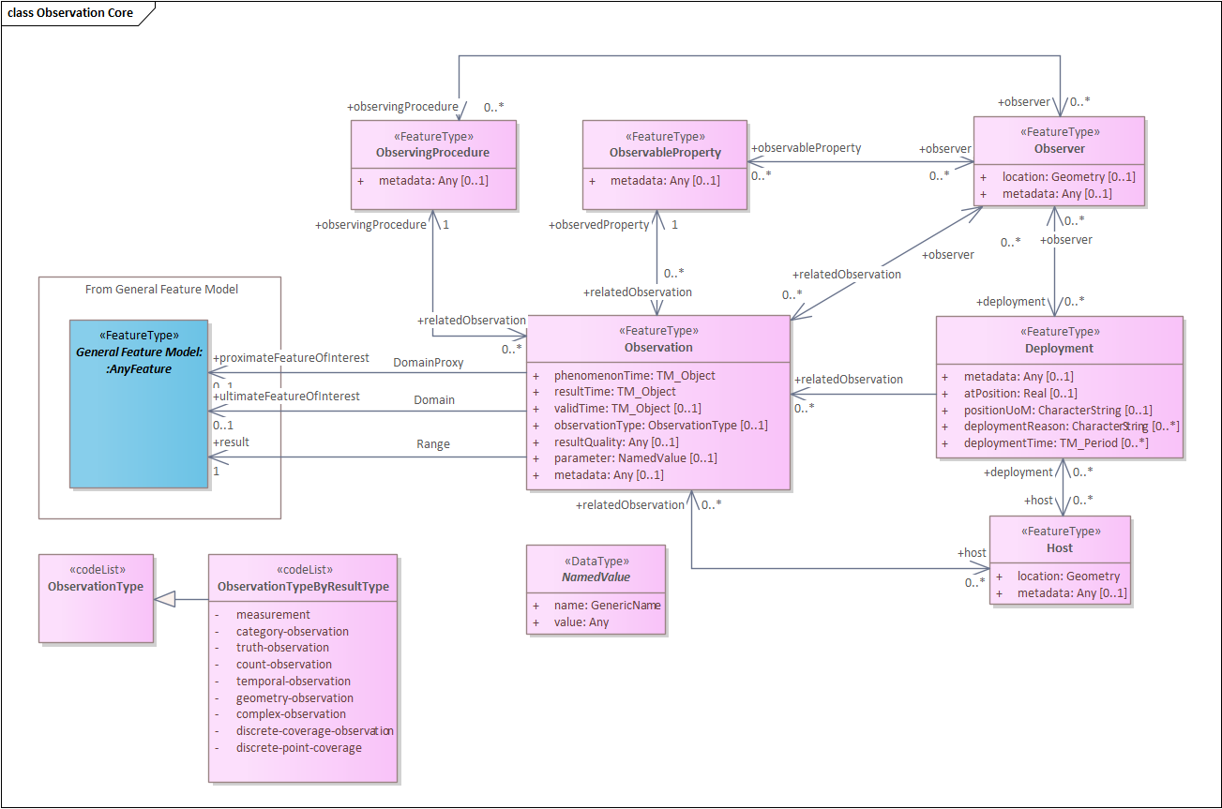
In Figure 4 we see the additional classes ObservationCharacteristics and ObservationCollection.
Figure 3: Core Logical Observation Schema

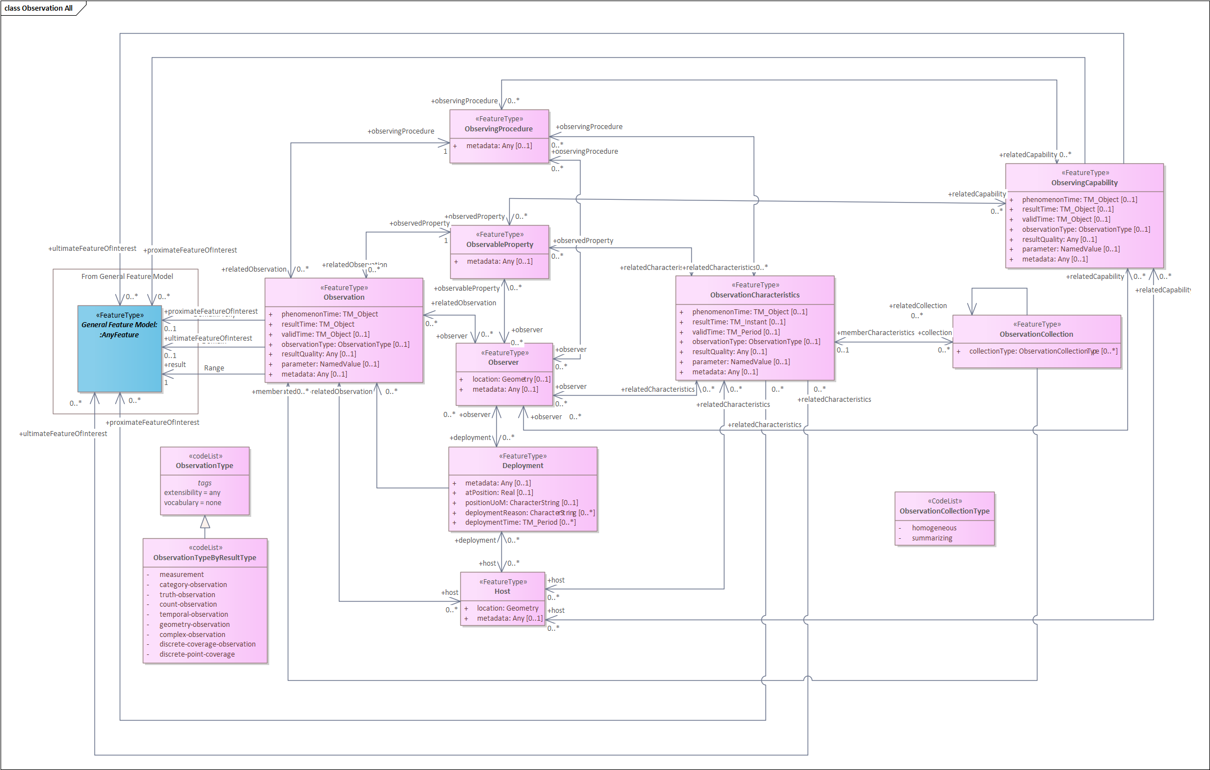
Figure 4: Logical ObservationCollection and ObservationCharacteristics Schema
Note: The OMS GenericDomainFeature class (ISO/DIS 19156 10.11) was not transposed into OMS-L, under the assumption that all actors who specialize their community models from OMS-L will define their own features as required.

Observation
Observation is the central class of the OMS Schema, tying together all relevant information required to describe an observation.
An Observation shall be defined as an act carried out by an Observer to determine the value of an ObservableProperty of an object (featureOfInterest) by using an ObservingProcedure; the value is provided as the result.
Requirements Class
http://www.opengis.net/spec/OMS-L/1.0/req/Obs/req-class-Observation
Target type | Logical Model
Dependency | ISO 19103:2015 Geographic information – Conceptual schema language, UML2 conformance class
Dependency | ISO 19103:2015 Geographic information – Conceptual schema language, CoreTypes conformance class
Dependency | ISO 19108:2002 Geographic information – Temporal schema, Application schemas for data transfer conformance class
Dependency | ISO 19156:2023
Req 1 | /req/req-class-Observation/Observation-sem  An Observation shall be defined as an act carried out by an Observer to determine the value of an ObservableProperty of an object (featureOfInterest) by using an ObservingProcedure; the value is provided as the result.
Req 2 | /req/req-class-Observation/type-sem  Information providing further detail on the type of Observations being described.  If information on the type of Observation is provided, the property observationType:ObservationType shall be used.
Req 3 | /req/req-class-Observation/observationType-sem  If information on the type of Observation is provided, the constraints defined in the referenced codelist shall be used.
Req 4 | /req/req-class-Observation/parameter-sem  Arbitrary event-specific parameter relevant to the Observation.  If additional parameter information is provided, the property parameter:NamedValue shall be used.
Req 5 | /req/req-class-Observation/parameterName-card  The name attribute of a parameter NamedValue shall be unique within an Observation.
Req 6 | /req/req-class-Observation/resultQuality-sem  Information pertaining to the data quality of the result.  If additional data quality information is provided, the property resultQuality:Any shall be used.
Req 7 | /req/req-class-Observation/phenomenonTime-sem  The time for which the result applies to the characteristic of the FeatureOfInterest being observed.  If the phenomenonTime is described, this shall be provided by the attribute phenomenonTime:TM_Object
Req 8 | /req/req-class-Observation/phenomenonTime-card  An Observation shall have exactly 1 phenomenonTime.
Req 9 | /req/req-class-Observation/resultTime-sem  The instant of time when the result of the Observation became available.  If the resultTime is described, this shall be provided by the attribute resultTime:TM_Object
Req 10 | /req/req-class-Observation/resultTime-card  An Observation shall have exactly 1 resultTime.
Req 11 | /req/req-class-Observation/resultTime-type  If the result time of the Observation is provided, the resultTime attribute shall be of type TM_Instant.
Req 12 | /req/req-class-Observation/validTime-sem  The time interval during which the result is assumed to be applicable for use.  If validTime(s) is/are described, they shall be provided by the attribute validTime:TM_Period
Req 13 | /req/req-class-Observation/pFoI-sem  The entity that is directly of interest in the act of observing.  If a reference to the entity being directly observed is provided, the association with the role proximateFeatureOfInterest shall be used.  This association is a specialization of the featureOfInterest role.
Req 14 | /req/req-class-Observation/uFoI-sem  The entity that is ultimately of interest in the act of observing.  If a reference to the entity ultimately being observed is provided, the association with the role ultimateFeatureOfInterest shall be used.  This association is a specialization of the featureOfInterest role.
Req 15 | /req/req-class-Observation/featureOfInterest-con  At least one proximateFeatureOfInterest or ultimateFeatureOfInterest shall be given.
Req 16 | /req/req-class-Observation/observedProperty-sem  The ObservableProperty that is the subject of the Observation.  If a reference to an ObservableProperty is provided, the association with the role observedProperty shall be used.
Req 17 | /req/req-class-Observation/observedProperty-card  An Observation shall have exactly 1 observedProperty.
Req 18 | /req/req-class-Observation/observedProperty-con  The ObservableProperty referenced by observedProperty shall correspond to a characteristic associated with the featureOfInterest
Req 19 | /req/req-class-Observation/result-sem  The result of the Observation.  If a reference to a result is provided, the association Range with the role result shall be used.
Req 20 | /req/req-class-Observation/result-card  An Observation shall have exactly 1 result.
Req 21 | /req/req-class-Observation/result-con  The type of the result provided by the result association shall be suitable for the associated ObservableProperty
Req 22 | /req/req-class-Observation/observingProcedure-sem  The ObservingProcedure used by the Observation to determine the value of the ObservableProperty provided by the result.  If a reference to an ObservingProcedure is provided, the association with the role procedure shall be used.
Req 23 | /req/req-class-Observation/observingProcedure-card  An Observation shall have exactly 1 observingProcedure.
Req 24 | /req/req-class-Observation/observingProcedure-con  The ObservingProcedure referenced by procedure shall be suitable for the associated ObservableProperty.
Req 25 | /req/req-class-Observation/observer-sem  An Observer that is involved in the creation of this Observation.  If a reference to an Observer is provided, the association with the role observer shall be used.
Req 26 | /req/req-class-Observation/host-sem  A Host that is involved in the creation of this Observation  If a reference to a Host is provided, the association with the role host shall be used.
Req 27 | /req/req-class-Observation/observerhost-con  At least one Observer or Host shall be provided
Req 28 | /req/req-class-Observation/uom  The Observation shall provide a unit of measure (UoM) if the result is measurable. If the UoM is not contained in the result, it shall be provided in the context of the Observation; the provision modality is to be defined by communities.
Req 29 | /req/req-class-Observation/relatedObservation-sem  An Observation the object is related to.  If a reference to a related Observation is provided, the association with role relatedObservation shall be used. The context:GenericName qualifier of this association may be used to provide further information as to the nature of the relation.
Req 30 | /req/req-class-Observation/metadata  If descriptive metadata is provided, the association role metadata shall link to descriptive metadata as commonly understood by communities.
Rec 1 | /rec/req-class-Observation/parameter-procedure  Parameter should not be used instead of the procedure to describe the steps performed in order to determine the value of the ObservableProperty.
Rec 2 | /rec/req-class-Observation/parameter-redundant  Parameter should not be utilized to provide information already contained in the model by existing attributes or associations.
Rec 3 | /rec/req-class-Observation/uFoI  In the case where ultimate and proximate features-of-interest are the same object, the association should be provided using the ultimateFeatureOfInterest association role.
Rec 4 | /rec/req-class-Observation/phenomenonTimeResult-con  If the observedProperty of an Observation is ‘occurrence time’ then the result should be the same as the phenomenonTime.
Rec 5 | /rec/req-class-Observation/uom-con  The unit of measure should be suitable for the associated ObservableProperty and ObservingProcedure

ObservableProperty
An ObservableProperty shall be defined as a quality (property, characteristic) of the feature-of-interest that can be observed.
Requirements Class
http://www.opengis.net/spec/OMS-L/1.0/req/req-class-ObservableProperty
Target type | OMS Logical Model
Dependency | ISO 19103:2015 Geographic information – Conceptual schema language, UML2 conformance class
Req 1 | /req/req-class-ObservableProperty/ObservableProperty-sem  An ObservableProperty shall be defined as a quality (property, characteristic) of the feature-of-interest that can be observed.
Req 2 | /req/req-class-ObservableProperty/observer-sem  An Observer capable of observing this ObservableProperty.  If a reference to the Observer is provided, the association with the role observer shall be used.
Req 3 | /req/req-class-ObservableProperty/relatedObservation-sem  An Observation the object is related to.  If a reference to a related Observation is provided, the association with role relatedObservation shall be used. The context:GenericName qualifier of this association may be used to provide further information as to the nature of the relation.
Req 4 | /req/req-class-ObservableProperty/metadata  If descriptive metadata is provided, the association role metadata shall link to descriptive metadata as commonly understood by communities.

ObservingProcedure
An ObservingProcedure shall be defined as the description of steps performed in order to determine the value of an observableProperty by an Observer.
Requirements Class
http://www.opengis.net/spec/OMS-L/1.0/req/req-class-ObservingProcedure
Target type | OMS Logical Model
Dependency | ISO 19103:2015 Geographic information – Conceptual schema language, UML2 conformance class
Req 1 | /req/req-class-ObservingProcedure/ObservingProcedure-sem  An ObservingProcedure shall be defined as the description of steps performed in order to determine the value of an observableProperty by an Observer.
Req 2 | /req/req-class-ObservingProcedure/observer-sem  An Observer capable of performing this ObservingProcedure.  If a reference to an Observer is provided, the association with the role observer shall be used.
Req 3 | /req/req-class-ObservingProcedure/relatedObservation-sem  An Observation the object is related to.  If a reference to a related Observation is provided, the association with role relatedObservation shall be used. The context:GenericName qualifier of this association may be used to provide further information as to the nature of the relation.
Req 4 | /req/req-class-ObservingProcedure/metadata  If descriptive metadata is provided, the association role metadata shall link to descriptive metadata as commonly understood by communities.

Observer
An Observer shall be defined as an identifiable entity that can generate Observations pertaining to an observableProperty by implementing an ObservingProcedure.
Requirements Class
http://www.opengis.net/spec/OMS-L/1.0/req/req-class-Observer
Target type | OMS Logical Model
Dependency | ISO 19103:2015 Geographic information – Conceptual schema language, UML2 conformance class
Req 1 | /req/req-class-Observer/Observer-sem  An Observer shall be defined as an identifiable entity that can generate Observations pertaining to an observableProperty by implementing an ObservingProcedure.
Req 2 | /req/req-class-Observer/observableProperty-sem  An ObservableProperty that this Observer can observe.  If a reference to ObservableProperty(s) is provided, the association with the role observableProperty shall be used.
Req 3 | /req/req-class-Observer/observingProcedure-sem  An ObservingProcedure that this Observer can perform.  If a reference to ObservingProcedure(s) is provided, the association with the role observingProcedure shall be used.
Req 4 | /req/req-class-Observer/deployment-sem  A Deployment to which this Observer is either physically or organizationally attached.  If a reference to Deployment(s) is provided, the association with the role deployment shall be used.
Req 5 | /req/req-class-Observer/location-sem  Location information pertaining to a feature.  If location information is provided, the attribute location:Geometry shall be used.
Req 6 | /req/req-class-Observer/relatedObservation-sem  An Observation the object is related to.  If a reference to a related Observation is provided, the association with role relatedObservation shall be used. The context:GenericName qualifier of this association may be used to provide further information as to the nature of the relation.
Req 7 | /req/req-class-Observer/metadata  If descriptive metadata is provided, the association role metadata shall link to descriptive metadata as commonly understood by communities.

Host
A Host shall be defined as a grouping of Observers for a specific reason.
Requirements Class
http://www.opengis.net/spec/OMS-L/1.0/req/req-class-Host
Target type | OMS Logical Model
Dependency | ISO 19103:2015 Geographic information – Conceptual schema language, UML2 conformance class
Req 1 | /req/req-class-Host/Host-sem  A Host shall be defined as a grouping of Observers for a specific reason.
Req 2 | /req/req-class-Host/deployment-sem  A Deployment at this Host.  If a reference to a Deployment is provided, the association with the role host shall be used.
Req 3 | /req/req-class-Host/relatedHost-sem  A Host the Host is related to.  If a reference to a related Host is provided, the association with role relatedHost shall be used. The context:GenericName qualifier of this association may be used to provide further information as to the nature of the relation.
Req 4 | /req/req-class-Host/location-sem  Location information pertaining to a feature.  If location information is provided, the attribute location:Geometry shall be used.
Req 5 | /req/req-class-Host/relatedObservation-sem  An Observation the object is related to.  If a reference to a related Observation is provided, the association with role relatedObservation shall be used. The context:GenericName qualifier of this association may be used to provide further information as to the nature of the relation.
Req 6 | /req/req-class-Host/metadata  If descriptive metadata is provided, the association role metadata shall link to descriptive metadata as commonly understood by communities.

Deployment
A Deployment shall be defined as information on the assignment of an Observer to a Host.
Requirements Class
http://www.opengis.net/spec/OMS-L/1.0/req/req-class-Deployment
Target type | OMS Logical Model
Dependency | ISO 19103:2015 Geographic information – Conceptual schema language, UML2 conformance class
Req 1 | /req/req-class-Deployment/Deployment-sem  A Deployment shall be defined as information on the assignment of an Observer to a Host.
Req 2 | /req/req-class-Deployment/observer-sem  The Observer associated with this Deployment.  If a reference to an Observer is provided, the association with the role observer shall be used.
Req 3 | /req/req-class-Deployment/host-sem  The Host to which this Deployment pertains.  If a reference to a Host is provided, the association with the role host shall be used
Req 4 | /req/req-class-Deployment/deploymentReason-sem  A human readable description of the reason for the Deployment.  If the reason for the Deployment is provided, the property deploymentReason:CharacterString shall be used.
Req 5 | /req/req-class-Deployment/deploymentTime-sem  The time that the Deployment pertains to.  If the time of the Deployment is provided, property deploymentTime:TM_Period shall be used.
Req 6 | /req/req-class-Deployment/atPosition-sem  Position of the Observer relative to the Host. Up is positive, down is negative  If the position of the Deployment is provided, the property atPosition:Real shall be used.
Req 7 | /req/req-class-Deployment/positionUoM-sem  Unit-of-Measure of the position of the Observer relative to the Host.  If the position of the Deployment is provided, the property positionUoM: CharacterString shall be used.
Req 8 | /req/req-class-Deployment/metadata-sem  If descriptive metadata is provided, the association role metadata shall link to descriptive metadata as commonly understood by communities.

ObservationCharacteristics
An ObservationCharacteristics shall be defined as a set of common characteristics used for describing an Observation or a collection of Observations.
Requirements Class
http://www.opengis.net/spec/OMS-L/1.0/req/req-class-ObservationCharacteristics
Target type | OMS Logical Model
Dependency | ISO 19103:2015 Geographic information – Conceptual schema language, UML2 conformance class
Req 1 | /req/req-class-ObservationCharacteristics/ObservationCharacteristics-sem  An ObservationCharacteristics shall be defined as a set of common characteristics used for describing an Observation or a collection of Observations.
Req 2 | /req/req-class-ObservationCharacteristics/type-sem  Information providing further detail on the type of Observations being described by the ObservationCharacteristics.  If information on the type of Observation is provided, the property observationType:ObservationType shall be used.
Req 3 | /req/req-class-ObservationCharacteristics/parameter-sem  Arbitrary event-specific parameter relevant to the ObservationCharacteristics.  If additional parameter information is provided, the property parameter:NamedValue shall be used.
Req 4 | /req/req-class-ObservationCharacteristics/resultQuality-sem  Information pertaining to the data quality of the result.  If additional data quality information is provided, the property resultQuality:Any shall be used.
Req 5 | /req/req-class-ObservationCharacteristics/phenomenonTime-sem  The time for which the result applies to the characteristic of the FeatureOfInterest being observed.  If the phenomenonTime is described, this shall be provided by the attribute phenomenonTime:TM_Object
Req 6 | /req/req-class-ObservationCharacteristics/resultTime-sem  The instant of time when the result of the Observation became available.  If the resultTime is described, this shall be provided by the attribute resultTime:TM_Object
Req 7 | /req/req-class-ObservationCharacteristics/validTime-sem  The time interval during which the result is assumed to be applicable for use.  If validTime(s) is/are described they shall be provided by the attribute validTime:TM_Period
Req 8 | /req/req-class-ObservationCharacteristics/featureOfInterest-sem  The subject of the Observation.  The reference(s) to featureOfInterest(s) shall be provided using the association Domain with the role featureOfInterest.
Req 9 | /req/req-class-ObservationCharacteristics/pFoI-sem  The entity that is directly of interest in the act of observing.  If a reference to the entity being directly observed is provided, the association with the role proximateFeatureOfInterest shall be used.  This association is a specialization of the featureOfInterest role.
Req 10 | /req/req-class-ObservationCharacteristics/uFoI-sem  The entity that is ultimately of interest in the act of observing.  If a reference to the entity ultimately being observed is provided, the association with the role ultimateFeatureOfInterest shall be used.  This association is a specialization of the featureOfInterest role.
Req 11 | /req/req-class-ObservationCharacteristics/collection-sem  An ObservationCollection that is described by these ObservationCharacteristics.  If a reference to an ObservationCollection from the ObservationCharacteristics is provided, the association with the role collection shall be used.
Req 12 | /req/req-class-ObservationCharacteristics/observedProperty-sem  The ObservableProperty that is the subject of the Observation.  If a reference to an ObservableProperty is provided, the association with the role observedProperty shall be used.
Req 13 | /req/req-class-ObservationCharacteristics/result-sem  The result of the Observation.  If a reference to a result is provided, the association Range with the role result shall be used.
Req 14 | /req/req-class-ObservationCharacteristics/observingProcedure-sem  The ObservingProcedure used by the Observation to determine the value of the ObservableProperty provided by the result.  If a reference to an ObservingProcedure is provided, the association with the role procedureshall be used.
Req 15 | /req/req-class-ObservationCharacteristics/observer-sem  An Observer that is involved in the creation of this Observation.  If a reference to an Observer is provided, the association with the role observer shall be used.
Req 16 | /req/req-class-ObservationCharacteristics/host-sem  A Host that is involved in the creation of this Observation  If a reference to a Host is provided, the association with the role host shall be used.
Req 17 | /req/req-class-ObservationCharacteristics/relatedObservation-sem  An Observation the object is related to.  If a reference to a related Observation is provided, the association with role relatedObservation shall be used. The context:GenericName qualifier of this association may be used to provide further information as to the nature of the relation.
Req 18 | /req/req-class-ObservationCharacteristics/metadata-sem  If descriptive metadata is provided, the association role metadata shall link to descriptive metadata as commonly understood by communities.
Rec 1 | /rec/req-class-ObservationCharacteristics/parameter-procedure  Parameter should not be used instead of the procedure to describe the steps performed in order to determine the value of the ObservableProperty.
Rec 2 | /rec/req-class-ObservationCharacteristics/parameter-redundant  Parameter should not be utilized to provide information already contained in the model by existing attributes or associations.
Rec 3 | /rec/req-class-ObservationCharacteristics/uFoI  In the case where ultimate and proximate features-of-interest are the same object, the association should be provided using the ultimateFeatureOfInterest association role.

ObservationCollection
An ObservationCollection shall be defined as a collection of similar Observations.
Requirements Class
http://www.opengis.net/spec/OMS-L/1.0/req/req-class-ObservationCollection
Target type | OMS Logical Model
Dependency | ISO 19103:2015 Geographic information – Conceptual schema language, UML2 conformance class
Req 1 | /req/req-class-ObservationCollection/ObservationCollection-sem  An ObservationCollection shall be defined as a collection of similar Observations.
Req 2 | /req/req-class-ObservationCollection/collectionType-sem  Information on the type of the ObservationCollection.  If information on the collection type is provided, the attribute collectionType:ObservationCollectionType shall be used.
Req 3 | /req/req-class-ObservationCollection/collectionType-con  If the collectionType is provided, property values of the associated Observation and ObservationCharacteristics instances shall comply with the constraints defined for this collectionType value.
Req 4 | /req/req-class-ObservationCollection/member-sem  An Observation that is part of this ObservationCollection.  If a reference to a member Observation is provided, the association with the role member shall be used.
Req 5 | /req/req-class-ObservationCollection/memberCharacteristics-sem  Information on ObservationCharacteristics of Observations contained within the ObservationCollection.  If a reference to ObservationCharacteristics pertaining to the collection members is provided, the association with the role memberCharacteristics shall be used.
Req 6 | /req/req-class-ObservationCollection/relatedCollection-sem  A ObservationCollection the ObservationCollection is related to.  If a reference to a related ObservationCollection is provided, the association with role relatedCollection shall be used. The context:GenericName qualifier of this association may be used to provide further information as to the nature of the relation.
Req 7 | /req/req-class-ObservationCollection/relatedObservation-sem  An Observation the object is related to.  If a reference to a related Observation is provided, the association with role relatedObservation shall be used. The context:GenericName qualifier of this association may be used to provide further information as to the nature of the relation.

ObservingCapability
An ObservingCapability shall be defined as information on Observation(s) that could potentially be provided.
Requirements Class
http://www.opengis.net/spec/OMS-L/1.0/req/req-class-ObservingCapability
Target type | OMS Logical Model
Dependency | ISO 19103:2015 Geographic information – Conceptual schema language, UML2 conformance class
Req 1 | /req/req-class-ObservingCapability/ObservingCapability-sem  An ObservingCapability shall be defined as information on Observation(s) that could potentially be provided.
Req 2 | /req/req-class-ObservingCapability/type-sem  Information providing further detail on the type of Observations being described by the ObservingCapability.  If information on the type of Observation is provided, the property observationType:ObservationType shall be used.
Req 3 | /req/req-class-ObservingCapability/parameter-sem  Arbitrary event-specific parameter relevant to the ObservingCapability.  If additional parameter information is provided, the property parameter:NamedValue shall be used.
Req 4 | /req/req-class-ObservingCapability/resultQuality-sem  Information pertaining to the data quality of the result.  If additional data quality information is provided, the property resultQuality:Any shall be used.
Req 5 | /req/req-class-ObservingCapability/phenomenonTime-sem  The time for which the result applies to the characteristic of the FeatureOfInterest being observed.  If the phenomenonTime is described, this shall be provided by the attribute phenomenonTime:TM_Object
Req 6 | /req/req-class-ObservingCapability/resultTime-sem  The instant of time when the result of the Observation became available.  If the resultTime is described, this shall be provided by the attribute resultTime:TM_Object
Req 7 | /req/req-class-ObservingCapability/validTime-sem  The time interval during which the result is assumed to be applicable for use.  If validTime(s) is/are described they shall be provided by the attribute validTime:TM_Period
Req 8 | /req/req-class-ObservingCapability/featureOfInterest-sem  The subject of the Observation.  The reference(s) to featureOfInterest(s) shall be provided using the association Domain with the role featureOfInterest.
Req 9 | /req/req-class-ObservingCapability/pFoI-sem  The entity that is directly of interest in the act of observing.  If a reference to the entity being directly observed is provided, the association with the role proximateFeatureOfInterest shall be used.  This association is a specialization of the featureOfInterest role.
Req 10 | /req/req-class-ObservingCapability/uFoI-sem  The entity that is ultimately of interest in the act of observing.  If a reference to the entity ultimately being observed is provided, the association with the role ultimateFeatureOfInterest shall be used.  This association is a specialization of the featureOfInterest role.
Req 11 | /req/req-class-ObservingCapability/observedProperty-sem  The ObservableProperty that is the subject of the Observation.  If a reference to an ObservableProperty is provided, the association with the role observedProperty shall be used.
Req 12 | /req/req-class-ObservingCapability/result-sem  The result of the Observation.  If a reference to a result is provided, the association Range with the role result shall be used.
Req 13 | /req/req-class-ObservingCapability/observingProcedure-sem  The ObservingProcedure used by the Observation to determine the value of the ObservableProperty provided by the result.  If a reference to an ObservingProcedure is provided, the association with the role procedureshall be used.
Req 14 | /req/req-class-ObservingCapability/observer-sem  An Observer that is involved in the creation of this Observation.  If a reference to an Observer is provided, the association with the role observer shall be used.
Req 15 | /req/req-class-ObservingCapability/host-sem  A Host that is involved in the creation of this Observation  If a reference to a Host is provided, the association with the role host shall be used.
Req 16 | /req/req-class-ObservingCapability/relatedObservation-sem  An Observation the object is related to.  If a reference to a related Observation is provided, the association with role relatedObservation shall be used. The context:GenericName qualifier of this association may be used to provide further information as to the nature of the relation.
Req 17 | /req/req-class-ObservingCapability/metadata-sem  If descriptive metadata is provided, the association role metadata shall link to descriptive metadata as commonly understood by communities.
Rec 1 | /rec/req-class-ObservingCapability/parameter-procedure  Parameter should not be used instead of the procedure to describe the steps performed in order to determine the value of the ObservableProperty.
Rec 2 | /rec/req-class-ObservingCapability/parameter-redundant  Parameter should not be utilized to provide information already contained in the model by existing attributes or associations.
Rec 3 | /rec/req-class-ObservingCapability/uFoI  In the case where ultimate and proximate features-of-interest are the same object, the association should be provided using the ultimateFeatureOfInterest association role.

NamedValue
The class NamedValue provides for a generic soft-typed parameter value.

Requirements Class
http://www.opengis.net/spec/OMS-L/1.0/req/req-class-NamedValue
Target type | OMS Logical Model
Dependency | ISO 19103:2015 Geographic information – Conceptual schema language, UML2 conformance class
Req 1 | /req/req-class-NamedValue/NamedValue-sem  The class NamedValue provides for a generic soft-typed parameter value.
Req 2 | /req/req-class-NamedValue/name-sem  The attribute name:GenericName shall indicate the meaning of the named value.
Req 3 | /req/req-class-NamedValue/valu-sem  The attribute value:Any shall provide the value.

Codelist ObservationType
An empty extension-point for providing various classification schemes for Observations.
Requirements Class
http://www.opengis.net/spec/OMS-L/1.0/req/req-class-ObservationType
Target type | OMS Logical Model
Dependency | ISO 19103:2015 Geographic information – Conceptual schema language, UML2 conformance class
Req 1 | /req/req-class-ObservationType/ObservationType-sem  An empty extension-point for providing various classification schemes for Observations.  If Observation classification schemes are used in the implementing application schemas, a concrete realization shall be created for the application.

Codelist ObservationTypeByResultType
A codelist for classifying Observations by their result type
Requirements Class
http://www.opengis.net/spec/OMS-L/1.0/req/req-class-ObservationTypeByResultType
Target type | OMS Logical Model
Dependency | ISO 19103:2015 Geographic information – Conceptual schema language, UML2 conformance class
Req 1 | /req/req-class-ObservationTypeByResultType/ObservationTypeByResultType-sem  The following entries shall be provided:  - measurement: the result is of type Measure;  - category-observation: the result is of type ScopedName;  - truth-observation: result is a truth value;  - count-observation: the result is of type Integer;  - temporal-observation: the result is of type TM_Object;  - geometry-observation: the result is of type Geometry;  - complex-observation: the result is of type Record;  - discrete-coverage-observation: result is a coverage that returns the same feature attribute values for every direct position within any single spatial object, temporal object, or spatiotemporal object in its domain;  - discrete-point-coverage: result is a coverage that has a domain composed of points;  - timeseries-observation: the result is a timeseries (a sequence of data values which are ordered in time).
Req 2 | /req/req-class-ObservationTypeByResultType/ObservationTypeByResultType-con  The following constraints shall be applied to the value of the result association of the Observation based on the codelist value used:  - If the value "measurement" is used, the value of the result shall be of type Measure;  - If the value "category-observation" is used the value of the result shall be of type ScopedName;  - If the value "truth-observation" is used, the value of result shall be a truth value;  - If the value "count-observation" is used, the value of the result shall be of type Integer;  - If the value "temporal-observation" is used, the value of the result shall be of type TM_Object;  - If the value "geometry-observation" is used, the value of the result shall be of type Geometry;  - If the value "complex-observation" is used, the value of the result shall be of type Record.

Codelist ObservationCollectionType
A codelist for classifying ObservationCollections.

Requirements Class
http://www.opengis.net/spec/OMS-L/1.0/req/req-class-ObservationCollectionType
Target type | OMS Logical Model
Dependency | ISO 19103:2015 Geographic information – Conceptual schema language, UML2 conformance class
Req 1 | /req/req-class-ObservationCollectionType/ObservationCollectionType-sem  The following entries shall be provided:  - homogeneous: all observations contained are of a similar nature;  - summarizing: a wider grab-bag type of collection.
Req 2 | /req/req-class-ObservationCollectionType/homogeneous-con  If collectionType in the ObservationCollection is specified as “homogeneous” from this Codelist, the following constraints apply to the associated ObservationCharacteristics and all Observation instances referenced via the member association.  If a property value is provided within the ObservationCharacteristics, this value applies to all Observations contained in the ObservationCollection:  - property not provided – values may be provided by the Observations but is not provided at this level  property provided but with no content – no Observation within the collection provides this property  - property = value – this value applies to all Observations within the collection  property = value set/range – this value set/range applies to all Observations within the collection
Req 3 | /req/req-class-ObservationCollectionType/summarizing-con  If collectionType in the ObservationCollection is specified as “summarizing” from this Codelist, the following constraints apply to the associated ObservationCharacteristics and all Observation instances referenced via the member association.  If multiple values for a property are available in the contained Observations, all values for this attribute (or the range of values contained in all Observations) are provided in the ObservationCharacteristics. A property may also be empty in the ObservationCharacteristics – in this case any value can be provided for this attribute within the contained Observations:  - property not provided – values may be provided by the Observations but a summary is not provided at this level;  - property provided but with no content – no Observation within the collection provides this property;  - property = value – this value applies to all Observations within the collection;  - property = value set/range – all Observations provide a value within this set/range.

Logical Sampling Schema (normative)

General
The Core Logical Sampling schema is described as a class diagram in Figure 5.

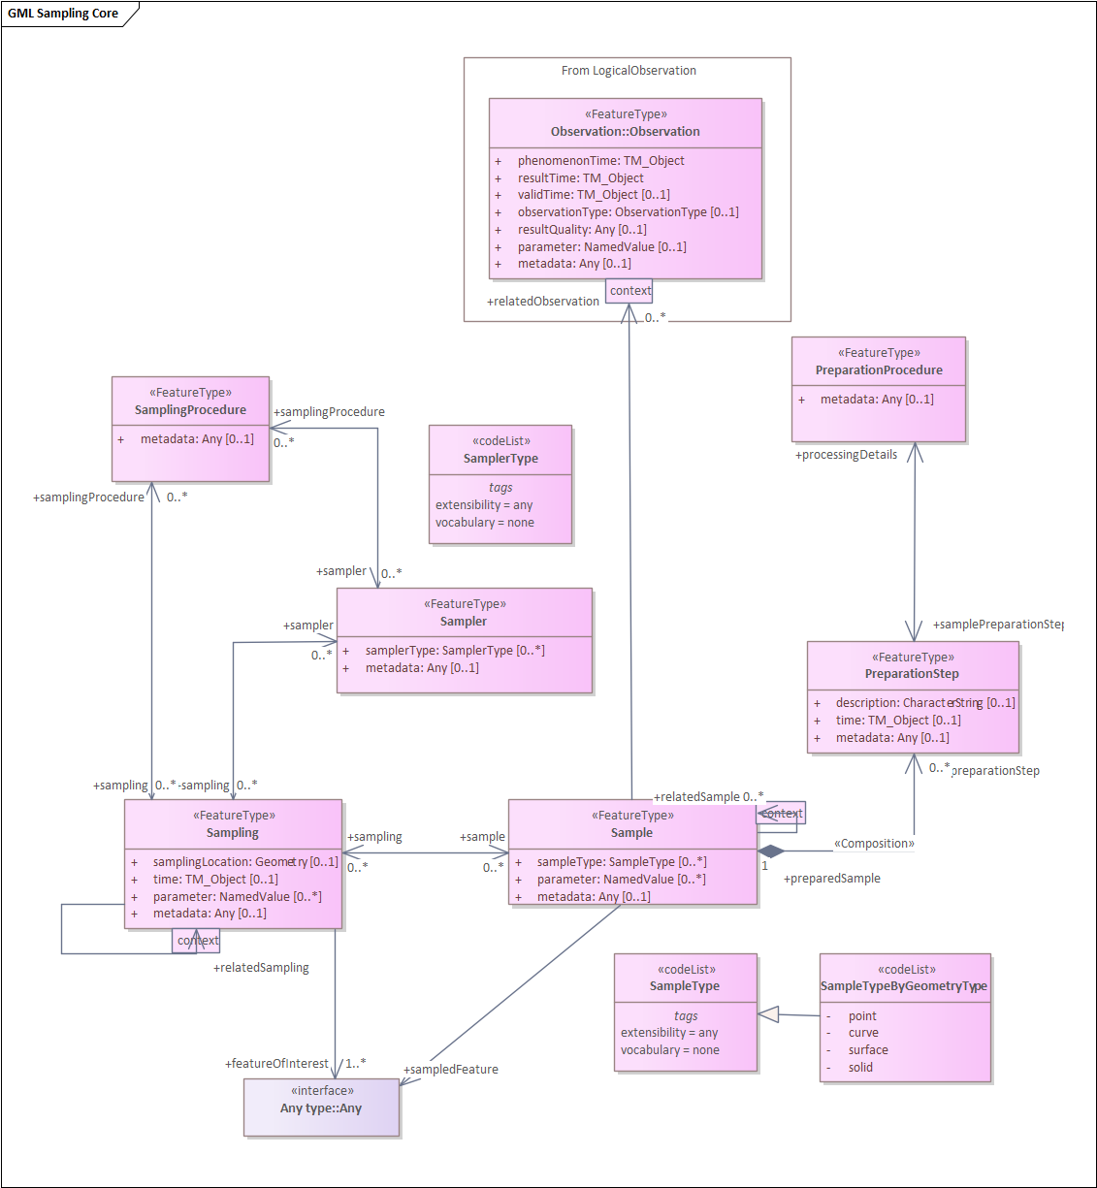
In Figure 6 the additional classes SampleCollection as well as the specialized Sample types StatisticalSample, MaterialSample and SpatialSample are presented.
Figure 5: Core Sampling Schema

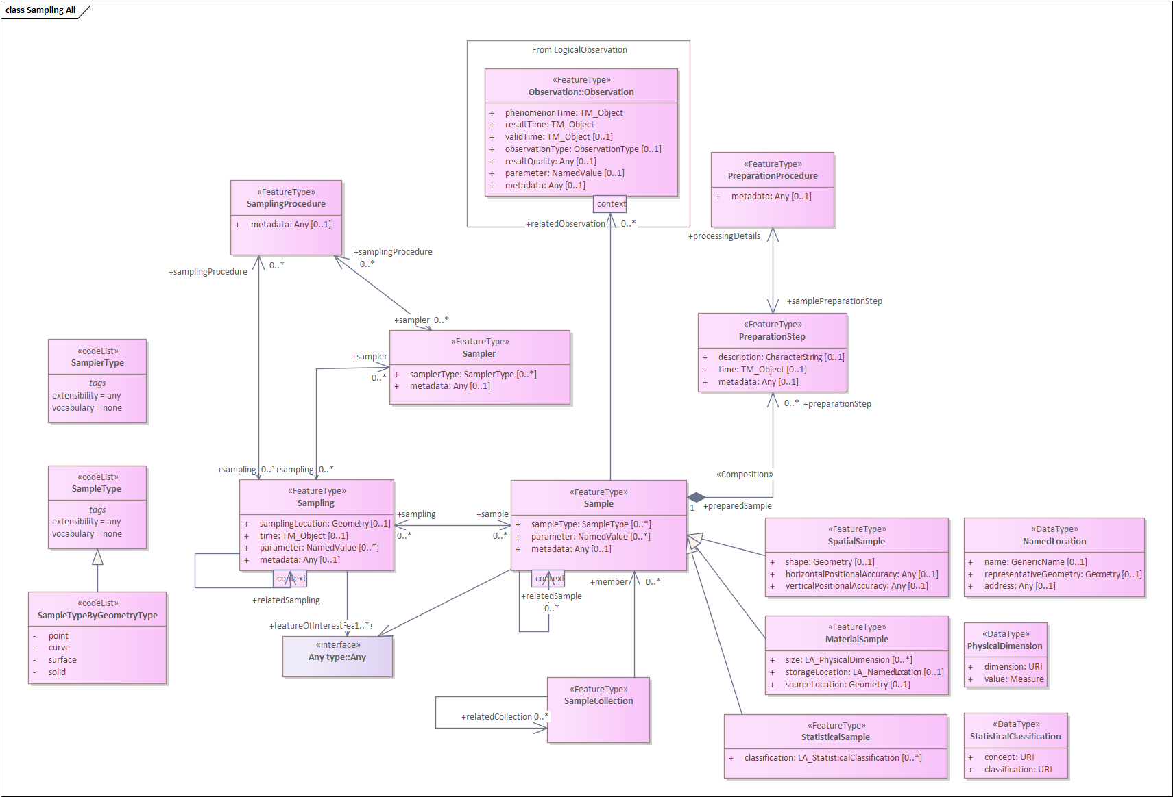
Figure 6: Full Sampling Schema

Sample
A Sample shall be defined as an object that is representative of a concept, real-world object or phenomenon.
Requirements Class
http://www.opengis.net/spec/OMS-L/1.0/req/req-class-Sample
Target type | OMS Logical Model
Dependency | ISO 19103:2015 Geographic information – Conceptual schema language, UML2 conformance class
Req 1 | /req/req-class-Sample/Sample-sem  A Sample shall be defined as an object that is representative of a concept, real-world object or phenomenon.
Req 2 | /req/req-class-Sample/sampling-sem  The Sampling the Sample is the result of.  If Sampling(s) are described they shall be referred to using the association with the role sampling.
Req 3 | /req/req-class-Sample/preparationStep-sem  The PreparationStep(s) applied to prepare the Sample.  If PreparationSteps are described, they shall be referred to using the association with the role preparationStep.
Req 4 | /req/req-class-Sample/sampledFeature-sem  The sampledFeature is the feature the Sample is intended to be representative of.  References to the sampled feature shall be provided using the association with the role sampledFeature.
Req 5 | /req/req-class-Sample/sampleType-sem  The type of Sample according to a community agreed typology.  If information on the type of Sample is provided, the attribute sampleType:SampleType shall be used.
Req 6 | /req/req-class-Sample/parameter-sem  Arbitrary event-specific parameter relevant to the Sample.  If additional parameter information is provided, the property parameter:NamedValue shall be used.
Req 7 | /req/req-class-Sample/metadata-sem  If descriptive metadata is provided, the association role metadata shall link to descriptive metadata as commonly understood by communities.
Req 8 | /req/req-class-Sample/relatedSample-sem  A Sample the Sample is related to.  If a reference to a related Sample is provided, the association with role relatedSample shall be used. The context:GenericName qualifier of this association may be used to provide further information as to the nature of the relation.
Req 9 | /req/req-class-Sample/relatedObservation-sem  An Observation the object is related to.  If a reference to a related Observation is provided, the association with role relatedObservation shall be used. The context:GenericName qualifier of this association may be used to provide further information as to the nature of the relation.

SpatialSample
A SpatialSample shall be defined as a geospatial Sample.
Requirements Class
http://www.opengis.net/spec/OMS-L/1.0/req/req-class-SpatialSample
Target type | OMS Logical Model
Dependency | ISO 19103:2015 Geographic information – Conceptual schema language, UML2 conformance class
Req 1 | /req/req-class-SpatialSample/Sample-sem  A Sample shall be defined as an object that is representative of a concept, real-world object or phenomenon.
Req 2 | /req/req-class-SpatialSample/sampling-sem  The Sampling the Sample is the result of.  If Sampling(s) are described they shall be referred to using the association with the role sampling.
Req 3 | /req/req-class-SpatialSample/preparationStep-sem  The PreparationStep(s) applied to prepare the Sample.  If PreparationSteps are described, they shall be referred to using the association with the role preparationStep.
Req 4 | /req/req-class-SpatialSample/sampledFeature-sem  The sampledFeature is the feature the Sample is intended to be representative of.  References to the sampled feature shall be provided using the association with the role sampledFeature.
Req 5 | /req/req-class-SpatialSample/sampleType-sem  The type of Sample according to a community agreed typology.  If information on the type of Sample is provided, the attribute sampleType:SampleType shall be used.
Req 6 | /req/req-class-SpatialSample/parameter-sem  Arbitrary event-specific parameter relevant to the Sample.  If additional parameter information is provided, the property parameter:NamedValue shall be used.
Req 7 | /req/req-class-SpatialSample/SpatialSample-sem  A SpatialSample shall be defined as a geospatial Sample.
Req 8 | /req/req-class-SpatialSample/shape-sem  The shape is the Geometry of the SpatialSample.  If location information pertaining to the SpatialSample is provided, the attribute shape:Geometry shall be used.
Req 9 | /req/req-class-SpatialSample/horizontalPositionalAccuracy-sem  The positional accuracy of the horizontal component of the Geometry of the SpatialSample.  If horizontal positional accuracy information pertaining to the SpatialSample is provided, the attribute horizontalPositionalAccuracy:Any shall be used.
Req 10 | /req/req-class-SpatialSample/verticalPositionalAccuracy-sem  The positional accuracy of the vertical component of the Geometry of the SpatialSample.  If vertical positional accuracy information pertaining to the SpatialSample is provided, the attribute verticalPositionalAccuracy:Any shall be used.
Req 11 | /req/req-class-SpatialSample/metadata-sem  If descriptive metadata is provided, the association role metadata shall link to descriptive metadata as commonly understood by communities.
Req 12 | /req/req-class-SpatialSample/relatedSample-sem  A Sample the Sample is related to.  If a reference to a related Sample is provided, the association with role relatedSample shall be used. The context:GenericName qualifier of this association may be used to provide further information as to the nature of the relation.
Req 13 | /req/req-class-SpatialSample/relatedObservation-sem  An Observation the object is related to.  If a reference to a related Observation is provided, the association with role relatedObservation shall be used. The context:GenericName qualifier of this association may be used to provide further information as to the nature of the relation.

MaterialSample
A MaterialSample shall be defined as a physical, tangible Sample.
Requirements Class
http://www.opengis.net/spec/OMS-L/1.0/req/req-class-MaterialSample
Target type | OMS Logical Model
Dependency | ISO 19103:2015 Geographic information – Conceptual schema language, UML2 conformance class
Req 1 | /req/req-class-MaterialSample/Sample-sem  A Sample shall be defined as an object that is representative of a concept, real-world object or phenomenon.
Req 2 | /req/req-class-MaterialSample/sampling-sem  The Sampling the Sample is the result of.  If Sampling(s) is/are described, they shall be referred to using the association with the role sampling.
Req 3 | /req/req-class-MaterialSample/preparationStep-sem  The PreparationStep(s) applied to prepare the Sample.  If PreparationSteps are described, they shall be referred to using the association with the role preparationStep.
Req 4 | /req/req-class-MaterialSample/sampledFeature-sem  The sampledFeature is the feature the Sample is intended to be representative of.  References to the sampled feature shall be provided using the association with the role sampledFeature.
Req 5 | /req/req-class-MaterialSample/sampleType-sem  The type of Sample according to a community agreed typology.  If information on the type of Sample is provided, the attribute sampleType:SampleType shall be used.
Req 6 | /req/req-class-MaterialSample/parameter-sem  Arbitrary event-specific parameter relevant to the Sample.  If additional parameter information is provided, the property parameter:NamedValue shall be used.
Req 7 | /req/req-class-MaterialSample/MaterialSample-sem  A MaterialSample shall be defined as a physical, tangible Sample.
Req 8 | /req/req-class-MaterialSample/size-sem  The size describes a physical extent of the MaterialSample.  If size information pertaining to the MaterialSample is provided, the attribute size:PhysicalDimension shall be used.
Req 9 | /req/req-class-MaterialSample/storageLocation-sem  The storageLocation is the location of a MaterialSample.  If information pertaining to the storage location of the MaterialSample is provided, the attribute storageLocation:NamedLocation shall be used.
Req 10 | /req/req-class-MaterialSample/sourceLocation-sem  The sourceLocation is the location from where the MaterialSample was obtained.  If information pertaining to the source location of the MaterialSample is provided, the attribute sourceLocation:Geometry shall be used.
Req 11 | /req/req-class-MaterialSample/metadata-sem  If descriptive metadata is provided, the association role metadata shall link to descriptive metadata as commonly understood by communities.
Req 12 | /req/req-class-MaterialSample/relatedSample-sem  A Sample the Sample is related to.  If a reference to a related Sample is provided, the association with role relatedSample shall be used. The context:GenericName qualifier of this association may be used to provide further information as to the nature of the relation.
Req 13 | /req/req-class-MaterialSample/relatedObservation-sem  An Observation the object is related to.  If a reference to a related Observation is provided, the association with role relatedObservation shall be used. The context:GenericName qualifier of this association may be used to provide further information as to the nature of the relation.

StatisticalSample
A StatisticalSample shall be defined as a statistical subset of a feature-of-interest, defined for the purpose of creating Observation(s).
Requirements Class
http://www.opengis.net/spec/OMS-L/1.0/req/req-class-StatisticalSample
Target type | OMS Logical Model
Dependency | ISO 19103:2015 Geographic information – Conceptual schema language, UML2 conformance class
Req 1 | /req/req-class-StatisticalSample/Sample-sem  A Sample shall be defined as an object that is representative of a concept, real-world object or phenomenon.
Req 2 | /req/req-class-StatisticalSample/sampling-sem  The Sampling the Sample is the result of.  If Sampling(s) is/are described, they shall be referred to using the association with the role sampling.
Req 3 | /req/req-class-StatisticalSample/preparationStep-sem  The PreparationStep(s) applied to prepare the Sample.  If PreparationSteps is/are described, they shall be referred to using the association with the role preparationStep.
Req 4 | /req/req-class-StatisticalSample/sampledFeature-sem  The sampledFeature is the feature the Sample is intended to be representative of.  References to the sampled feature shall be provided using the association with the role sampledFeature.
Req 5 | /req/req-class-StatisticalSample/sampleType-sem  The type of Sample according to a community agreed typology.  If information on the type of Sample is provided, the attribute sampleType:SampleType shall be used.
Req 6 | /req/req-class-StatisticalSample/parameter-sem  Arbitrary event-specific parameter relevant to the Sample.  If additional parameter information is provided, the property parameter:NamedValue shall be used.
Req 7 | /req/req-class-StatisticalSample/StatisticalSample-sem  A StatisticalSample shall be defined as a statistical subset of a feature-of-interest, defined for the purpose of creating Observation(s).
Req 8 | /req/req-class-StatisticalSample/classification-sem  The classification describes a criterion by which the subset was defined.  If information pertaining to the subsetting criteria by which a StatisticalSample is defined is provided, the attribute classification:StatisticalClassification shall be used.
Req 9 | /req/req-class-StatisticalSample/metadata-sem  If descriptive metadata is provided, the association role metadata shall link to descriptive metadata as commonly understood by communities.
Req 10 | /req/req-class-StatisticalSample/relatedSample-sem  A Sample the Sample is related to.  If a reference to a related Sample is provided, the association with role relatedSample shall be used. The context:GenericName qualifier of this association may be used to provide further information as to the nature of the relation.
Req 11 | /req/req-class-StatisticalSample/relatedObservation-sem  An Observation the object is related to.  If a reference to a related Observation is provided, the association with role relatedObservation shall be used. The context:GenericName qualifier of this association may be used to provide further information as to the nature of the relation.

Sampling
A Sampling shall be defined as an act applying a SamplingProcedure to create or transform one or more Sample(s).
Requirements Class
http://www.opengis.net/spec/OMS-L/1.0/req/req-class-Sampling
Target type | OMS Logical Model
Dependency | ISO 19103:2015 Geographic information – Conceptual schema language, UML2 conformance class
Req 1 | /req/req-class-Sampling/Sampling-sem  A Sampling shall be defined as an act applying a SamplingProcedure to create or transform one or more Sample(s).
Req 2 | /req/req-class-Sampling/sample-sem  The Sample generated by the Sampling.  If Samples are described, they shall be referred to using the association with the role sample.
Req 3 | /req/req-class-Sampling/featureOfInterest-sem  A feature-of-interest shall be defined as the concept, real-world object or phenomenon (feature-of-interest) the Sample(s) of the Sampling represent.
Req 4 | /req/req-class-Sampling/featureOfInterest-card  Reference to the feature-of-interest shall be done using the association with the role featureOfInterest.
Req 5 | /req/req-class-Sampling/sampler-sem  The Sampler that performed the Sampling.  If Sampler(s) is/are described, they shall be referred to using the association with the role sampler.
Req 6 | /req/req-class-Sampling/samplingProcedure-sem  The SamplingProcedure used by the Sampling.  If SamplingProcedures are described, they shall be referred to using the association with the role samplingProcedure.
Req 7 | /req/req-class-Sampling/samplingLocation-sem  If location information pertaining to the Sampling is provided, the attribute samplingLocation:Geometry shall be used.
Req 8 | /req/req-class-Sampling/time-sem  If information on the time of the Sampling is provided, the attribute time:TM_Object shall be used.
Req 9 | /req/req-class-Sampling/parameter-sem  Arbitrary event-specific parameter relevant to the Sampling.  If additional parameter information is provided, the property parameter:NamedValue shall be used.
Req 10 | /req/req-class-Sampling/relatedSampling-sem  Related Sampling(s).  If a reference to a related Sampling is provided, the association with role relatedSampling shall be used. The context:GenericName qualifier of this association may be used to provide further information as to the nature of the relation.
Req 11 | /req/req-class-Sampling/metadata-sem  If descriptive metadata is provided, the association role metadata shall link to descriptive metadata as commonly understood by communities.

Sampler
A Sampler shall be defined as a device or entity (including humans) that is used by, or implements, a SamplingProcedure to create or transform one or more Sample(s).
Requirements Class
http://www.opengis.net/spec/OMS-L/1.0/req/req-class-Sampler
Target type | OMS Logical Model
Dependency | ISO 19103:2015 Geographic information – Conceptual schema language, UML2 conformance class
Req 1 | /req/req-class-Sampler/Sampler-sem  A Sampler shall be defined as a device or entity (including humans) that is used by, or implements, a SamplingProcedure to create or transform one or more Sample(s).
Req 2 | /req/req-class-Sampler/sampling-sem  The Sampling act performed by the Sampler.  If Sampling(s) is/are described, they shall be referred to using the association with the role sampling.
Req 3 | /req/req-class-Sampler/implementedProcedure-sem  The SamplingProcedure implemented by the Sampler.  If SamplingProcedure(s) is/are described, they shall be referred to using the association with the role implementedProcedure.
Req 4 | /req/req-class-Sampler/samplerType-sem  The type of Sampler according to a community agreed typology.  If information on the type of Sampler is provided, the attribute samplerType:SamplerType shall be used.
Req 5 | /req/req-class-Sampler/metadata-sem  If descriptive metadata is provided, the association role metadata shall link to descriptive metadata as commonly understood by communities.

SamplingProcedure
A SamplingProcedure shall be defined as the description of steps performed by a Sampler in order to extract a Sample from its sampledFeature in the frame of a Sampling.
Requirements Class
http://www.opengis.net/spec/OMS-L/1.0/req/req-class-SamplingProcedure
Target type | OMS Logical Model
Dependency | ISO 19103:2015 Geographic information – Conceptual schema language, UML2 conformance class
Req 1 | /req/req-class-SamplingProcedure/SamplingProcedure-sem  A SamplingProcedure shall be defined as the description of steps performed by a Sampler in order to extract a Sample from its sampledFeature in the frame of a Sampling.
Req 2 | /req/req-class-SamplingProcedure/sampling-sem  If the SamplingProcedure provides information on the Sampling where this procedure has been used, the association with the role sampling shall be used.
Req 3 | /req/req-class-SamplingProcedure/sampler-sem  If the SamplingProcedure provides information on the Sampler that implements this procedure, the association with the role sampler shall be used.
Req 4 | /req/req-class-SamplingProcedure/metadata-sem  If descriptive metadata is provided, the association role metadata shall link to descriptive metadata as commonly understood by communities.

PreparationStep
A PreparationStep shall be defined as an individual step pertaining to a PreparationProcedure.
Requirements Class
http://www.opengis.net/spec/OMS-L/1.0/req/req-class-PreparationStep
Target type | OMS Logical Model
Dependency | ISO 19103:2015 Geographic information – Conceptual schema language, UML2 conformance class
Req 1 | /req/req-class-PreparationStep/PreparationStep-sem  A PreparationStep shall be defined as an individual step pertaining to a PreparationProcedure.
Req 2 | /req/req-class-PreparationStep/processingDetails-sem  A PreparationProcedure step performed on the Sample the PreparationStep pertains to.  If PreparationProcedure(s) is/are described, they shall be referred to using the association with the role processingDetails.
Req 3 | /req/req-class-PreparationStep/preparedSample-sem  The Sample on which the PreparationProcedure is performed.  The Sample shall be referred to using the association with the role preparedSample.
Req 4 | /req/req-class-PreparationStep/description-sem  Description of the preparationStep.  If a description pertaining to the preparationStep is provided, the attribute description:CharacterString shall be used.
Req 5 | /req/req-class-PreparationStep/time-sem  Time of the preparationStep.  If information on the time of the preparationStep of the Sampling is provided, the attribute time:TM_Object shall be used.
Req 6 | /req/req-class-PreparationStep/metadata-sem  If descriptive metadata is provided, the association role metadata shall link to descriptive metadata as commonly understood by communities.

PreparationProcedure
A PreparationProcedure shall be defined as the description of preparation steps performed on a Sample.
Requirements Class
http://www.opengis.net/spec/OMS-L/1.0/req/req-class-PreparationProcedure
Target type | OMS Logical Model
Dependency | ISO 19103:2015 Geographic information – Conceptual schema language, UML2 conformance class
Req 1 | /req/req-class-PreparationProcedure/PreparationProcedure-sem  A PreparationProcedure shall be defined as the description of preparation steps performed on a Sample.
Req 2 | /req/req-class-PreparationProcedure/samplePreparationStep-sem  If the PreparingProcedure provides information on the PreparationStep where this procedure has been used, the association with the role samplePreparationStep shall be used.
Req 3 | /req/req-class-PreparationProcedure/metadata-sem  If descriptive metadata is provided, the association role metadata shall link to descriptive metadata as commonly understood by communities.

SampleCollection
A SampleCollection shall be defined as a collection of Samples.
Requirements Class
http://www.opengis.net/spec/OMS-L/1.0/req/req-class-SampleCollection
Target type | OMS Logical Model
Dependency | ISO 19103:2015 Geographic information – Conceptual schema language, UML2 conformance class
Req 1 | /req/req-class-SampleCollection/SampleCollection-sem  A SampleCollection shall be defined as a collection of Samples.
Req 2 | /req/req-class-SampleCollection/member-sem  A Sample that is part of this SampleCollection.  If the SampleCollection has members, the association with the role member shall be used.
Req 3 | /req/req-class-SampleCollection/relatedCollection-sem  A SampleCollection the SampleCollection is related to.  If a reference to a related SampleCollection is provided, the association with role relatedCollection shall be used. The context:GenericName qualifier of this association may be used to provide further information as to the nature of the relation.
Req 4 | /req/req-class-SampleCollection/metadata-sem  If descriptive metadata is provided, the association role metadata shall link to descriptive metadata as commonly understood by communities.

PhysicalDimension
A PhysicalDimension shall be defined as a dataType for the provision of various size quantities.
Requirements Class
http://www.opengis.net/spec/OMS-L/1.0/req/req-class-PhysicalDimension
Target type | OMS Logical Model
Dependency | ISO 19103:2015 Geographic information – Conceptual schema language, UML2 conformance class
Req 1 | /req/req-class-PhysicalDimension/PhysicalDimension-sem  A PhysicalDimension shall be defined as a dataType for the provision of various size quantities.
Req 2 | /req/req-class-PhysicalDimension/dimension-sem  The name of the PhysicalDimension about which a value is provided.  The identifier of the physical dimension shall be provided in the attribute dimension:URI.
Req 3 | /req/req-class-PhysicalDimension/value-sem  The value of the PhysicalDimension.  The measure of the quantity being provided shall be provided in the attribute value:Measure

NamedLocation
A NamedLocation shall be defined as a location identified by its name, address, spatial geometry or a combination of any of these three.
Requirements Class
http://www.opengis.net/spec/OMS-L/1.0/req/req-class-NamedLocation
Target type | OMS Logical Model
Dependency | ISO 19103:2015 Geographic information – Conceptual schema language, UML2 conformance class
Req 1 | /req/req-class-NamedLocation/NamedLocation-sem  A NamedLocation shall be defined as a location identified by its name, address, spatial geometry or a combination of any of these three.
Req 2 | /req/req-class-NamedLocation/address-sem  An address used for identifying a NamedLocation.  If address information is provided, the attribute address:Any shall be used.
Req 3 | /req/req-class-NamedLocation/name-sem  A name used for identifying a NamedLocation.  If name information is provided, the attribute name:GenericName shall be used.
Req 4 | /req/req-class-NamedLocation/representativeGeometry-sem  A geometry used for providing a representative spatial location of a NamedLocation.  If geometry is provided, the attribute representativeGeometry:Geometry shall be used.

StatisticalClassification
A StatisticalClassification shall be defined as a dataType for the provision of information on statistical classifications.
Requirements Class
http://www.opengis.net/spec/OMS-L/1.0/req/req-class-StatisticalClassification
Target type | OMS Logical Model
Dependency | ISO 19103:2015 Geographic information – Conceptual schema language, UML2 conformance class
Req 1 | /req/req-class-StatisticalClassification/StatisticalClassification-sem  A StatisticalClassification shall be defined as a dataType for the provision of information on statistical classifications.
Req 2 | /req/req-class-StatisticalClassification/concept-sem  The concept by which a StatisticalClassification is to be performed.  The name of the concept by which the statistical classification is performed shall be provided in the attribute concept:URI.
Req 3 | /req/req-class-StatisticalClassification/classification-sem  The explicit classification class pertaining to the classification concept described by the StatisticalClassification.  The classification class of the StatisticalClassification shall be provided in the attribute classification:URI.

Codelist SampleType
The code list SampleType can be specialized as required to more precisely define the semantics of sample types.

Requirements Class
http://www.opengis.net/spec/OMS-L/1.0/req/req-class-SampleType
Target type | OMS Logical Model
Dependency | ISO 19103:2015 Geographic information – Conceptual schema language, UML2 conformance class
Req 1 | /req/req-class-SampleType/SampleType-sem  An empty extension-point for providing various classification schemes for Samples.  If Sample classification schemes are used in the implementing application schemas, a concrete realization shall be created for the application.

Codelist SampleTypeByGeometryType
The code list SampleType can be specialized by geometry type

Requirements Class
http://www.opengis.net/spec/OMS-L/1.0/req/req-class-SampleTypeByGeometryType
Target type | OMS Logical Model
Dependency | ISO 19103:2015 Geographic information – Conceptual schema language, UML2 conformance class
Req 1 | /req/req-class-SampleTypeByGeometryType/SampleTypeByGeometryType-sem  The following entries shall be provided:  - point: the provided geometry is of type Point.  - curve: the provided geometry is of type Curve.  - surface: the provided geometry is of type Surface.  - solid: the provided geometry is of type Solid.
Req 2 | /req/req-class-SampleTypeByGeometryType/SampleTypeByGeometryType-con  The following constraints shall be applied to the value of the result association of the Observation based on the codelist value used:  - If value “point” is used, the provided geometry shall be of type Point.  - If value “curve” is used, the provided geometry shall be of type Curve.  - If value “surface” is used, the provided geometry shall be of type Surface.  - If value “solid” is used, the provided geometry shall be of type Solid.

Codelist SamplerType
The code list SamplerType can be specialized as required to more precisely define the semantics of sampler types.

Requirements Class
http://www.opengis.net/spec/OMS-L/1.0/req/req-class-SamplerType
Target type | OMS Logical Model
Dependency | ISO 19103:2015 Geographic information – Conceptual schema language, UML2 conformance class
Req 1 | /req/req-class-SamplerType/SamplerType-sem  An empty extension-point for providing various classification schemes for Samplers.  If Sampler classification schemes are used in the implementing application schemas, a concrete realization shall be created for the application.

Logical Monitoring Core (normative)

General
Within the European INSPIRE Environmental Monitoring Facilities specification, one finds the OMS Host concept fully fleshed out including relevant contextual information. As these have been proven useful in real world scenarios, they are being provided as an extension in the context of the OMS Logical model. As parts of the full INSPIRE model have a strong European focus, a simplified core model is derived, reduced to the most essential concepts. These are described in this section as the core model. In addition to the core model, the next section provides an extended version, including the full richness of the original INSPIRE model.
Please note that as all core classes are modelled as FeatureType, basic attributes such as identifier, name and geometry are already covered by this basic stereotype, they are not provided within this specification.
The core classes of this model, as shown in Figure 7, are:
- MonitoringFacility: A georeferenced object directly collecting or processing data about objects whose properties (e.g. physical, chemical, biological or other aspects of environmental conditions) are repeatedly observed or measured.
- MonitoringNetwork: Administrative or organizational grouping of MonitoringFacilities managed the same way for a specific purpose, targeting a specific area.
- MonitoringActivity: Specific set of MonitoringFacilities or MonitoringNetworks used for a given domain in a coherent and concise timeframe, area and purpose. Usually, the information collected is treated as one time step in a long term monitoring Program. It is a concrete realization of a given MonitoringProgram.
- MonitoringProgram: Framework based on policy relevant documents defining the target of a collection of observations and/or the deployment of MonitoringFacilities or MonitoringNetworks on the field. Usually, a Monitoring Program has a long-term perspective over at least a few years.
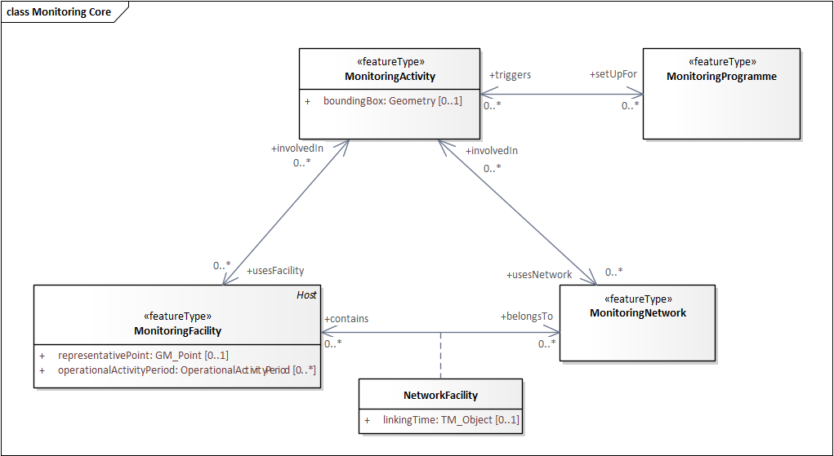
Figure 7: Core Monitoring Schema
In Figure 8 below, the Monitoring Schema is shown with OMS context, illustrating both how MonitoringFacility is derived from OMS:Host as well as how OMS:ObservingCapability is utilized by MonitoringFacility, MonitoringNetwork and MonitoringProgram.

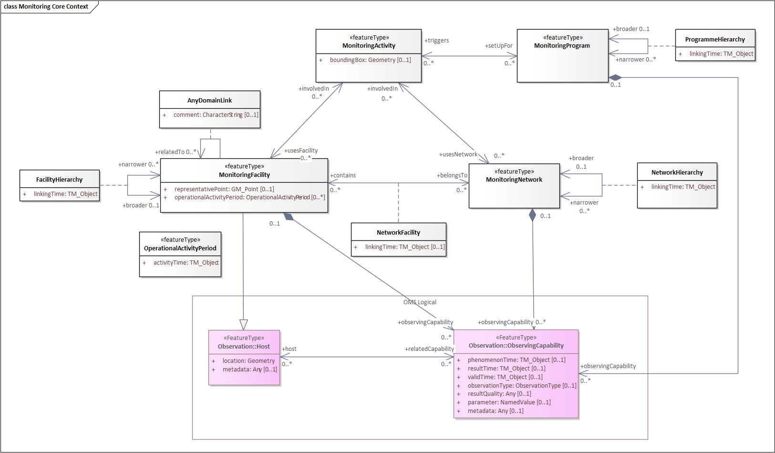
Figure 8: Monitoring Schema - OMS Context

MonitoringFacility
Requirements Class
http://www.opengis.net/spec/OMS-L/1.0/req/req-class-MonitoringFacility
Target type | OMS Logical Model
Dependency | ISO 19103:2015 Geographic information – Conceptual schema language, UML2 conformance class
Req 1 | /req/req-class-MonitoringFacility/MonitoringFacility-sem  A georeferenced object directly collecting or processing data about objects whose properties (e.g. physical, chemical, biological or other aspects of environmental conditions) are repeatedly observed or measured. An environmental monitoring facility can also host other environmental monitoring facilities.
Req 2 | /req/req-class-MonitoringFacility/representativePoint  Representative location for the MonitoringFacility.  If information on the representative location of the MonitoringFacility is provided, the property representativePoint:GM_Point shall be used.
Req 3 | /req/req-class-MonitoringFacility/operationalActivityPeriod  Lifespan of the physical object (facility).  If information on the lifespan of the MonitoringFacility is provided, the property operationalActivityPeriod:OperationalActivityPeriod shall be used.
Req 4 | /req/req-class-MonitoringFacility/observingCapability  A link pointing to the explicit capability of a MonitoringFacility. This provides a clean link between the observed property, the procedure used as well as the location of the measurement.  If a reference to the explicit capability of a MonitoringFacility is provided, the association with the role observingCapability shall be used.
Req 5 | /req/req-class-MonitoringFacility/broader  A link pointing to a broader MonitoringFacility (a higher level in a hierarchical structure). The association has additional properties as defined in the association class FacilityHierarchy.  If a reference to a broader MonitoringFacility is provided, the association with the role a broader and association class FacilityHierarchy shall be used.
Req 6 | /req/req-class-MonitoringFacility/narrower  A link pointing to narrower MonitoringFacility(s) (a lower level in a hierarchical structure). The association has additional properties as defined in the association class FacilityHierarchy.  If a reference to a narrower MonitoringFacility(s) is provided, the association with the role a narrower and association class FacilityHierarchy shall be used.
Req 7 | /req/req-class-MonitoringFacility/belongsTo  A link pointing to the MonitoringNetwork(s) this MonitoringFacility pertains to. The association has additional properties as defined in the association class NetworkFacility.  If a reference to the MonitoringNetwork(s) this MonitoringFacility pertains to is provided, the association with the role a belongsTo and association class NetworkFacility shall be used.
Req 8 | /req/req-class-MonitoringFacility/relatedTo  Any Thematic Link to a MonitoringFacility. The association has additional properties as defined in the association class AnyDomainLink.  If a reference to a MonitoringFacility(s) this MonitoringFacility is related to is provided, the association with the role a relatedTo and association class AnyDomainLink shall be used.
Req 9 | /req/req-class-MonitoringFacility/involvedIn  MonitoringActivity(s) in which the MonitoringFacility is involved.  If a reference to MonitoringActivity(s) in which the MonitoringFacility is involved is provided, the association with the role involvedIn shall be used.

MonitoringNetwork
Requirements Class
http://www.opengis.net/spec/OMS-L/1.0/req/req-class-MonitoringNetwork
Target type | OMS Logical Model
Dependency | ISO 19103:2015 Geographic information – Conceptual schema language, UML2 conformance class
Req 1 | /req/req-class-MonitoringNetwork/MonitoringNetwork-sem  Administrative or organizational grouping of MonitoringFacilities managed the same way for a specific purpose, targeting a specific area. Each network respects common rules aiming at ensuring coherence of the observations, especially for purposes of MonitoringFacilities, mandatory parameters selection, measurement methods and measurement regime.
Req 2 | /req/req-class-MonitoringNetwork/contains  A link pointing to the MonitoringFacility(s) included in this MonitoringNetwork. The association has additional properties as defined in the association class NetworkFacility.  If a reference to the MonitoringFacility(s) included in this MonitoringNetwork is provided, the association with the role a contains and association class NetworkFacility shall be used.
Req 3 | /req/req-class-MonitoringNetwork/observingCapability  A link pointing to the explicit capability of a MonitoringNetwork. This provides a clean link between the observed property, the procedure used as well as the location of the measurement.  If a reference to the explicit capability of a MonitoringNetwork is provided, the association with the role observingCapability shall be used.
Req 4 | /req/req-class-MonitoringNetwork/broader  A link pointing to a broader MonitoringNetwork (a higher level in a hierarchical structure). The association has additional properties as defined in the association class NetworkHierarchy.  If a reference to a broader MonitoringNetwork is provided, the association with the role a broader and association class NetworkHierarchy shall be used.
Req 5 | /req/req-class-MonitoringNetwork/narrower  A link pointing to narrower MonitoringNetwork(s) (a lower level in a hierarchical structure). The association has additional properties as defined in the association class NetworkHierarchy.  If a reference to a narrower MonitoringNetwork(s) is provided, the association with the role a narrower and association class NetworkHierarchy shall be used.
Req 6 | /req/req-class-MonitoringNetwork/involvedIn  MonitoringActivity(s) in which the MonitoringNetwork is involved.  If a reference to MonitoringActivity(s) in which the MonitoringNetwork is involved is provided, the association with the role involvedIn shall be used.

MonitoringActivity
Requirements Class
http://www.opengis.net/spec/OMS-L/1.0/req/req-class-MonitoringActivity
Target type | OMS Logical Model
Dependency | ISO 19103:2015 Geographic information – Conceptual schema language, UML2 conformance class
Req 1 | /req/req-class-MonitoringActivity/MonitoringActivity-sem  Specific set of MonitoringFacility(s) and/or MonitoringNetwork(s) used for a given domain in a coherent and concise timeframe, area and purpose. Usually, the information collected is treated as one time step in a long-term monitoring program. It is a concrete realisation of a given MonitoringProgram.
Req 2 | /req/req-class-MonitoringActivity/boundingBox  Bounding box in which the MonitoringActivity takes place.  If information on the bounding box is provided, the property boundingBox:Geometry shall be used.
Req 3 | /req/req-class-MonitoringActivity/usesFacility  Specific set of MonitoringFacilities involved in a MonitoringActivity.  If a reference to a set of MonitoringFacilities involved in a MonitoringActivity is provided, the association with the role usesFacility shall be used.
Req 4 | /req/req-class-MonitoringActivity/usesNetwork  Specific set of MonitoringNetworks involved in a MonitoringActivity.  If a reference to a set of MonitoringNetworks involved in a MonitoringActivity is provided, the association with the role usesNetwork shall be used.
Req 5 | /req/req-class-MonitoringActivity/setUpFor  MonitoringProgram(s) for which the MonitoringActivity is set up.  If a reference to MonitoringProgram(s) for which the MonitoringActivity is set up is provided, the association with the role setUpFor shall be used.

MonitoringProgram
Requirements Class
http://www.opengis.net/spec/OMS-L/1.0/req/req-class-MonitoringProgram
Target type | OMS Logical Model
Dependency | ISO 19103:2015 Geographic information – Conceptual schema language, UML2 conformance class
Req 1 | /req/req-class-MonitoringProgram/MonitoringProgram-sem  Framework based on policy relevant documents defining the target of a collection of observations and/or the deployment of MonitoringFacility(s) and/or MonitoringNetwork(s) on the field. Usually, a MonitoringProgram has a long-term perspective over at least a few years.
Req 2 | /req/req-class-MonitoringProgram/observingCapability  A link pointing to the explicit capability of a MonitoringProgram. This provides a clean link between the observed property, the procedure used as well as the location of the measurement.  If a reference to the explicit capability of a MonitoringProgram is provided, the association with the role observingCapability shall be used.
Req 3 | /req/req-class-MonitoringProgram/broader  A link pointing to a broader MonitoringProgram (a higher level in a hierarchical structure). The association has additional properties as defined in the association class ProgramHierarchy.  If a reference to a broader MonitoringProgram is provided, the association with the role a broader and association class ProgramHierarchy shall be used.
Req 4 | /req/req-class-MonitoringProgram/narrower  A link pointing to narrower MonitoringProgram(s) (a lower level in a hierarchical structure). The association has additional properties as defined in the association class ProgramHierarchy.  If a reference to narrower MonitoringProgram(s) is provided, the association with the role a narrower and association class ProgramHierarchy shall be used.
Req 5 | /req/req-class-MonitoringProgram/triggers  A Link pointing to MonitoringActivity(s) triggered by the MonitoringProgram.  If a reference to MonitoringActivity(s) triggered by the MonitoringProgram is provided, the association with the role triggers shall be used.

NetworkFacility
Requirements Class
http://www.opengis.net/spec/OMS-L/1.0/req/req-class-NetworkFacility
Target type | OMS Logical Model
Dependency | ISO 19103:2015 Geographic information – Conceptual schema language, UML2 conformance class
Req 1 | /req/req-class-NetworkFacility/NetworkFacility-sem  Time during which a MonitoringFacility is linked to a MonitoringNetwork.
Req 2 | /req/req-class-NetworkFacility/linkingTime  Lifespan of the hierarchy relation of the MonitoringFacility.  If information on the time during which a MonitoringFacility is linked to a MonitoringNetwork is provided, the property linkingTime:TM_Period shall be used.

FacilityHierarchy
Requirements Class
http://www.opengis.net/spec/OMS-L/1.0/req/req-class-FacilityHierarchy
Target type | OMS Logical Model
Dependency | ISO 19103:2015 Geographic information – Conceptual schema language, UML2 conformance class
Req 1 | /req/req-class-FacilityHierarchy/FacilityHierarchy-sem  Time during which a MonitoringFacility is active
Req 2 | /req/req-class-FacilityHierarchy/linkingTime  Lifespan of the hierarchy relation of the MonitoringFacility.  If information on the hierarchy of the MonitoringFacility is provided, the property linkingTime:TM_Period shall be used.

NetworkHierarchy
Requirements Class
http://www.opengis.net/spec/OMS-L/1.0/req/req-class-NetworkHierarchy
Target type | OMS Logical Model
Dependency | ISO 19103:2015 Geographic information – Conceptual schema language, UML2 conformance class
Req 1 | /req/req-class-NetworkHierarchy/NetworkHierarchy-sem  Time during which a MonitoringNetwork is active
Req 2 | /req/req-class-NetworkHierarchy/linkingTime  Lifespan of the hierarchy relation of the MonitoringNetwork.  If information on the hierarchy of the MonitoringNetwork is provided, the property linkingTime:TM_Period shall be used.

ProgramHierarchy
Requirements Class
http://www.opengis.net/spec/OMS-L/1.0/req/req-class-ProgramHierarchy
Target type | OMS Logical Model
Dependency | ISO 19103:2015 Geographic information – Conceptual schema language, UML2 conformance class
Req 1 | /req/req-class-ProgramHierarchy/ProgramHierarchy-sem  Time during which a MonitoringProgram is active
Req 2 | /req/req-class-ProgramHierarchy/linkingTime  Lifespan of the hierarchy relation of the MonitoringProgram.  If information on the hierarchy of the MonitoringProgram is provided, the property linkingTime:TM_Period shall be used.

OperationalActivityPeriod
Requirements Class
http://www.opengis.net/spec/OMS-L/1.0/req/req-class-OperationalActivityPeriod
Target type | OMS Logical Model
Dependency | ISO 19103:2015 Geographic information – Conceptual schema language, UML2 conformance class
Req 1 | /req/req-class-OperationalActivityPeriod/OperationalActivityPeriod-sem  Time during which a MonitoringFacility is active
Req 2 | /req/req-class-OperationalActivityPeriod/activityTime  Lifespan of the MonitoringFacility.  If information on the lifespan of the MonitoringFacility is provided, the property activityTime:TM_Period shall be used.

AnyDomainLink
Requirements Class
http://www.opengis.net/spec/OMS-L/1.0/req/req-class-AnyDomainLink
Target type | OMS Logical Model
Dependency | ISO 19103:2015 Geographic information – Conceptual schema language, UML2 conformance class
Req 1 | /req/req-class-AnyDomainLink/AnyDomainLink-sem  Any domain relevant link to an MonitoringFacility that is not hierarchical or associated with a notion of genealogy.
Req 2 | /req/req-class-AnyDomainLink/comment  Description of the link to another MonitoringFacility.  If a description of the link to another MonitoringFacility is provided, the property comment:CharacterString shall be used.

Logical Monitoring Extended (normative)

General
In this section an extended version of the Monitoring model is presented, providing additional attributes stemming from the original INSPIRE Environmental Monitoring Facilities specification. This has been done to enable reuse of these extended attributes as required within specific scenarios: Fine grained requirements classes enable mix and match of these extensions, as required to tailor custom solutions.
The core classes of this model, as shown in Figure 9, are:
- MonitoringFacility: A georeferenced object directly collecting or processing data about objects whose properties (e.g. physical, chemical, biological or other aspects of environmental conditions) are repeatedly observed or measured.
- MonitoringNetwork: Administrative or organizational grouping of MonitoringFacilities managed the same way for a specific purpose, targeting a specific area.
- MonitoringActivity: Specific set of MonitoringFacilities or MonitoringNetworks used for a given domain in a coherent and concise timeframe, area and purpose. Usually, the information collected is treated as one time step in a long-term monitoring program. It is a concrete realization of a given MonitoringProgram.
- MonitoringProgram: Framework based on policy relevant documents defining the target of a collection of observations and/or the deployment of MonitoringFacilities or MonitoringNetworks on the field. Usually, a Monitoring Program has a long-term perspective over at least a few years.

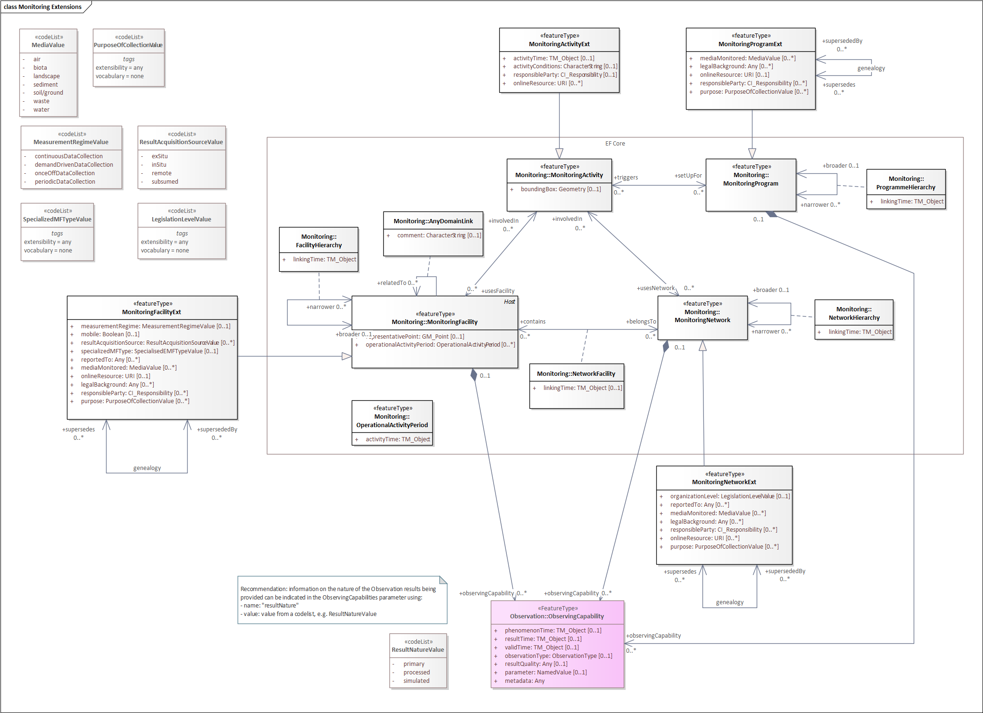
Figure 9: Extended Monitoring Schema

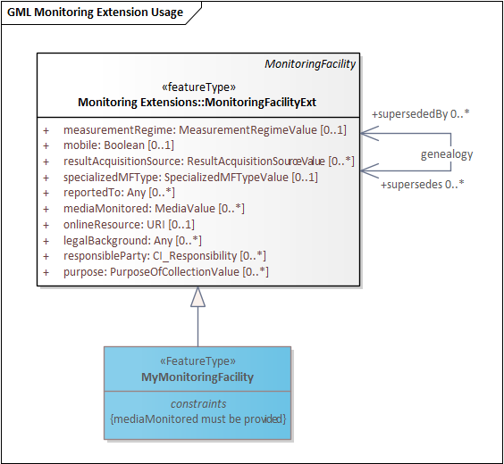
When utilizing the Monitoring Extensions in the creation of domain models, constraints can be useful to tailor the complexity of these types to specific use cases. In Figure 10, MyMonitoringFacility has been created based on MonitoringFacilityExt, adding a constraint mandating the provision of the mediaMonitored attribute.
Figure 10: Using Extended Monitoring

MonitoringFacility Extended

reportedTo
Requirements Class
http://www.opengis.net/spec/OMS-L/1.0/req/req-class-MonitoringFacilityExt-reportedTo
Target type | OMS Logical Model
Dependency | ISO 19103:2015 Geographic information – Conceptual schema language, UML2 conformance class
Req 1 | /req/req-class-MonitoringFacilityExt-reportedTo/reportedTo  Information on the involvement of the MonitoringFacility in reporting.  If information on reporting activities is provided, the property reportedTo:Any shall be used.

mediaMonitored
Requirements Class
http://www.opengis.net/spec/OMS-L/1.0/req/req-class-MonitoringFacilityExt-mediaMonitored
Target type | OMS Logical Model
Dependency | ISO 19103:2015 Geographic information – Conceptual schema language, UML2 conformance class
Req 1 | /req/req-class-MonitoringFacilityExt-mediaMonitored/mediaMonitored  Monitored environmental medium.  If information on the environmental media being observed at the MonitoringFacility is provided, the property mediaMonitored:Media shall be used.

legalBackground
Requirements Class
http://www.opengis.net/spec/OMS-L/1.0/req/req-class-MonitoringFacilityExt-legalBackground
Target type | OMS Logical Model
Dependency | ISO 19103:2015 Geographic information – Conceptual schema language, UML2 conformance class
Req 1 | /req/req-class-MonitoringFacilityExt-legalBackground/legalBackground  The legal context, in which the management and regulation of the MonitoringFacility is defined.  If information on the legal context of the MonitoringFacility is provided, the association with the role legalBackground:Any shall be used.

responsibleParty
Requirements Class
http://www.opengis.net/spec/OMS-L/1.0/req/req-class-MonitoringFacilityExt-responsibleParty
Target type | OMS Logical Model
Dependency | ISO 19103:2015 Geographic information – Conceptual schema language, UML2 conformance class
Req 1 | /req/req-class-MonitoringFacilityExt-responsibleParty/responsibleParty  Responsible party for the MonitoringFacility.  If information on the responsible party of the MonitoringFacility is provided, the property responsibleParty:CI_Responsibility shall be used.

onlineResource
Requirements Class
http://www.opengis.net/spec/OMS-L/1.0/req/req-class-MonitoringFacilityExt-onlineResource
Target type | OMS Logical Model
Dependency | ISO 19103:2015 Geographic information – Conceptual schema language, UML2 conformance class
Req 1 | /req/req-class-MonitoringFacilityExt-onlineResource/onlineResource  A link to an external document providing further information on the MonitoringFacility.  If a link to an external document providing further information on the MonitoringFacility is provided, the property onlineResource:URI shall be used.

purpose
Requirements Class
http://www.opengis.net/spec/OMS-L/1.0/req/req-class-MonitoringFacilityExt-purpose
Target type | OMS Logical Model
Dependency | ISO 19103:2015 Geographic information – Conceptual schema language, UML2 conformance class
Req 1 | /req/req-class-MonitoringFacilityExt-purpose/purpose  Reason for which the MonitoringFacility was created.  If information on the reason for which the MonitoringFacility was created is provided, the property purpose:PurposeOfCollection shall be used.

measurementRegime
Requirements Class
http://www.opengis.net/spec/OMS-L/1.0/req/req-class-MonitoringFacilityExt-measurementRegime
Target type | OMS Logical Model
Dependency | ISO 19103:2015 Geographic information – Conceptual schema language, UML2 conformance class
Req 1 | /req/req-class-MonitoringFacilityExt-measurementRegime/measurementRegime  Regime of the measurement.  If information on the regime of the measurement of the MonitoringFacility is provided, the property measurementRegime:MeasurementRegime shall be used.

mobile
Requirements Class
http://www.opengis.net/spec/OMS-L/1.0/req/req-class-MonitoringFacilityExt-mobile
Target type | OMS Logical Model
Dependency | ISO 19103:2015 Geographic information – Conceptual schema language, UML2 conformance class
Req 1 | /req/req-class-MonitoringFacilityExt-mobile/mobile  Indicate whether the MonitoringFacility is mobile (repositionable) during the acquisition of the observation.  If indication whether the MonitoringFacility is mobile is provided, the property mobile:Boolean shall be used.

resultAcquisitionSource
Requirements Class
http://www.opengis.net/spec/OMS-L/1.0/req/req-class-MonitoringFacilityExt-resultAcquisitionSource
Target type | OMS Logical Model
Dependency | ISO 19103:2015 Geographic information – Conceptual schema language, UML2 conformance class
Req 1 | /req/req-class-MonitoringFacilityExt-resultAcquisitionSource/resultAcquisitionSource  Source of result acquisition.  If information on the source of result acquisition of the MonitoringFacility is provided, the property resultAcquisitionSource:ResultAcquisitionSource shall be used.

observerProximity
Requirements Class
http://www.opengis.net/spec/OMS-L/1.0/req/req-class-MonitoringFacilityExt-observerProximity
Target type | OMS Logical Model
Dependency | ISO 19103:2015 Geographic information – Conceptual schema language, UML2 conformance class
Req 1 | /req/req-class-MonitoringFacilityExt-observerProximity/observerProximity  Proximity of the Observer (Sensor) to the feature of interest.  If information on the source of result acquisition of the MonitoringFacility is provided, the property observerProximity:ObserverProximity shall be used.

specializedMFType
Requirements Class
http://www.opengis.net/spec/OMS-L/1.0/req/req-class-MonitoringFacilityExt-specializedMFType
Target type | OMS Logical Model
Dependency | ISO 19103:2015 Geographic information – Conceptual schema language, UML2 conformance class
Dependency | http://www.opengis.net/spec/OMS-L/1.0/req/req-class-SpecializedMFType
Req 1 | /req/req-class-MonitoringFacilityExt-specializedMFType/specializedMFType  Categorization of MonitoringFacility(s) generally used by domain and in national settings.  If a categorization of the MonitoringFacility(s) is provided, the property specializedMFType:SpecializedMFType shall be used.

geometryRequired
Requirements Class
http://www.opengis.net/spec/OMS-L/1.0/req/req-class-MonitoringFacilityExt-geometryRequired
Target type | OMS Logical Model
Dependency | ISO 19103:2015 Geographic information – Conceptual schema language, UML2 conformance class
Req 1 | /req/req-class-MonitoringFacilityExt-geometryRequired/geometryRequired  Geometry and representativePoint shall not both be empty.

supersedes
Requirements Class
http://www.opengis.net/spec/OMS-L/1.0/req/req-class-MonitoringFacilityExt-supersedes
Target type | OMS Logical Model
Dependency | ISO 19103:2015 Geographic information – Conceptual schema language, UML2 conformance class
Req 1 | /req/req-class-MonitoringFacilityExt-supersedes/supersedes  In genealogy, the MonitoringFacility(s) that has(have) been deactivated/replaced by another one.  If a reference to a previous version of the MonitoringFacility is provided, the association with the role supersedes shall be used.

supersededBy
Requirements Class
http://www.opengis.net/spec/OMS-L/1.0/req/req-class-MonitoringFacilityExt-supersededBy
Target type | OMS Logical Model
Dependency | ISO 19103:2015 Geographic information – Conceptual schema language, UML2 conformance class
Req 1 | /req/req-class-MonitoringFacilityExt-supersededBy/supersededBy  In genealogy, the newly active MonitoringFacility(s) that replaces(replace) the superseded one.  If a reference to a subsequent version of the MonitoringFacility is provided, the association with the role supersededBy shall be used.

MonitoringNetwork Extended

mediaMonitored
Requirements Class
http://www.opengis.net/spec/OMS-L/1.0/req/req-class-MonitoringNetworkExt-mediaMonitored
Target type | OMS Logical Model
Dependency | ISO 19103:2015 Geographic information – Conceptual schema language, UML2 conformance class
Req 1 | /req/req-class-MonitoringNetworkExt-mediaMonitored/mediaMonitored  Monitored environmental medium.  If information on the environmental media being observed by the MonitoringNetwork is provided, the property mediaMonitored:Media shall be used.

legalBackground
Requirements Class
http://www.opengis.net/spec/OMS-L/1.0/req/req-class-MonitoringNetworkExt-legalBackground
Target type | OMS Logical Model
Dependency | ISO 19103:2015 Geographic information – Conceptual schema language, UML2 conformance class
Req 1 | /req/req-class-MonitoringNetworkExt-legalBackground/legalBackground  The legal context, in which the management and regulation of the MonitoringNetwork is defined.  If information on the legal context of the MonitoringNetwork is provided, the property legalBackground:Any shall be used.

responsibleParty
Requirements Class
http://www.opengis.net/spec/OMS-L/1.0/req/req-class-MonitoringNetworkExt-responsibleParty
Target type | OMS Logical Model
Dependency | ISO 19103:2015 Geographic information – Conceptual schema language, UML2 conformance class
Req 1 | /req/req-class-MonitoringNetworkExt-responsibleParty/responsibleParty  Responsible party for the MonitoringNetwork.  If information on the responsible party of the MonitoringNetwork is provided, the property responsibleParty:responsibleParty shall be used.

onlineResource
Requirements Class
http://www.opengis.net/spec/OMS-L/1.0/req/req-class-MonitoringNetworkExt-onlineResource
Target type | OMS Logical Model
Dependency | ISO 19103:2015 Geographic information – Conceptual schema language, UML2 conformance class
Req 1 | /req/req-class-MonitoringNetworkExt-onlineResource/onlineResource  A link to an external document providing further information on the MonitoringNetwork.  If a link to an external document providing further information on the MonitoringNetwork is provided, the property onlineResource:URI shall be used.

purpose
Requirements Class
http://www.opengis.net/spec/OMS-L/1.0/req/req-class-MonitoringNetworkExt-purpose
Target type | OMS Logical Model
Dependency | ISO 19103:2015 Geographic information – Conceptual schema language, UML2 conformance class
Req 1 | /req/req-class-MonitoringNetworkExt-purpose/purpose  Reason for which the MonitoringNetwork was created.  If information on the reason for which the MonitoringNetwork was created is provided, the property purpose:PurposeOfCollection shall be used.

organizationLevel
Requirements Class
http://www.opengis.net/spec/OMS-L/1.0/req/req-class-MonitoringNetworkExt-organizationLevel
Target type | OMS Logical Model
Dependency | ISO 19103:2015 Geographic information – Conceptual schema language, UML2 conformance class
Req 1 | /req/req-class-MonitoringNetworkExt-organizationLevel/organizationLevel  Level of legal organization the MonitoringNetwork is affiliated with.  If information on the level of legal organization the MonitoringNetwork is affiliated with is provided, the property organizationLevel:LegislationLevel shall be used.

supersedes
Requirements Class
http://www.opengis.net/spec/OMS-L/1.0/req/req-class-MonitoringNetworkExt-supersedes
Target type | OMS Logical Model
Dependency | ISO 19103:2015 Geographic information – Conceptual schema language, UML2 conformance class
Req 1 | /req/req-class-MonitoringNetworkExt-supersedes/supersedes  In genealogy, the MonitoringNetwork(s) that has(have) been deactivated/replaced by another one.  If a reference to a previous version of the MonitoringNetwork is provided, the association with the role supersedes shall be used.

supersededBy
Requirements Class
http://www.opengis.net/spec/OMS-L/1.0/req/req-class-MonitoringNetworkExt-supersededBy
Target type | OMS Logical Model
Dependency | ISO 19103:2015 Geographic information – Conceptual schema language, UML2 conformance class
Req 1 | /req/req-class-MonitoringNetworkExt-supersededBy/supersededBy  In a genealogy, the newly active MonitoringNetwork(s) that replaces(replace) the superseded one.  If a reference to a subsequent version of the MonitoringNetwork is provided, the association with the role supersededBy shall be used.

MonitoringActivity Extended

activityTime
Requirements Class
http://www.opengis.net/spec/OMS-L/1.0/req/req-class-MonitoringActivityExt-activityTime
Target type | OMS Logical Model
Dependency | ISO 19103:2015 Geographic information – Conceptual schema language, UML2 conformance class
Req 1 | /req/req-class-MonitoringActivityExt-activityTime/activityTime  Lifespan of the MonitoringActivity.  If information on the lifespan of the MonitoringActivity is provided, the property activityTime:TM_Object shall be used.

activityConditions
Requirements Class
http://www.opengis.net/spec/OMS-L/1.0/req/req-class-MonitoringActivityExt-activityConditions
Target type | OMS Logical Model
Dependency | ISO 19103:2015 Geographic information – Conceptual schema language, UML2 conformance class
Req 1 | /req/req-class-MonitoringActivityExt-activityConditions/activityConditions  Textual description of the MonitoringActivity.  If a textual description of the MonitoringActivity is provided, the property activityConditions:CharacterString shall be used.

responsibleParty
Requirements Class
http://www.opengis.net/spec/OMS-L/1.0/req/req-class-MonitoringActivityExt-responsibleParty
Target type | OMS Logical Model
Dependency | ISO 19103:2015 Geographic information – Conceptual schema language, UML2 conformance class
Req 1 | /req/req-class-MonitoringActivityExt-responsibleParty/responsibleParty  Responsible party for the MonitoringActivity.  If information on the responsible party for the MonitoringActivity is provided, the property responsibleParty:CI_Responsibility shall be used.

onlineResource
Requirements Class
http://www.opengis.net/spec/OMS-L/1.0/req/req-class-MonitoringActivityExt-onlineResource
Target type | OMS Logical Model
Dependency | ISO 19103:2015 Geographic information – Conceptual schema language, UML2 conformance class
Req 1 | /req/req-class-MonitoringActivityExt-onlineResource/onlineResource  A link to an external document providing further information on the MonitoringActivity.  If a link to an external document providing further information on the MonitoringActivity is provided, the property onlineResource:URI shall be used.

MonitoringProgram Extended

mediaMonitored
Requirements Class
http://www.opengis.net/spec/OMS-L/1.0/req/req-class-MonitoringProgramExt-mediaMonitored
Target type | OMS Logical Model
Dependency | ISO 19103:2015 Geographic information – Conceptual schema language, UML2 conformance class
Req 1 | /req/req-class-MonitoringProgramExt-mediaMonitored/mediaMonitored  Monitored environmental medium.  If a reference to the environmental media being observed by the MonitoringProgram is provided, the association with the role mediaMonitored shall be used.

legalBackground
Requirements Class
http://www.opengis.net/spec/OMS-L/1.0/req/req-class-MonitoringProgramExt-legalBackground
Target type | OMS Logical Model
Dependency | ISO 19103:2015 Geographic information – Conceptual schema language, UML2 conformance class
Req 1 | /req/req-class-MonitoringProgramExt-legalBackground/legalBackground  The legal context, in which the management and regulation of the MonitoringProgram is defined.  If information on the legal context of the MonitoringProgram is provided, the association with the role legalBackground:Any shall be used.

responsibleParty
Requirements Class
http://www.opengis.net/spec/OMS-L/1.0/req/req-class-MonitoringProgramExt-responsibleParty
Target type | OMS Logical Model
Dependency | ISO 19103:2015 Geographic information – Conceptual schema language, UML2 conformance class
Req 1 | /req/req-class-MonitoringProgramExt-responsibleParty/responsibleParty  Responsible party for the MonitoringProgram.  If information on the responsible party of the MonitoringProgram is provided, the property responsibleParty:CI_Responsibility shall be used.

onlineResource
Requirements Class
http://www.opengis.net/spec/OMS-L/1.0/req/req-class-MonitoringProgramExt-onlineResource
Target type | OMS Logical Model
Dependency | ISO 19103:2015 Geographic information – Conceptual schema language, UML2 conformance class
Req 1 | /req/req-class-MonitoringProgramExt-onlineResource/onlineResource  A link to an external document providing further information on the MonitoringProgram.  If a link to an external document providing further information on the MonitoringProgram is provided, the property onlineResource:URI shall be used.

purpose
Requirements Class
http://www.opengis.net/spec/OMS-L/1.0/req/req-class-MonitoringProgramExt-purpose
Target type | OMS Logical Model
Dependency | ISO 19103:2015 Geographic information – Conceptual schema language, UML2 conformance class
Req 1 | /req/req-class-MonitoringProgramExt-purpose/purpose  Reason for which the MonitoringProgram was created.  If information on the reason for which the MonitoringProgram was created is provided, the property purpose:PurposeOfCollection shall be used.

supersedes
Requirements Class
http://www.opengis.net/spec/OMS-L/1.0/req/req-class-MonitoringProgramExt-supersedes
Target type | OMS Logical Model
Dependency | ISO 19103:2015 Geographic information – Conceptual schema language, UML2 conformance class
Req 1 | /req/req-class-MonitoringProgramExt-supersedes/supersedes  In genealogy, the MonitoringProgram(s)that has(have) been deactivated/replaced by another one.  If a reference to a previous version of the MonitoringProgram is provided, the association with the role supersedes shall be used.

supersededBy
Requirements Class
http://www.opengis.net/spec/OMS-L/1.0/req/req-class-MonitoringProgramExt-supersededBy
Target type | OMS Logical Model
Dependency | ISO 19103:2015 Geographic information – Conceptual schema language, UML2 conformance class
Req 1 | /req/req-class-MonitoringProgramExt-supersededBy/supersededBy  In genealogy, the newly active MonitoringProgram(s) that replaces(replace) the superseded one.  If a reference to a subsequent version of the MonitoringProgram is provided, the association with the role supersededBy shall be used.

Codelists

Codelist SpecializedMFType
An empty extension-point for providing various classification schemes for MonitoringFacilities.
Requirements Class
http://www.opengis.net/spec/OMS-L/1.0/req/req-class-MonitoringProgramExt-SpecializedMFType
Target type | OMS Logical Model
Dependency | ISO 19103:2015 Geographic information – Conceptual schema language, UML2 conformance class
Req 1 | /req/req-class-MonitoringProgramExt-SpecializedMFType/SpecializedMFType-sem  An empty extension-point for providing various classification schemes for MonitoringFacilities, generally used by domain and in national settings.  EXAMPLES: platform, site, station, sensor, ....

Codelist PurposeOfCollection
An empty extension-point for providing various classification schemes describing the reason for which MonitoringFacilities, MonitoringNetworks or MonitoringPrograms were created.
Requirements Class
http://www.opengis.net/spec/OMS-L/1.0/req/req-class-MonitoringProgramExt-PurposeOfCollection
Target type | OMS Logical Model
Dependency | ISO 19103:2015 Geographic information – Conceptual schema language, UML2 conformance class
Req 1 | /req/req-class-MonitoringProgramExt-PurposeOfCollection/PurposeOfCollection-sem  An empty extension-point for providing various classification schemes describing the reason for which MonitoringFacilities, MonitoringNetworks or MonitoringPrograms were created.  EXAMPLES: European reporting obligation, international collaboration, long term monitoring of contaminated sites, ....

Codelist Media
A codelist for classifying MonitoringFacilities, MonitoringNetworks or MonitoringPrograms by the media they monitor.
Requirements Class
http://www.opengis.net/spec/OMS-L/1.0/req/req-class-MonitoringProgramExt-Media
Target type | OMS Logical Model
Dependency | ISO 19103:2015 Geographic information – Conceptual schema language, UML2 conformance class
Req 1 | /req/req-class-MonitoringProgramExt-Media/Media-sem  A codelist for classifying MonitoringFacilities, MonitoringNetworks or MonitoringPrograms by the media they monitor.  The following entries shall be included:  - air  - biota  - landscape  - sediment  - soil/ground  - waste  - water

Codelist MeasurementRegime
A codelist for classifying MonitoringFacilities by the measurement regime guiding their operation.
Requirements Class
http://www.opengis.net/spec/OMS-L/1.0/req/req-class-MonitoringProgramExt-MeasurementRegime
Target type | OMS Logical Model
Dependency | ISO 19103:2015 Geographic information – Conceptual schema language, UML2 conformance class
Req 1 | /req/req-class-MonitoringProgramExt-MeasurementRegime/MeasurementRegime-sem  A codelist for classifying MonitoringFacilities by the measurement regime guiding their operation.  The following entries shall be provided:  - continuousDataCollection: Data is collected on a continuous basis. There is usually no end date, as further data is collected.  - demandDrivenDataCollection: Data is collected on demand.  - onceOffDataCollection: Data is collected only once in this configuration. No further observations in this configuration can be expected.  - periodicDataCollection: Data is collected at regular intervals. No information is available as to the data collection interval.

Codelist ResultAcquisitionSource
A codelist for classifying MonitoringFacilities by their result acquisition source.
Requirements Class
http://www.opengis.net/spec/OMS-L/1.0/req/req-class-MonitoringProgramExt-ResultAcquisitionSource
Target type | OMS Logical Model
Dependency | ISO 19103:2015 Geographic information – Conceptual schema language, UML2 conformance class
Req 1 | /req/req-class-MonitoringProgramExt-ResultAcquisitionSource/ResultAcquisitionSource-sem  A codelist for classifying MonitoringFacilities by their result acquisition source.  The following entries shall be provided:  - exSitu: referring to the study, maintenance or conservation of a specimen or population away from its natural surroundings.  - inSitu: referring to the study, maintenance or conservation of a specimen or population without removing it from its natural surroundings.

Codelist ObserverProximity
A codelist for classifying MonitoringFacilities by the proximity of the Observer (Sensor) to the Feature of Interest.
Requirements Class
http://www.opengis.net/spec/OMS-L/1.0/req/req-class-MonitoringProgramExt-ObserverProximity
Target type | OMS Logical Model
Dependency | ISO 19103:2015 Geographic information – Conceptual schema language, UML2 conformance class
Req 1 | /req/req-class-MonitoringProgramExt-ObserverProximity/ObserverProximity-sem  A codelist for classifying MonitoringFacilities by the proximity of the Observer (Sensor) to the Feature of Interest.  The following entries shall be provided:  - direct: Observer was co-located with the Feature of Interest.  - remote: Observer was in a different location than the Feature of Interest

Codelist ResultNature
A codelist for classifying MonitoringFacilities, MonitoringNetworks or MonitoringPrograms by the nature of their results.
Requirements Class
http://www.opengis.net/spec/OMS-L/1.0/req/req-class-MonitoringProgramExt-ResultNature
Target type | OMS Logical Model
Dependency | ISO 19103:2015 Geographic information – Conceptual schema language, UML2 conformance class
Req 1 | /req/req-class-MonitoringProgramExt-ResultNature/ResultNature-sem  A codelist for classifying MonitoringFacilities, MonitoringNetworks or MonitoringPrograms by the nature of their results.  The following entries shall be provided:  - primary: The result provided with the observation is the direct result of an estimate of a property on the featureOfInterest. No further processing was performed. Processing may have taken place, but only in the sense of the measurement methodology itself, i.e. converting the millivolt returned from the sensor to the concentration of a substance.  - processed: The result provided, while usually based on primary measurements, has been substantially processed. This processing can be of diverse natures, in some situations complex aggregates are provided, in other situations, the existing values are interpolated to a continuum.  - simulated: The result provided, while usually based on primary measurements, is based on an interpretation model, and provides a simulation of past or future states of the media being analyzed. In this case, the existing values are usually extrapolated into the past or future.

Codelist LegislationLevel
An empty extension-point for indicating the level of legal organisation the Monitoring object is affiliated with.
Requirements Class
http://www.opengis.net/spec/OMS-L/1.0/req/req-class-MonitoringProgramExt-LegislationLevel
Target type | OMS Logical Model
Dependency | ISO 19103:2015 Geographic information – Conceptual schema language, UML2 conformance class
Req 1 | /req/req-class-MonitoringProgramExt-LegislationLevel/LegislationLevel-sem  An empty extension-point for indicating the level of legal organisation the Monitoring object is affiliated with.  EXAMPLES: European, national, regional, ....

Annex

Observation
Annex A: Conformance Class Test Suite (Normative)
Conformance class: Observation
Conformance Class
http://www.opengis.net/spec/OMS-L/1.0/conf/conf-class-Observation
Requirement | http://www.opengis.net/spec/OMS-L/1.0/req/req-class-Observation
Test | http://www.opengis.net/spec/OMS-L/1.0/conf/conf-class-Observation/test-1
Test | Test purpose | Verify that all requirements from the requirements class have been fulfilled.
Test | Test method | Inspect the documentation of the application, schema or profile.

Conformance class: ObservableProperty
Conformance Class
http://www.opengis.net/spec/OMS-L/1.0/conf/conf-class-ObservableProperty
Requirement | http://www.opengis.net/spec/OMS-L/1.0/req/req-class-ObservableProperty
Test | http://www.opengis.net/spec/OMS-L/1.0/conf/conf-class-ObservableProperty/test-1
Test | Test purpose | Verify that all requirements from the requirements class have been fulfilled.
Test | Test method | Inspect the documentation of the application, schema or profile.

Conformance class: ObservingProcedure
Conformance Class
http://www.opengis.net/spec/OMS-L/1.0/conf/conf-class-ObservingProcedure
Requirement | http://www.opengis.net/spec/OMS-L/1.0/req/req-class-ObservingProcedure
Test | http://www.opengis.net/spec/OMS-L/1.0/conf/conf-class-ObservingProcedure/test-1
Test | Test purpose | Verify that all requirements from the requirements class have been fulfilled.
Test | Test method | Inspect the documentation of the application, schema or profile.

Conformance class: Observer
Conformance Class
http://www.opengis.net/spec/OMS-L/1.0/conf/conf-class-Observer
Requirement | http://www.opengis.net/spec/OMS-L/1.0/req/req-class-Observer
Test | http://www.opengis.net/spec/OMS-L/1.0/conf/conf-class-Observer/test-1
Test | Test purpose | Verify that all requirements from the requirements class have been fulfilled.
Test | Test method | Inspect the documentation of the application, schema or profile.

Conformance class: Host
Conformance Class
http://www.opengis.net/spec/OMS-L/1.0/conf/conf-class-Host
Requirement | http://www.opengis.net/spec/OMS-L/1.0/req/req-class-Host
Test | http://www.opengis.net/spec/OMS-L/1.0/conf/conf-class-Host/test-1
Test | Test purpose | Verify that all requirements from the requirements class have been fulfilled.
Test | Test method | Inspect the documentation of the application, schema or profile.

Conformance class: Deployment
Conformance Class
http://www.opengis.net/spec/OMS-L/1.0/conf/conf-class-Deployment
Requirement | http://www.opengis.net/spec/OMS-L/1.0/req/req-class-Deployment
Test | http://www.opengis.net/spec/OMS-L/1.0/conf/conf-class-Deployment/test-1
Test | Test purpose | Verify that all requirements from the requirements class have been fulfilled.
Test | Test method | Inspect the documentation of the application, schema or profile.

Conformance class: ObservationCharacteristics
Conformance Class
http://www.opengis.net/spec/OMS-L/1.0/conf/conf-class-ObservationCharacteristics
Requirement | http://www.opengis.net/spec/OMS-L/1.0/req/req-class-ObservationCharacteristics
Test | http://www.opengis.net/spec/OMS-L/1.0/conf/conf-class-ObservationCharacteristics/test-1
Test | Test purpose | Verify that all requirements from the requirements class have been fulfilled.
Test | Test method | Inspect the documentation of the application, schema or profile.

Conformance class: ObservationCollection
Conformance Class
http://www.opengis.net/spec/OMS-L/1.0/conf/conf-class-ObservationCollection
Requirement | http://www.opengis.net/spec/OMS-L/1.0/req/req-class-ObservationCollection
Test | http://www.opengis.net/spec/OMS-L/1.0/conf/conf-class-ObservationCollection/test-1
Test | Test purpose | Verify that all requirements from the requirements class have been fulfilled.
Test | Test method | Inspect the documentation of the application, schema or profile.

Conformance class: ObservingCapability
Conformance Class
http://www.opengis.net/spec/OMS-L/1.0/conf/conf-class-ObservingCapability
Requirement | http://www.opengis.net/spec/OMS-L/1.0/req/req-class-ObservingCapability
Test | http://www.opengis.net/spec/OMS-L/1.0/conf/conf-class-ObservingCapability/test-1
Test | Test purpose | Verify that all requirements from the requirements class have been fulfilled.
Test | Test method | Inspect the documentation of the application, schema or profile.

Conformance class: NamedValue
Conformance Class
http://www.opengis.net/spec/OMS-L/1.0/conf/conf-class-NamedValue
Requirement | http://www.opengis.net/spec/OMS-L/1.0/req/req-class-NamedValue
Test | http://www.opengis.net/spec/OMS-L/1.0/conf/conf-class-NamedValue/test-1
Test | Test purpose | Verify that all requirements from the requirements class have been fulfilled.
Test | Test method | Inspect the documentation of the application, schema or profile.

Conformance class: ObservationType
Conformance Class
http://www.opengis.net/spec/OMS-L/1.0/conf/conf-class-ObservationType
Requirement | http://www.opengis.net/spec/OMS-L/1.0/req/req-class-ObservationType
Test | http://www.opengis.net/spec/OMS-L/1.0/conf/conf-class-ObservationType/test-1
Test | Test purpose | Verify that all requirements from the requirements class have been fulfilled.
Test | Test method | Inspect the documentation of the application, schema or profile.

Conformance class: ObservationTypeByResultType
Conformance Class
http://www.opengis.net/spec/OMS-L/1.0/conf/conf-class-ObservationTypeByResultType
Requirement | http://www.opengis.net/spec/OMS-L/1.0/req/req-class-ObservationTypeByResultType
Test | http://www.opengis.net/spec/OMS-L/1.0/conf/conf-class-ObservationTypeByResultType/test-1
Test | Test purpose | Verify that all requirements from the requirements class have been fulfilled.
Test | Test method | Inspect the documentation of the application, schema or profile.

Conformance class: ObservationCollectionType
Conformance Class
http://www.opengis.net/spec/OMS-L/1.0/conf/conf-class-ObservationCollectionType
Requirement | http://www.opengis.net/spec/OMS-L/1.0/req/req-class-ObservationCollectionType
Test | http://www.opengis.net/spec/OMS-L/1.0/conf/conf-class-ObservationCollectionType/test-1
Test | Test purpose | Verify that all requirements from the requirements class have been fulfilled.
Test | Test method | Inspect the documentation of the application, schema or profile.

Sampling
Conformance class: Sample
Conformance Class
http://www.opengis.net/spec/OMS-L/1.0/conf/conf-class-Sample
Requirement | http://www.opengis.net/spec/OMS-L/1.0/req/req-class-Sample
Test | http://www.opengis.net/spec/OMS-L/1.0/conf/conf-class-Sample/test-1
Test | Test purpose | Verify that all requirements from the requirements class have been fulfilled.
Test | Test method | Inspect the documentation of the application, schema or profile.

Conformance class: SpatialSample
Conformance Class
http://www.opengis.net/spec/OMS-L/1.0/conf/conf-class-SpatialSample
Requirement | http://www.opengis.net/spec/OMS-L/1.0/req/req-class-SpatialSample
Test | http://www.opengis.net/spec/OMS-L/1.0/conf/conf-class-SpatialSample/test-1
Test | Test purpose | Verify that all requirements from the requirements class have been fulfilled.
Test | Test method | Inspect the documentation of the application, schema or profile.

Conformance class: MaterialSample
Conformance Class
http://www.opengis.net/spec/OMS-L/1.0/conf/conf-class-MaterialSample
Requirement | http://www.opengis.net/spec/OMS-L/1.0/req/req-class-MaterialSample
Test | http://www.opengis.net/spec/OMS-L/1.0/conf/conf-class-MaterialSample/test-1
Test | Test purpose | Verify that all requirements from the requirements class have been fulfilled.
Test | Test method | Inspect the documentation of the application, schema or profile.

Conformance class: StatisticalSample
Conformance Class
http://www.opengis.net/spec/OMS-L/1.0/conf/conf-class-StatisticalSample
Requirement | http://www.opengis.net/spec/OMS-L/1.0/req/req-class-StatisticalSample
Test | http://www.opengis.net/spec/OMS-L/1.0/conf/conf-class-StatisticalSample/test-1
Test | Test purpose | Verify that all requirements from the requirements class have been fulfilled.
Test | Test method | Inspect the documentation of the application, schema or profile.

Conformance class: Sampling
Conformance Class
http://www.opengis.net/spec/OMS-L/1.0/conf/conf-class-Sampling
Requirement | http://www.opengis.net/spec/OMS-L/1.0/req/req-class-Sampling
Test | http://www.opengis.net/spec/OMS-L/1.0/conf/conf-class-Sampling/test-1
Test | Test purpose | Verify that all requirements from the requirements class have been fulfilled.
Test | Test method | Inspect the documentation of the application, schema or profile.

Conformance class: Sampler
Conformance Class
http://www.opengis.net/spec/OMS-L/1.0/conf/conf-class-Sampler
Requirement | http://www.opengis.net/spec/OMS-L/1.0/req/req-class-Sampler
Test | http://www.opengis.net/spec/OMS-L/1.0/conf/conf-class-Sampler/test-1
Test | Test purpose | Verify that all requirements from the requirements class have been fulfilled.
Test | Test method | Inspect the documentation of the application, schema or profile.

Conformance class: SamplingProcedure
Conformance Class
http://www.opengis.net/spec/OMS-L/1.0/conf/conf-class-SamplingProcedure
Requirement | http://www.opengis.net/spec/OMS-L/1.0/req/req-class-SamplingProcedure
Test | http://www.opengis.net/spec/OMS-L/1.0/conf/conf-class-SamplingProcedure/test-1
Test | Test purpose | Verify that all requirements from the requirements class have been fulfilled.
Test | Test method | Inspect the documentation of the application, schema or profile.

Conformance class: PreparationStep
Conformance Class
http://www.opengis.net/spec/OMS-L/1.0/conf/conf-class-PreparationStep
Requirement | http://www.opengis.net/spec/OMS-L/1.0/req/req-class-PreparationStep
Test | http://www.opengis.net/spec/OMS-L/1.0/conf/conf-class-PreparationStep/test-1
Test | Test purpose | Verify that all requirements from the requirements class have been fulfilled.
Test | Test method | Inspect the documentation of the application, schema or profile.

Conformance class: PreparationProcedure
Conformance Class
http://www.opengis.net/spec/OMS-L/1.0/conf/conf-class-PreparationProcedure
Requirement | http://www.opengis.net/spec/OMS-L/1.0/req/req-class-PreparationProcedure
Test | http://www.opengis.net/spec/OMS-L/1.0/conf/conf-class-PreparationProcedure/test-1
Test | Test purpose | Verify that all requirements from the requirements class have been fulfilled.
Test | Test method | Inspect the documentation of the application, schema or profile.

Conformance class: SampleCollection
Conformance Class
http://www.opengis.net/spec/OMS-L/1.0/conf/conf-class-SampleCollection
Requirement | http://www.opengis.net/spec/OMS-L/1.0/req/req-class-SampleCollection
Test | http://www.opengis.net/spec/OMS-L/1.0/conf/conf-class-SampleCollection/test-1
Test | Test purpose | Verify that all requirements from the requirements class have been fulfilled.
Test | Test method | Inspect the documentation of the application, schema or profile.

Conformance class: PhysicalDimension
Conformance Class
http://www.opengis.net/spec/OMS-L/1.0/conf/conf-class-PhysicalDimension
Requirement | http://www.opengis.net/spec/OMS-L/1.0/req/req-class-PhysicalDimension
Test | http://www.opengis.net/spec/OMS-L/1.0/conf/conf-class-PhysicalDimension/test-1
Test | Test purpose | Verify that all requirements from the requirements class have been fulfilled.
Test | Test method | Inspect the documentation of the application, schema or profile.

Conformance class: NamedLocation
Conformance Class
http://www.opengis.net/spec/OMS-L/1.0/conf/conf-class-NamedLocation
Requirement | http://www.opengis.net/spec/OMS-L/1.0/req/req-class-NamedLocation
Test | http://www.opengis.net/spec/OMS-L/1.0/conf/conf-class-NamedLocation/test-1
Test | Test purpose | Verify that all requirements from the requirements class have been fulfilled.
Test | Test method | Inspect the documentation of the application, schema or profile.

Conformance class: StatisticalClassification
Conformance Class
http://www.opengis.net/spec/OMS-L/1.0/conf/conf-class-StatisticalClassification
Requirement | http://www.opengis.net/spec/OMS-L/1.0/req/req-class-StatisticalClassification
Test | http://www.opengis.net/spec/OMS-L/1.0/conf/conf-class-StatisticalClassification/test-1
Test | Test purpose | Verify that all requirements from the requirements class have been fulfilled.
Test | Test method | Inspect the documentation of the application, schema or profile.

Conformance class: SampleType
Conformance Class
http://www.opengis.net/spec/OMS-L/1.0/conf/conf-class-SampleType
Requirement | http://www.opengis.net/spec/OMS-L/1.0/req/req-class-SampleType
Test | http://www.opengis.net/spec/OMS-L/1.0/conf/conf-class-SampleType/test-1
Test | Test purpose | Verify that all requirements from the requirements class have been fulfilled.
Test | Test method | Inspect the documentation of the application, schema or profile.

Conformance class: SampleTypeByGeometryType
Conformance Class
http://www.opengis.net/spec/OMS-L/1.0/conf/conf-class-SampleTypeByGeometryType
Requirement | http://www.opengis.net/spec/OMS-L/1.0/req/req-class-SampleTypeByGeometryType
Test | http://www.opengis.net/spec/OMS-L/1.0/conf/conf-class-SampleTypeByGeometryType/test-1
Test | Test purpose | Verify that all requirements from the requirements class have been fulfilled.
Test | Test method | Inspect the documentation of the application, schema or profile.

Conformance class: SamplerType
Conformance Class
http://www.opengis.net/spec/OMS-L/1.0/conf/conf-class-SamplerType
Requirement | http://www.opengis.net/spec/OMS-L/1.0/req/req-class-SamplerType
Test | http://www.opengis.net/spec/OMS-L/1.0/conf/conf-class-SamplerType/test-1
Test | Test purpose | Verify that all requirements from the requirements class have been fulfilled.
Test | Test method | Inspect the documentation of the application, schema or profile.

EF
Conformance class: MonitoringFacility
Conformance Class
http://www.opengis.net/spec/OMS-L/1.0/conf/conf-class-MonitoringFacility
Requirement | http://www.opengis.net/spec/OMS-L/1.0/req/req-class-MonitoringFacility
Test | http://www.opengis.net/spec/OMS-L/1.0/conf/conf-class-MonitoringFacility/test-1
Test | Test purpose | Verify that all requirements from the requirements class have been fulfilled.
Test | Test method | Inspect the documentation of the application, schema or profile.

Conformance class: MonitoringFacility-geometryRequired
Conformance Class
http://www.opengis.net/spec/OMS-L/1.0/conf/conf-class-MonitoringFacility-geometryRequired
Requirement | http://www.opengis.net/spec/OMS-L/1.0/req/req-class-MonitoringFacility-geometryRequired
Test | http://www.opengis.net/spec/OMS-L/1.0/conf/conf-class-MonitoringFacility-geometryRequired/test-1
Test | Test purpose | Verify that all requirements from the requirements class have been fulfilled.
Test | Test method | Inspect the documentation of the application, schema or profile.

Conformance class: MonitoringNetwork
Conformance Class
http://www.opengis.net/spec/OMS-L/1.0/conf/conf-class-MonitoringNetwork
Requirement | http://www.opengis.net/spec/OMS-L/1.0/req/req-class-MonitoringNetwork
Test | http://www.opengis.net/spec/OMS-L/1.0/conf/conf-class-MonitoringNetwork/test-1
Test | Test purpose | Verify that all requirements from the requirements class have been fulfilled.
Test | Test method | Inspect the documentation of the application, schema or profile.

Conformance class: MonitoringActivity
Conformance Class
http://www.opengis.net/spec/OMS-L/1.0/conf/conf-class-MonitoringActivity
Requirement | http://www.opengis.net/spec/OMS-L/1.0/req/req-class-MonitoringActivity
Test | http://www.opengis.net/spec/OMS-L/1.0/conf/conf-class-MonitoringActivity/test-1
Test | Test purpose | Verify that all requirements from the requirements class have been fulfilled.
Test | Test method | Inspect the documentation of the application, schema or profile.

Conformance class: MonitoringProgram
Conformance Class
http://www.opengis.net/spec/OMS-L/1.0/conf/conf-class-MonitoringProgram
Requirement | http://www.opengis.net/spec/OMS-L/1.0/req/req-class-MonitoringProgram
Test | http://www.opengis.net/spec/OMS-L/1.0/conf/conf-class-MonitoringProgram/test-1
Test | Test purpose | Verify that all requirements from the requirements class have been fulfilled.
Test | Test method | Inspect the documentation of the application, schema or profile.

Conformance class: NetworkFacility
Conformance Class
http://www.opengis.net/spec/OMS-L/1.0/conf/conf-class-NetworkFacility
Requirement | http://www.opengis.net/spec/OMS-L/1.0/req/req-class-NetworkFacility
Test | http://www.opengis.net/spec/OMS-L/1.0/conf/conf-class-NetworkFacility/test-1
Test | Test purpose | Verify that all requirements from the requirements class have been fulfilled.
Test | Test method | Inspect the documentation of the application, schema or profile.

Conformance class: FacilityHierarchy
Conformance Class
http://www.opengis.net/spec/OMS-L/1.0/conf/conf-class-FacilityHierarchy
Requirement | http://www.opengis.net/spec/OMS-L/1.0/req/req-class-FacilityHierarchy
Test | http://www.opengis.net/spec/OMS-L/1.0/conf/conf-class-FacilityHierarchy/test-1
Test | Test purpose | Verify that all requirements from the requirements class have been fulfilled.
Test | Test method | Inspect the documentation of the application, schema or profile.

Conformance class: NetworkHierarchy
Conformance Class
http://www.opengis.net/spec/OMS-L/1.0/conf/conf-class-NetworkHierarchy
Requirement | http://www.opengis.net/spec/OMS-L/1.0/req/req-class-NetworkHierarchy
Test | http://www.opengis.net/spec/OMS-L/1.0/conf/conf-class-NetworkHierarchy/test-1
Test | Test purpose | Verify that all requirements from the requirements class have been fulfilled.
Test | Test method | Inspect the documentation of the application, schema or profile.

Conformance class: ProgramHierarchy
Conformance Class
http://www.opengis.net/spec/OMS-L/1.0/conf/conf-class-ProgramHierarchy
Requirement | http://www.opengis.net/spec/OMS-L/1.0/req/req-class-ProgramHierarchy
Test | http://www.opengis.net/spec/OMS-L/1.0/conf/conf-class-ProgramHierarchy/test-1
Test | Test purpose | Verify that all requirements from the requirements class have been fulfilled.
Test | Test method | Inspect the documentation of the application, schema or profile.

Conformance class: OperationalActivityPeriod
Conformance Class
http://www.opengis.net/spec/OMS-L/1.0/conf/conf-class-OperationalActivityPeriod
Requirement | http://www.opengis.net/spec/OMS-L/1.0/req/req-class-OperationalActivityPeriod
Test | http://www.opengis.net/spec/OMS-L/1.0/conf/conf-class-OperationalActivityPeriod/test-1
Test | Test purpose | Verify that all requirements from the requirements class have been fulfilled.
Test | Test method | Inspect the documentation of the application, schema or profile.

Conformance class: AnyDomainLink
Conformance Class
http://www.opengis.net/spec/OMS-L/1.0/conf/conf-class-AnyDomainLink
Requirement | http://www.opengis.net/spec/OMS-L/1.0/req/req-class-AnyDomainLink
Test | http://www.opengis.net/spec/OMS-L/1.0/conf/conf-class-AnyDomainLink/test-1
Test | Test purpose | Verify that all requirements from the requirements class have been fulfilled.
Test | Test method | Inspect the documentation of the application, schema or profile.

EF Extended

MonitoringFacilityExt

Conformance class: MonitoringFacilityExt-reportedTo
Conformance Class
http://www.opengis.net/spec/OMS-L/1.0/conf/conf-class-MonitoringFacilityExt-reportedTo
Requirement | http://www.opengis.net/spec/OMS-L/1.0/req/req-class-MonitoringFacilityExt-reportedTo
Test | http://www.opengis.net/spec/OMS-L/1.0/conf/conf-class-MonitoringFacilityExt-reportedTo/test-1
Test | Test purpose | Verify that all requirements from the requirements class have been fulfilled.
Test | Test method | Inspect the documentation of the application, schema or profile.

Conformance class: MonitoringFacilityExt-mediaMonitored
Conformance Class
http://www.opengis.net/spec/OMS-L/1.0/conf/conf-class-MonitoringFacilityExt-mediaMonitored
Requirement | http://www.opengis.net/spec/OMS-L/1.0/req/req-class-MonitoringFacilityExt-mediaMonitored
Test | http://www.opengis.net/spec/OMS-L/1.0/conf/conf-class-MonitoringFacilityExt-mediaMonitored/test-1
Test | Test purpose | Verify that all requirements from the requirements class have been fulfilled.
Test | Test method | Inspect the documentation of the application, schema or profile.

Conformance class: MonitoringFacilityExt-legalBackground
Conformance Class
http://www.opengis.net/spec/OMS-L/1.0/conf/conf-class-MonitoringFacilityExt-legalBackground
Requirement | http://www.opengis.net/spec/OMS-L/1.0/req/req-class-MonitoringFacilityExt-legalBackground
Test | http://www.opengis.net/spec/OMS-L/1.0/conf/conf-class-MonitoringFacilityExt-legalBackground/test-1
Test | Test purpose | Verify that all requirements from the requirements class have been fulfilled.
Test | Test method | Inspect the documentation of the application, schema or profile.

Conformance class: MonitoringFacilityExt-responsibleParty
Conformance Class
http://www.opengis.net/spec/OMS-L/1.0/conf/conf-class-MonitoringFacilityExt-responsibleParty
Requirement | http://www.opengis.net/spec/OMS-L/1.0/req/req-class-MonitoringFacilityExt-responsibleParty
Test | http://www.opengis.net/spec/OMS-L/1.0/conf/conf-class-MonitoringFacilityExt-responsibleParty/test-1
Test | Test purpose | Verify that all requirements from the requirements class have been fulfilled.
Test | Test method | Inspect the documentation of the application, schema or profile.

Conformance class: MonitoringFacilityExt-onlineResource
Conformance Class
http://www.opengis.net/spec/OMS-L/1.0/conf/conf-class-MonitoringFacilityExt-onlineResource
Requirement | http://www.opengis.net/spec/OMS-L/1.0/req/req-class-MonitoringFacilityExt-onlineResource
Test | http://www.opengis.net/spec/OMS-L/1.0/conf/conf-class-MonitoringFacilityExt-onlineResource/test-1
Test | Test purpose | Verify that all requirements from the requirements class have been fulfilled.
Test | Test method | Inspect the documentation of the application, schema or profile.

Conformance class: MonitoringFacilityExt-purpose
Conformance Class
http://www.opengis.net/spec/OMS-L/1.0/conf/conf-class-MonitoringFacilityExt-purpose
Requirement | http://www.opengis.net/spec/OMS-L/1.0/req/req-class-MonitoringFacilityExt-purpose
Test | http://www.opengis.net/spec/OMS-L/1.0/conf/conf-class-MonitoringFacilityExt-purpose/test-1
Test | Test purpose | Verify that all requirements from the requirements class have been fulfilled.
Test | Test method | Inspect the documentation of the application, schema or profile.

Conformance class: MonitoringFacilityExt-measurementRegime
Conformance Class
http://www.opengis.net/spec/OMS-L/1.0/conf/conf-class-MonitoringFacilityExt-measurementRegime
Requirement | http://www.opengis.net/spec/OMS-L/1.0/req/req-class-MonitoringFacilityExt-measurementRegime
Test | http://www.opengis.net/spec/OMS-L/1.0/conf/conf-class-MonitoringFacilityExt-measurementRegime/test-1
Test | Test purpose | Verify that all requirements from the requirements class have been fulfilled.
Test | Test method | Inspect the documentation of the application, schema or profile.

Conformance class: MonitoringFacilityExt-mobile
Conformance Class
http://www.opengis.net/spec/OMS-L/1.0/conf/conf-class-MonitoringFacilityExt-mobile
Requirement | http://www.opengis.net/spec/OMS-L/1.0/req/req-class-MonitoringFacilityExt-mobile
Test | http://www.opengis.net/spec/OMS-L/1.0/conf/conf-class-MonitoringFacilityExt-mobile/test-1
Test | Test purpose | Verify that all requirements from the requirements class have been fulfilled.
Test | Test method | Inspect the documentation of the application, schema or profile.

Conformance class: MonitoringFacilityExt-resultAcquisitionSource
Conformance Class
http://www.opengis.net/spec/OMS-L/1.0/conf/conf-class-MonitoringFacilityExt-resultAcquisitionSource
Requirement | http://www.opengis.net/spec/OMS-L/1.0/req/req-class-MonitoringFacilityExt-resultAcquisitionSource
Test | http://www.opengis.net/spec/OMS-L/1.0/conf/conf-class-MonitoringFacilityExt-resultAcquisitionSource/test-1
Test | Test purpose | Verify that all requirements from the requirements class have been fulfilled.
Test | Test method | Inspect the documentation of the application, schema or profile.

Conformance class: MonitoringFacilityExt-specializedMFType
Conformance Class
http://www.opengis.net/spec/OMS-L/1.0/conf/conf-class-MonitoringFacilityExt-specializedMFType
Requirement | http://www.opengis.net/spec/OMS-L/1.0/req/req-class-MonitoringFacilityExt-specializedMFType
Test | http://www.opengis.net/spec/OMS-L/1.0/conf/conf-class-MonitoringFacilityExt-specializedMFType/test-1
Test | Test purpose | Verify that all requirements from the requirements class have been fulfilled.
Test | Test method | Inspect the documentation of the application, schema or profile.

Conformance class: MonitoringFacilityExt-supersedes
Conformance Class
http://www.opengis.net/spec/OMS-L/1.0/conf/conf-class-MonitoringFacilityExt-supersedes
Requirement | http://www.opengis.net/spec/OMS-L/1.0/req/req-class-MonitoringFacilityExt-supersedes
Test | http://www.opengis.net/spec/OMS-L/1.0/conf/conf-class-MonitoringFacilityExt-supersedes/test-1
Test | Test purpose | Verify that all requirements from the requirements class have been fulfilled.
Test | Test method | Inspect the documentation of the application, schema or profile.

Conformance class: MonitoringFacilityExt-supersededBy
Conformance Class
http://www.opengis.net/spec/OMS-L/1.0/conf/conf-class-MonitoringFacilityExt-supersededBy
Requirement | http://www.opengis.net/spec/OMS-L/1.0/req/req-class-MonitoringFacilityExt-supersededBy
Test | http://www.opengis.net/spec/OMS-L/1.0/conf/conf-class-MonitoringFacilityExt-supersededBy/test-1
Test | Test purpose | Verify that all requirements from the requirements class have been fulfilled.
Test | Test method | Inspect the documentation of the application, schema or profile.

MonitoringNetwork

Conformance class: MonitoringNetworkExt-mediaMonitored
Conformance Class
http://www.opengis.net/spec/OMS-L/1.0/conf/conf-class-MonitoringNetworkExt-mediaMonitored
Requirement | http://www.opengis.net/spec/OMS-L/1.0/req/req-class-MonitoringNetworkExt-mediaMonitored
Test | http://www.opengis.net/spec/OMS-L/1.0/conf/conf-class-MonitoringNetworkExt-mediaMonitored/test-1
Test | Test purpose | Verify that all requirements from the requirements class have been fulfilled.
Test | Test method | Inspect the documentation of the application, schema or profile.

Conformance class: MonitoringNetworkExt-legalBackground
Conformance Class
http://www.opengis.net/spec/OMS-L/1.0/conf/conf-class-MonitoringNetworkExt-legalBackground
Requirement | http://www.opengis.net/spec/OMS-L/1.0/req/req-class-MonitoringNetworkExt-legalBackground
Test | http://www.opengis.net/spec/OMS-L/1.0/conf/conf-class-MonitoringNetworkExt-legalBackground/test-1
Test | Test purpose | Verify that all requirements from the requirements class have been fulfilled.
Test | Test method | Inspect the documentation of the application, schema or profile.

Conformance class: MonitoringNetworkExt-responsibleParty
Conformance Class
http://www.opengis.net/spec/OMS-L/1.0/conf/conf-class-MonitoringNetworkExt-responsibleParty
Requirement | http://www.opengis.net/spec/OMS-L/1.0/req/req-class-MonitoringNetworkExt-responsibleParty
Test | http://www.opengis.net/spec/OMS-L/1.0/conf/conf-class-MonitoringNetworkExt-responsibleParty/test-1
Test | Test purpose | Verify that all requirements from the requirements class have been fulfilled.
Test | Test method | Inspect the documentation of the application, schema or profile.

Conformance class: MonitoringNetworkExt-onlineResource
Conformance Class
http://www.opengis.net/spec/OMS-L/1.0/conf/conf-class-MonitoringNetworkExt-onlineResource
Requirement | http://www.opengis.net/spec/OMS-L/1.0/req/req-class-MonitoringNetworkExt-onlineResource
Test | http://www.opengis.net/spec/OMS-L/1.0/conf/conf-class-MonitoringNetworkExt-onlineResource/test-1
Test | Test purpose | Verify that all requirements from the requirements class have been fulfilled.
Test | Test method | Inspect the documentation of the application, schema or profile.

Conformance class: MonitoringNetworkExt-purpose
Conformance Class
http://www.opengis.net/spec/OMS-L/1.0/conf/conf-class-MonitoringNetworkExt-purpose
Requirement | http://www.opengis.net/spec/OMS-L/1.0/req/req-class-MonitoringNetworkExt-purpose
Test | http://www.opengis.net/spec/OMS-L/1.0/conf/conf-class-MonitoringNetworkExt-purpose/test-1
Test | Test purpose | Verify that all requirements from the requirements class have been fulfilled.
Test | Test method | Inspect the documentation of the application, schema or profile.

Conformance class: MonitoringNetworkExt-organizationLevel
Conformance Class
http://www.opengis.net/spec/OMS-L/1.0/conf/conf-class-MonitoringNetworkExt-organizationLevel
Requirement | http://www.opengis.net/spec/OMS-L/1.0/req/req-class-MonitoringNetworkExt-organizationLevel
Test | http://www.opengis.net/spec/OMS-L/1.0/conf/conf-class-MonitoringNetworkExt-organizationLevel/test-1
Test | Test purpose | Verify that all requirements from the requirements class have been fulfilled.
Test | Test method | Inspect the documentation of the application, schema or profile.

Conformance class: MonitoringNetworkExt-supersedes
Conformance Class
http://www.opengis.net/spec/OMS-L/1.0/conf/conf-class-MonitoringNetworkExt-supersedes
Requirement | http://www.opengis.net/spec/OMS-L/1.0/req/req-class-MonitoringNetworkExt-supersedes
Test | http://www.opengis.net/spec/OMS-L/1.0/conf/conf-class-MonitoringNetworkExt-supersedes/test-1
Test | Test purpose | Verify that all requirements from the requirements class have been fulfilled.
Test | Test method | Inspect the documentation of the application, schema or profile.

Conformance class: MonitoringNetworkExt-supersededBy
Conformance Class
http://www.opengis.net/spec/OMS-L/1.0/conf/conf-class-MonitoringNetworkExt-supersededBy
Requirement | http://www.opengis.net/spec/OMS-L/1.0/req/req-class-MonitoringNetworkExt-supersededBy
Test | http://www.opengis.net/spec/OMS-L/1.0/conf/conf-class-MonitoringNetworkExt-supersededBy/test-1
Test | Test purpose | Verify that all requirements from the requirements class have been fulfilled.
Test | Test method | Inspect the documentation of the application, schema or profile.

MonitoringActivity

Conformance class: MonitoringActivityExt-activityTime
Conformance Class
http://www.opengis.net/spec/OMS-L/1.0/conf/conf-class-MonitoringActivityExt-activityTime
Requirement | http://www.opengis.net/spec/OMS-L/1.0/req/req-class-MonitoringActivityExt-activityTime
Test | http://www.opengis.net/spec/OMS-L/1.0/conf/conf-class-MonitoringActivityExt-activityTime/test-1
Test | Test purpose | Verify that all requirements from the requirements class have been fulfilled.
Test | Test method | Inspect the documentation of the application, schema or profile.

Conformance class: MonitoringActivityExt-activityConditions
Conformance Class
http://www.opengis.net/spec/OMS-L/1.0/conf/conf-class-MonitoringActivityExt-activityConditions
Requirement | http://www.opengis.net/spec/OMS-L/1.0/req/req-class-MonitoringActivityExt-activityConditions
Test | http://www.opengis.net/spec/OMS-L/1.0/conf/conf-class-MonitoringActivityExt-activityConditions/test-1
Test | Test purpose | Verify that all requirements from the requirements class have been fulfilled.
Test | Test method | Inspect the documentation of the application, schema or profile.

Conformance class: MonitoringActivityExt-responsibleParty
Conformance Class
http://www.opengis.net/spec/OMS-L/1.0/conf/conf-class-MonitoringActivityExt-responsibleParty
Requirement | http://www.opengis.net/spec/OMS-L/1.0/req/req-class-MonitoringActivityExt-responsibleParty
Test | http://www.opengis.net/spec/OMS-L/1.0/conf/conf-class-MonitoringActivityExt-responsibleParty/test-1
Test | Test purpose | Verify that all requirements from the requirements class have been fulfilled.
Test | Test method | Inspect the documentation of the application, schema or profile.

Conformance class: MonitoringActivityExt-onlineResource
Conformance Class
http://www.opengis.net/spec/OMS-L/1.0/conf/conf-class-MonitoringActivityExt-onlineResource
Requirement | http://www.opengis.net/spec/OMS-L/1.0/req/req-class-MonitoringActivityExt-onlineResource
Test | http://www.opengis.net/spec/OMS-L/1.0/conf/conf-class-MonitoringActivityExt-onlineResource/test-1
Test | Test purpose | Verify that all requirements from the requirements class have been fulfilled.
Test | Test method | Inspect the documentation of the application, schema or profile.

MonitoringProgram

Conformance class: MonitoringProgramExt-mediaMonitored
Conformance Class
http://www.opengis.net/spec/OMS-L/1.0/conf/conf-class-MonitoringProgramExt-mediaMonitored
Requirement | http://www.opengis.net/spec/OMS-L/1.0/req/req-class-MonitoringProgramExt-mediaMonitored
Test | http://www.opengis.net/spec/OMS-L/1.0/conf/conf-class-MonitoringProgramExt-mediaMonitored/test-1
Test | Test purpose | Verify that all requirements from the requirements class have been fulfilled.
Test | Test method | Inspect the documentation of the application, schema or profile.

Conformance class: MonitoringProgramExt-legalBackground
Conformance Class
http://www.opengis.net/spec/OMS-L/1.0/conf/conf-class-MonitoringProgramExt-legalBackground
Requirement | http://www.opengis.net/spec/OMS-L/1.0/req/req-class-MonitoringProgramExt-legalBackground
Test | http://www.opengis.net/spec/OMS-L/1.0/conf/conf-class-MonitoringProgramExt-legalBackground/test-1
Test | Test purpose | Verify that all requirements from the requirements class have been fulfilled.
Test | Test method | Inspect the documentation of the application, schema or profile.

Conformance class: MonitoringProgramExt-responsibleParty
Conformance Class
http://www.opengis.net/spec/OMS-L/1.0/conf/conf-class-MonitoringProgramExt-responsibleParty
Requirement | http://www.opengis.net/spec/OMS-L/1.0/req/req-class-MonitoringProgramExt-responsibleParty
Test | http://www.opengis.net/spec/OMS-L/1.0/conf/conf-class-MonitoringProgramExt-responsibleParty/test-1
Test | Test purpose | Verify that all requirements from the requirements class have been fulfilled.
Test | Test method | Inspect the documentation of the application, schema or profile.

Conformance class: MonitoringProgramExt-onlineResource
Conformance Class
http://www.opengis.net/spec/OMS-L/1.0/conf/conf-class-MonitoringProgramExt-onlineResource
Requirement | http://www.opengis.net/spec/OMS-L/1.0/req/req-class-MonitoringProgramExt-onlineResource
Test | http://www.opengis.net/spec/OMS-L/1.0/conf/conf-class-MonitoringProgramExt-onlineResource/test-1
Test | Test purpose | Verify that all requirements from the requirements class have been fulfilled.
Test | Test method | Inspect the documentation of the application, schema or profile.

Conformance class: MonitoringProgramExt-purpose
Conformance Class
http://www.opengis.net/spec/OMS-L/1.0/conf/conf-class-MonitoringProgramExt-purpose
Requirement | http://www.opengis.net/spec/OMS-L/1.0/req/req-class-MonitoringProgramExt-purpose
Test | http://www.opengis.net/spec/OMS-L/1.0/conf/conf-class-MonitoringProgramExt-purpose/test-1
Test | Test purpose | Verify that all requirements from the requirements class have been fulfilled.
Test | Test method | Inspect the documentation of the application, schema or profile.

Conformance class: MonitoringProgramExt-supersedes
Conformance Class
http://www.opengis.net/spec/OMS-L/1.0/conf/conf-class-MonitoringProgramExt-supersedes
Requirement | http://www.opengis.net/spec/OMS-L/1.0/req/req-class-MonitoringProgramExt-supersedes
Test | http://www.opengis.net/spec/OMS-L/1.0/conf/conf-class-MonitoringProgramExt-supersedes/test-1
Test | Test purpose | Verify that all requirements from the requirements class have been fulfilled.
Test | Test method | Inspect the documentation of the application, schema or profile.

Conformance class: MonitoringProgramExt-supersededBy
Conformance Class
http://www.opengis.net/spec/OMS-L/1.0/conf/conf-class-MonitoringProgramExt-supersededBy
Requirement | http://www.opengis.net/spec/OMS-L/1.0/req/req-class-MonitoringProgramExt-supersededBy
Test | http://www.opengis.net/spec/OMS-L/1.0/conf/conf-class-MonitoringProgramExt-supersededBy/test-1
Test | Test purpose | Verify that all requirements from the requirements class have been fulfilled.
Test | Test method | Inspect the documentation of the application, schema or profile.

Annex UML Mapping to OMS
In the following section, we show alignment between OMS Logical and the full OMS model at the UML level. Full diagram available from OGC Cloud.
OMS Observation
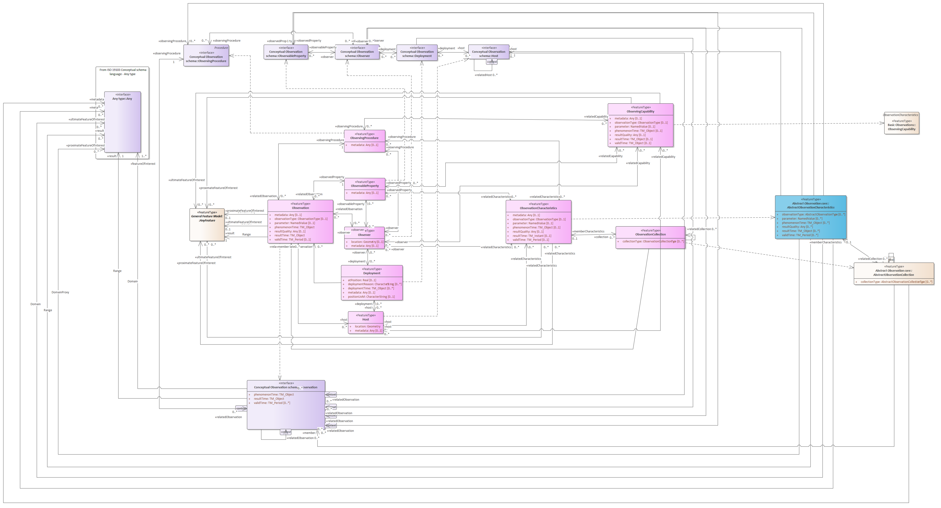
OMS Sampling
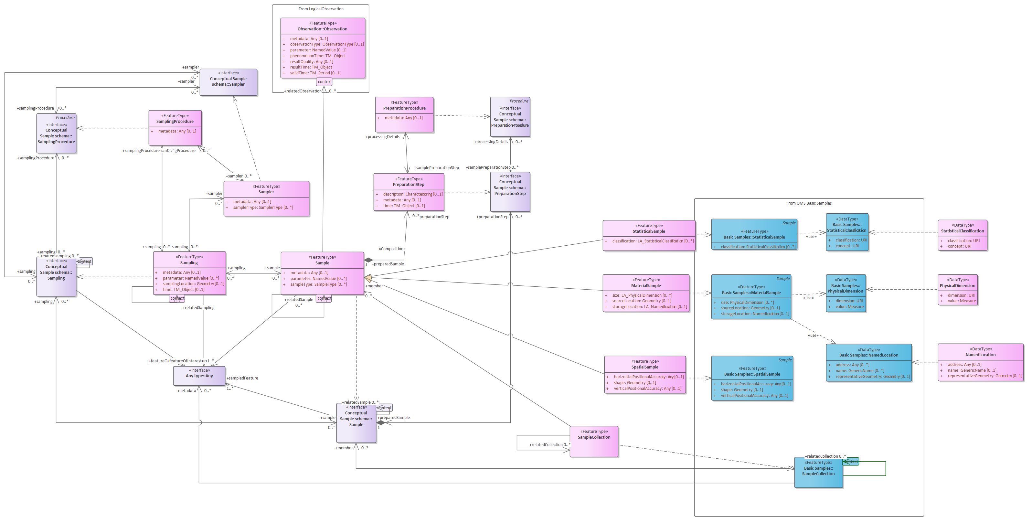

Bibliography
Liang, Steve H.L., Tania Khalafbeigi and Hylke van der Schaaf. "OGC SensorThings API Part 1: Sensing Version 1.1" OGC® Implementation Standard (2021); http://www.opengis.net/doc/is/sensorthings/1.1
Mickael Beaufils, Kathi Schleidt, Hylke van der Schaaf, Dan Ponti, Neil Chadwick, Derrick Dasenbrock. “OGC Geotech Interoperability Experiment Engineering Report” OGC® Engineering Report (2024); http://www.opengis.net/doc/per/geotech-ie
Sylvain Grellet, Kyle Onda, Kathi Schleidt, Hylke van Der Schaaf, Lee Stanish, Candice Hopkins, Meghan Mcleod, Kevin Christian, Cristina A. Mullin, Adam Griggs, Philipp Saile, Tony Boston, Ben Webb, Lucas Valarcher, Hélène Bressan, Lindsay Day, Washington Otieno, Abdelfettah Feliachi. “OGC Water Quality Interoperability Experiment Engineering Report” OGC® Engineering Report (2025); https://brgm.hal.science/hal-05408772
Kathi Schleidt. “Observation and Sampling of a Smiley Face - Observations, Measurements and Samples 101” OGC® Technical Paper (2026); https://docs.ogc.org/techpaper/25-038.pdf

www.opengeospatial.org/cite
https://portal.ogc.org/public_ogc/directives/directives.php
https://knowledge-base.inspire.ec.europa.eu/index_en
https://eur-lex.europa.eu/eli/dir/2007/2/oj/eng

